SENIOR SIX TERM 2 LESSON NOTES CHEMISTRY 2026

TOPIC 1/2: Electrochemistry
Topic competency: The learner analyses redox reactions, electrochemical processes and electrochemical cells, applies the principles of electrode potentials to predict reaction spontaneity and electrolysis outcomes.

Redox Equations
Redox reaction is a reaction in which both reduction and oxidation take place simultaneously. A reduction reaction is where there is addition of elections to an ion species;
e.g., Cu²⁺ (aq) + 2e Cu(aq)
whereas, oxidation is loss of electrons from a compound/ion species .
Zn(s) -2e Zn²⁺(aq)
The species which accepts electrons such as Cu²⁺ is reduced but is referred to as an oxidizing agent.
The species which donates electrons such as Zn²⁺ is oxidized but is referred to as an reducing agent Oxidation Number
An oxidation number is a hypothetical charge assigned to an atom in a chemical compound to track electron movement; an increase in this number indicates oxidation (loss of electrons), and a decrease indicates reduction (gain of electrons). These numbers can be positive, negative, or zero, and are used to determine the oxidation states of individual elements in a reaction. For a neutral compound, the sum of the oxidation numbers is zero, while for an ion, it equals the ion's charge.

Rules governing oxidation numbers
- Free elements: The oxidation number is always zero (e.g., O₂, Fe)
- Monatomic ions: The oxidation number is equal to the charge of the ion (e.g., Na+) has oxidation number +1
- Group 1 elements: Alkali metals (like Na and K) are always +1in a compound.
- Group 2 elements: Alkaline earth metals (like Ca and Mg) are always +2 in a compound.
- Hydrogen: It is +1 when bonded to a nonmetal but −1 when bonded to a metal (in metal hydrides).
- Oxygen: It is typically −2, except in peroxides (like H2O2), where it is −1, or when bonded to fluorine, where it can be positive.
- Fluorine: It is always −1in a compound.
- Overall charge: The sum of all oxidation numbers in a neutral compound equals zero. The sum of all oxidation numbers in a polyatomic ion equals the ion's charge.

Calculating oxidation number of ions of an element in complex ions
Unless otherwise state or implied in these calculations, the oxidation number of a metal is equal to group number, e.g., Na is 1, Mg is 2 Al is 3. Oxidation number of O is -2 and that of any group 7 element is -1.

Example 1
Calculate the oxidation number of manganese ion in KMnO₄.
Here the oxidation number of K = 1 and that of oxygen is implied to be -2. if the oxidation number of Mn is X
Then, 1 + X + -2 x 4 = 0 (overall charge ion the molecule)
X = 7

Trial 1
Calculate the oxidation numbers of the Bolden atoms in molecules or atoms below
1. (i) KIO₃ [5]
- SO₄²⁻ [6]
- Cr₂O₇²⁻ [6]
- H₂O₂ [-1]
- KClO4 [7]
- Na₂S₂O₆ [5]

Half equations
These are balanced based on the number of electrons lost or accepted by a central atom.
Example, equation for reduction of manganate (VII) in acidic medium is written as follows:
MnO₄⁻(aq) + 5e + 8H⁺(aq) → Mn²⁺(aq) + 4H₂O (l)
Five electrons are added because the oxidation number of Mn is reduced from 7 to 2.

Trial 2
Balance the following reduction equations
- Cr₂O₇²⁻(aq) + e + H⁺(aq) → Cr³⁺(aq) + H₂O(l)
- IO₃⁻ (aq) + e + H⁺(aq) → I₂(aq) + H₂O(l)
- H₂O₂ (aq) + e + H (aq) → H₂O (l)
The following are common oxidation half equation reactions:
  - Fe²⁺(aq) -e → F³⁺(aq)
  - H₂O₂(aq) -2e → 2H⁺(aq) + O₂ (g)
  - I- (aq) – e → ½ I₂ (aq)
  - C₂O₄²⁻ (aq) -2e → 2CO₂ (g)

Overall equation
These are constructed from half equation in such a way that the number electron received by an oxidizing agent is equal to the number of electron lost from a reducing agent.
For example a reaction between MnO₄⁻ and Fe²⁺ in acidic medium, the half equation of Fe²⁺ is multiplied by 5 to provide the 5 electron necessary to reduce MnO₄⁻.
That is,
MnO₄⁻(aq) + 5e + 8H⁺ (aq) → Mn²⁺ (aq) + 4H₂O (l)
Plus
5(Fe²⁺ (aq) -e → F³⁺ (aq))

Equals
MnO₄⁻(aq) + 5Fe²⁺ (aq) + 8H⁺ (aq) → Mn²⁺ (aq) + 5F³⁺(aq) + 4H₂O (l)

Trial 3
- Write overall equations between the following pairs of ions or compounds, assume acidic medium where necessary
  - MnO₄⁻ and I-
  - MnO₄⁻ and H₂O₂
  - KIO₃ and KI
  - MnO₄⁻ and C₂O₄²⁻

  - K₂Cr₂O₇ and FeSO₄
- 0.9875g of an impure potassium manganate (VII) was dissolved in water to make 250cm³ of solution. When 20.0cm³ of this solution was acidified with dilute sulphuric acid, warmed and titrated against sodium ethanedioate (oxalate) solution, made by dissolving 1.675g of anhydrous sodium ethanedioate to make 250 cm³, 24.40cm³ of sodium ethanedioate solution was used.
(Na₂C₂O₄ =134 and KMnO4 = 158).
Calculate percentage purity of potassium permanganate (VII) [97.6%]
- 10cm³ of concentrated hydrogen peroxide was diluted to 250cm³. 20cm³ of the dilute solution required 28.30cm³ of 0.02M potassium manganate (VII) solution for complete reaction. Find the volume strength of the concentrated hydrogen peroxide solution. [1.77M]
- Potassium permanganate is commonly used as a reagent in volumetric analysis. However it is not a primary standard.
  - State two disadvantage of using potassium manganate (VII) as a reagent in volumetric analysis.
  - Give two reasons why potassium manganate (VII) is not used as a primary standard
  - Write a half equation for the reduction of manganate (VII) ions in
    - acid solution
MnO₄⁻(aq) + 5e + 8H⁺(aq) Mn²⁺(aq) + 4H₂O(l)
    - alkaline solution
MnO₄⁻(aq) + 3e + 4H⁺(aq) MnO₂(aq) + 4H₂O(l)
- In volumetric estimation of reducing agent, potassium dichromate (VI) is preferred to potassium manganate (VII) as an oxidant
- Explain why potassium dichromate (VI) is preferred as an oxidant. (2 marks)

- 3.8g of solder containing tin was dissolved in excess hydrochloric acid. The solution was made up to 250cm³. 25.0cm³ of this solution required 23.5cm³ of a 0.01M potassium dichromate (VI) solution for complete reaction.
Calculate the percentage, by mass, of tin in the solder. [22%]
- Explain why chlorine is more soluble in dilute sodium hydroxide than in water (4 marks)
- (a) Determine the oxidation number of
    - Nitrogen in HNO₃ [5]
    - Sulphur in S₂O₈ (1marks) [8]
  - Write half equation for the conversion of S₂O₈²⁻ to SO₄²⁻ ions S₂O₈²⁻ + 2e  2SO₄²⁻
  - Complete the following and balance the equations
    - S₂O₈²⁻ + I⁻ →
    - Sn²⁺(aq) + S₂O₈²⁻ (aq) →

- Iron (II) sulphate is normally used to standardize a solution of potassium manganate (VII)
acidified with sulphuric acid.
- write equation for the reaction between potassium manganate (VII) and iron (II) sulphate
- State why hydrochloric acid is not used to acidify potassium manganate (VII) solution Cl⁻ are oxidized by MnO₄⁻ as well
(b) 25 cm³ of acidified solution of 0.02M potassium manganate (II) reacted exactly with 24.95 cm³ of sodium nitrite. Potassium manganate (VII) reacts with sodium nitrite according to the following equation
2MnO₄⁻(aq) + 5NO₂⁻(aq) + 6H⁺(aq) → 2Mn²⁺(aq) + 5NO₃⁻(aq) +3H₂O(l)
Calculate the concentration of sodium nitrite in moles per litre. [0.05M]

Application of redox reactions in Biological systems
- Cellular respiration: This process uses a series of redox reactions to convert chemical energy stored in glucose into adenosine triphosphate (ATP), the energy currency of the cell.
- Photosynthesis: The complementary process to respiration in plants also relies on redox reactions to convert light energy into chemical energy.
- Metabolic pathways: Redox reactions are the backbone of many metabolic pathways, where enzymes control the transfer of electrons in controlled steps.
- Oxidative stress: An imbalance between pro-oxidants and antioxidants can lead to oxidative stress, which is linked to various diseases.

Application of redox reactions in Industrial systems (i) Energy production:
  - Batteries and fuel cells: These devices generate electricity through controlled redox reactions, where electrons are transferred from one chemical to another.
  - Metal extraction: Redox reactions are used to extract pure metals from their ores.
- Corrosion: This is an unwanted redox process where metals oxidize, leading to degradation.
  - Rusting of iron: A common example where iron is oxidized by oxygen in the presence of water.
  - Prevention: Industries use techniques like cathodic protection, which makes the metal the cathode in an electrochemical cell, to prevent it from oxidizing.
- Chemical manufacturing: Redox reactions are used in the synthesis of numerous chemicals, such as the production of nitric acid from ammonia or chlorine from sodium chloride.
- Environmental remediation: Redox reactions can be used to treat pollutants, such as reducing toxic hexavalent chromium to a less harmful form.

Electro-chemical conductivity Resistance R of electrolytic solution
This is the drag force experienced by ions as they migrate towards the respective electrodes. Resistance of an electrolyte is proportional to the length l of an electrolyte between electrodes and inversely proportional to the square root of the cross section area A, of each electrode.
Thus, R 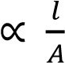
Or R = 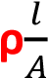
ρ is called resistivity of an electrolyte and is the resistance of an electrolyte placed between electrodes each 1cm² in area and 1cm apart.
In chemistry reciprocal terms are preferred.
That is, conductance, 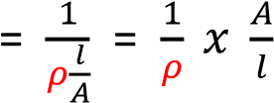
The reciprocal of resistivity, is called conductivity, K.
It implies that conductance, 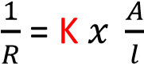
And K 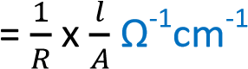

Factors that affect the conductivity of electrolytes
- Concentration of Ions in Solution: The higher the concentration of ions in solution, the higher its conductivity due to high number of conducting ions.
- Weak/Strong Electrolyte: Strong electrolyte have higher conductivity than weak electrolytes because they are completely ionized in water to produce many ions
- Temperature: The solubility of the solute increases with the increase in the temperature. Therefore, the conductivity of the electrolyte increases. Secondly temperature increase the speed of ions in solution

Molar conductivity, Λ_{c}
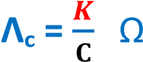
This is the conductivity of a solution that contains 1 mole of an electrolyte. -1 2 -1 cm mol
where C = moles of electrolyte in the solution between electrodes.

Example 2
The resistance of 0.1M KCl solution placed between electrodes each 1cm² in area and 0.5 cm apart is 400Ω. Calculate the molar conductivity of the solution.
K 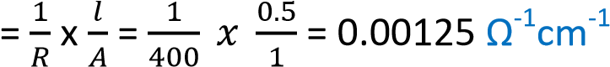
Volume of electrolyte between the electrodes = 1 x 0.5 = 0.5cm³
Moles of the electrolyte between the electrodes
1000cm³ contain 0.1mole
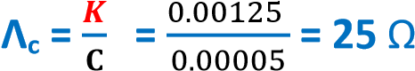
0.5cm³ contain 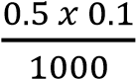 = 0.00005moles -1 2 -1 cm mol

Variation of molar conductivity with concentration
Molar conductivity for both strong and weak electrolyte decrease as the concentration increase as shown by the graphs below
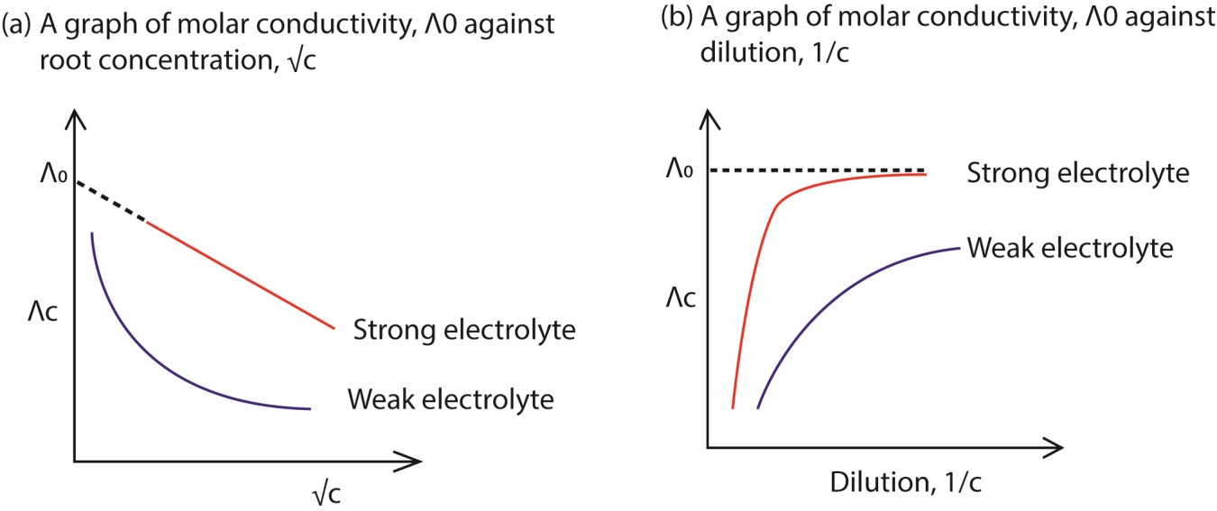

Explanation

(a) Strong electrolyte
- Strong electrolyte are completely ionized in solution;
- at high concentration the solution contains high density of ions
- high density of ions lead ion interaction which reduce mobility of ions which lowers molar conductivity.
- On dilution the tendency to form these interactions reduce lowering the drag force thus molar conductivity increases.

(b) Weak electrolyte
- Weak electrolytes are poorly ionized in solution which provides low concentration conducting ions which leads to low molar conductivity compared to strong electrolytes
- At high concentration, the percentage ionization of weak electrolytes is very low leading to very few conducting ions per mole of electrolytes and low molar conductivity.
- Percentage ionization of weak electrolytes increases with dilution leading to increase in the number of ions per mole of an electrolyte and molar conductivity.

Molar conductivity at infinite dilution, Λ₀
This is the conductivity of 1 mole of electrolyte when the solution is very dilute that the ions experience no interaction from other ions.
For strong electrolyte, molar conductivity at infinite dilution is obtained by extra plotting of molar conductivity against root concentration to zero concentration.
For weak electrolyte, molar conductivity at infinite dilution is obtained by application of Kohrlrausch’s law of independent migration of ions.
It state: “the molar conductivity of an electrolyte at infinite dilution is the sum of molar conductivity of the constituent ions at infinite dilution.
For example
Λ₀ NaCl = λ₀ Na⁺ + λ₀ Cl⁻ Λ₀ AB = Λ₀ AC + Λ₀ BD - Λ₀ CD

Example 3
The molar conductivity of nitric acid, potassium nitrate and potassium fluoride are 421, 145 and 129
Ω⁻¹cm²mol⁻¹ respectively at infinite dilution. Molar conductivity of hydrofluoric acid at infinite dilution.
Λ₀ HF = Λ₀ HNO₃ + Λ₀ KF – Λ₀ KNO₃
= 421 + 129 -145
= 405 Ω⁻¹cm²mol⁻¹

Factors affecting conductivity of an ion at infinite dilution
- Charge on the ion: the bigger the charge the higher the conductivity because the ion caries bigger charge per ion
- The size of an ion: small ions have high speed of movement leading to high conductivity. However, small ions with high charge have high density that may attract a big cloud of water of hydration that its effective mass may bigger than that of a big ion. That is why the small cations may have lower conductivity that big cation.

Example of conductivities of common ions at infinite dilution
ion | λ0 (Ω⁻¹cm²mol⁻¹)
Na⁺  OH⁻  H⁺  Cl⁻ | 50.1  198.6  349.8  76.4

Conductometric titrations
These are titrations in which ions are replaced by others of different conductivity, the titration followed by conductivity measurement.

(a) Titration of a strong acid with strong base



G

(Ω
-
1

A

B

C

Volume of NaOH

Explanation
Initially at A, conductivity is high due to presence of highly conducting H⁺ from ionization of hydrogen chloride
HCl → H⁺(aq) + Cl⁻(aq)
Along AB conductivity decreases up to the end point due to removal of highly conducting hydrogen ions.
H⁺(aq) + OH⁻(aq) → H₂O (l)
Along BC after the end point, conductivity increases due to excess OH⁻ ions that are relatively highly conducting.

(b) Titration of a weak acid e.g. CH₃COOH with strong base (e.g. NaOH)


G(Ω
-
1

A

B

C

Volume of NaOH

Explanation
Initially at A conductivity is low due to small concentration of H⁺ ions since the acid is partially ionized.
CH₃COOH CH₃CO⁻ + H⁺
Along AB conductivity increases up to end point due to addition of salt ions and further ionization of the acid due to dilution.
CH₃COOH (aq) + OH⁻ (aq) → CH₃COO⁻(aq) + H₂O(l)
Along BC conductivity increase to due to excess OH⁻.

(c) Titration of a weak acid (e.g. CH₃COOH) with weak base (e.g. NH₄OH)

G

(Ω
-
1

A

B

C

Volume of

NH
4
OH

D

Initially at A, conductivity is high due to presence of H⁺ from partial ionization of the acid CH₃COOH CH₃CO⁻ + H⁺
Along AB conductivity decreases due to removal of H+.
H⁺(aq) + OH⁻(aq) → H₂O (l)
Along BC conductivity increases due to addition of salt ion
CH₃COOH (aq) + NH₄OH (aq) → CH₃COO⁻(aq) + NH₄⁺(aq) + H₂O(l)
Along CD conductivity remains almost constant due to attainment of equilibrium.

Trial 4
- Define the term
    - Molar conductivity (1mark)
    - Electrolytic conductivity (1mark)
- The table below shows molar conductivities, Λ, of potassium chloride and ethanoic acid at different concentrations.
(concentration)^{½} (moldm-3)½ | 0.01 | 0.02 | 0.03 | 0.04 | 0.74 | 0.106
Λ, for KCl (Ω⁻¹cm²mol⁻¹) | 147.0 | 145.0 | 142.0 | 140.0 | 132.0 | 128.0
Λ, for ethanoic acid (Ω1 2 -1  cm mol ) | 70.0 | 49.0 | 33.0 | 24.0 | 10.0 | 6.0
(i) On the same axes draw graphs of molar conductivity against square root of concentration,
for both potassium chloride and ethanoic acid. (3marks) (ii) State the shapes of the graphs in (b)(i) and explain your answer. (5marks) (c) The electrolytic conductivity of a solution containing 6.66g of ethanoic acid in one litre is 5.21 x
10-2 Ω-1m-1 at 250C.
Calculate the dissociation constant Ka of ethanoic acid at 25⁰C.
(the molar conductivities of hydrochloric acid, sodium chloride and sodium ethanoate are 426 x
10⁻⁴, 126 x 10⁻⁴ and 91 x 10 ⁻⁴ Ω⁻¹m²mol⁻¹ respectively at infinite dilution). (06marks)
(d) To a solution of hydrochloric acid was added small amounts of sodium hydroxide solution at a time until in excess. State how the conductivity of the solution varied and explain your answer. (4marks)

Solution
- (i) Molar conductivity is a conductivity of solution that contains 1 mole of electrolyte.
(ii) Electrolytic conductivity is the reciprocal of resistance of a solution between electrodes each 1cm² in area and 1cm a part.
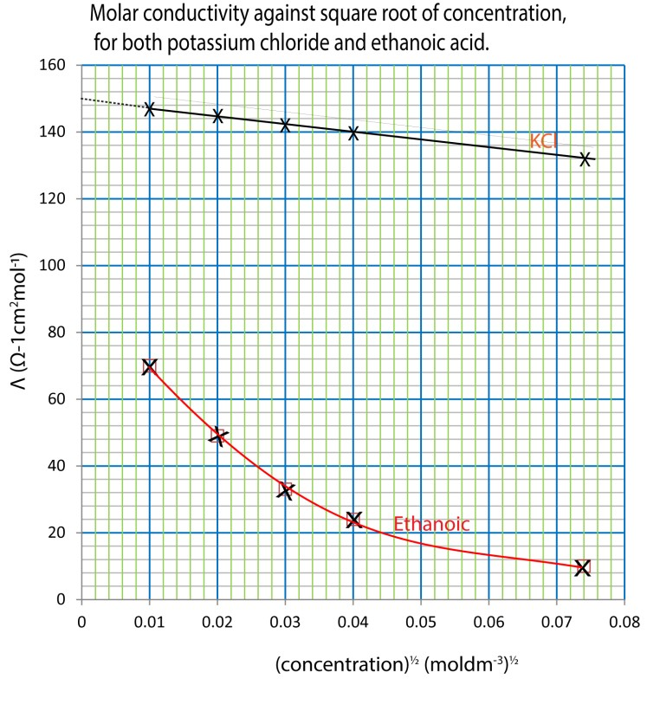
- (i)

KCl is Strong electrolyte
- It is are completely ionized in solution;
- at high concentration the solution contains high density of K⁺ and Cl⁻ ions
- high density of ions lead ion interaction that increases the drag force of ions which lowers molar conductivity.
- On dilution the tendency to form these interactions reduce lowering the drag force thus molar conductivity increases.

Ethanoic acid is weak electrolyte
- It is poorly ionized in solution which provides low concentration conducting CH₃COO⁻ and H⁺ ions which leads to low molar conductivity compared to strong electrolytes
- At high concentration, the percentage ionization of ethanoic is very low leading to very few conducting ions per mole of electrolytes and low molar conductivity.
- Percentage ionization of ethanoic acid increases with dilution leading to increase in the number of ions per mole of an electrolyte and molar conductivity.
- Formula mass of ethanoic acid, CH₃COOH = 60
Moles of ethanoic acid per dm 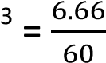= 0.111 moldm⁻³ ≡ 111molm⁻³.
Molar conductivity, 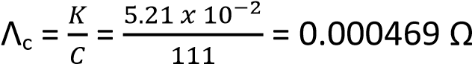⁻¹m²mol⁻¹
Λ₀ (CH₃COOH) = Λ₀ (HCl) + Λ₀ (CH₃COO⁻Na⁺) - Λ₀ (NaCl)
= 429 x 10⁻⁴ + 91 x 10⁻⁴ – 126 x 10⁻⁴ = 391 x 10⁻⁴ Ω⁻¹m²mol⁻¹
The degree of ionization, 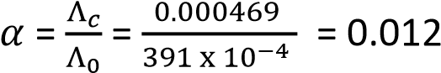
Acid constant, Ka = 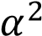C = (0.012)² x 0.111 = 1.6 x 10⁻⁵moldm⁻³.
- Conductivity initially decreases with increasing volume of sodium hydroxide due to removal of highly conducting hydrogen ions up to the end point. It then increases due to excess OH⁻ ions.

Trial 5
- State two factors that can affect the molar conductivity of an electrolyte.
- The molar conductivity of potassium hydroxide at various concentrations are given in the table below.
Molar conductivity (Ω⁻¹cm²mol⁻¹) | 238 | 230 | 224 | 217 | 210
Concentration of potassium hydroxide  (mol/dm³) | 0.01 | 0.04 | 0.09 | 0.16 | 0.25
Square root of concentration of potassium hydroxide (mol/dm³)^{½}
- Complete the table above. (1mark)
- Draw a graph of molar conductivity against the square root of the concentration of potassium hydroxide. (3marks)
- Explain the shape of the graph you have drawn in (b)(ii).
- Determine the value of molar conductivity of potassium hydroxide at infinite dilution

Solution
- – concentration and temperature

- (i)
Molar conductivity (Ω⁻¹cm²mol⁻¹) | 238 | 230 | 224 | 217 | 210
Concentration of potassium hydroxide (mol/dm³) | 0.01 | 0.04 | 0.09 | 0.16 | 0.25
Square root of concentration of potassium hydroxide  (mol/dm³)^{½} | 0.1 | 0.2 | 0.3 | 0.4 | 0.5
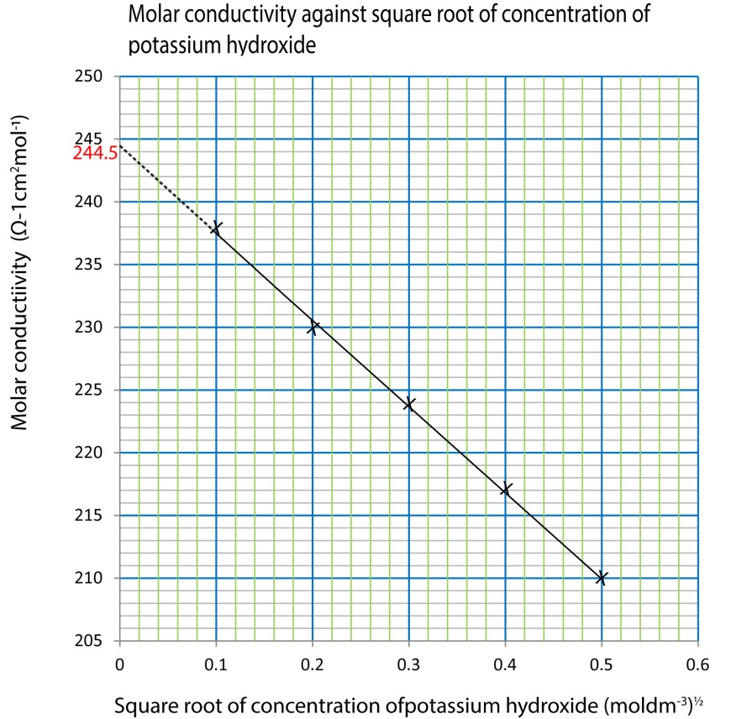
(ii)

(iii) KOH is Strong electrolyte: molar conductivity is decreases as concentration increase because
  - It is are completely ionized in solution;
  - at high concentration the solution contains high density of K⁺ and Cl⁻ ions
  - high density of ions lead ion interaction that increases the drag force of ions which lowers molar conductivity.
  - On dilution the tendency to form these interactions reduce lowering the drag force thus molar conductivity increases.

(i) 244.5 Ω⁻¹cm²mol⁻¹

6
State three factors that can affect molar conductivity of electrolytes (1 ½ marks)
- The graph below shows the variation of molar conductivity of a strong electrolyte with dilution


Λ
0

dilution

Briefly explain the shape of the graph
- The molar conductivity of nitric acid, potassium nitrate and potassium fluoride are 421, 145 and 129 Ω⁻¹cm²mol⁻¹ respectively at infinite dilution
- Molar conductivity of hydrofluoric acid at infinite dilution (02marks)
- Dissociation constant, Ka, of a 0.1M hydrofluoric acid solution. (The electrolytic conductivity of hydrofluoric acid is 3.15 x 10⁻⁵ Ω⁻¹cm⁻¹)

Solution
- concentration
- temperature
- whether weak or strong electrolyte
- molar conductivity increases with dilution because opposite ions get far apart which reduces ionic interference.
- (i) Λ₀ (HF) = Λ₀ (HNO₃) + Λ₀ (KF) - Λ₀ (KNO³)
= 421 + 129 - 145
= 405 Ω⁻1cm²mol⁻¹
(ii) Molar conductivity, 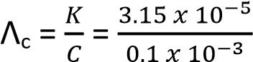= 0.001 Ω⁻¹m²mol⁻¹
Acid constant, Ka = 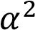C = (0.001)² x 0.1 = 1 x 10⁻⁷moldm⁻³.
7
Define ‘electrolytic conductivity’.
(b) The molar ionic conductivity at infinite dilution of some ionic species are shown below
ion | λ0 (Ω⁻¹cm²mol⁻¹)
Na⁺  OH⁻  H⁺  Cl⁻ | 50.1  198.6  349.8  76.4

Calculate the electrolytic conductivities for:
  - 0.01M sodium hydroxide solution
  - A solution made by mixing 50cm³ of 0.01M sodium hydroxide and 50cm³ of 0.02M hydrochloric acid

Solution
- Electro conductivity is the reciprocal of resistance of an electrolyte placed between electrodes each 1cm² and 1cm apart.
(b)(i) Electrolytic conductivity = C(λ₀Na⁺ + λ₀Cl⁻)
= 0.01(50.1 + 76.1)
=1.265 Ω⁻¹cm²mol⁻¹
(ii) Moles of sodium hydroxide = 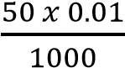 = 0.0005 moles
Moles of hydrochloric acid =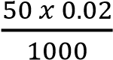 = 0.001 moles
Moles of unreacted hydrochloric acid = 0.001 – 0.0005 = 0.0005 moles
Moles of sodium chloride formed = moles of sodium hydroxide that reacted
= 0.0005moles
Electrolytic conductivity = C(λ₀Na⁺ + λ₀Cl⁻) + C(λ₀H⁺ + λ₀Cl⁻)
= 0.0005(50.1 + 76.1) + 0.0005(349.8 + 76.1)
= 0.06235 + 0.2122 = 0.27455 Ω⁻¹cm²mol⁻¹
8
The molar conductivity of sodium hydroxide solutions of different concentrations are shown in the table below:
Concentration/moldm3 | 0.01 | 0.04 | 0.09 | 0.16 | 0.25 | 0.36
Molar conductivity  (Ω-1cm2mol-1) | 238 | 230 | 224 | 217 | 210 | 202
(i) Draw a graph of molar conductivity against the square root of concentration (4marks) (ii) Explain the shape of the graph (4 ½
marks)
(iii) Determine the value of molar conductivity at infinite dilution of sodium hydroxide and indicate its units
(2marks)
- Using the same conductivity cell, the resistance of 0.1M potassium chloride and 0.1M bromoethanoic acid solution were found to be 24.96 and 66.50 ohms respectively at 25⁰C when determined using the same conductivity cell. [the conductivity of potassium chloride at 25⁰C is 0.01164 Ω⁻¹cm⁻¹ and the molar conductivity of bromoethanoic acid at infinite dilution is 389 Ω⁻¹cm²mol⁻¹]
  - Calculate the cell constant (2marks)
  - Calculate the molar conductivity of the 0.1M bromoethanoic acid (3marks) (iii) Determine the pH of 0.1M bromoethanoic acid (4 ½ marks)

Solution
(a)(i)
Concentration/moldm⁻³ | 0.01 | 0.04 | 0.09 | 0.16 | 0.25 | 0.36
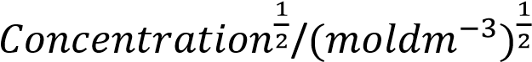 | 0.1 | 0.2 | 0.3 | 0.4 | 0.5 | 0.6
Molar conductivity (Ω⁻¹cm²mol⁻¹) | 238 | 230 | 224 | 217 | 210 | 202

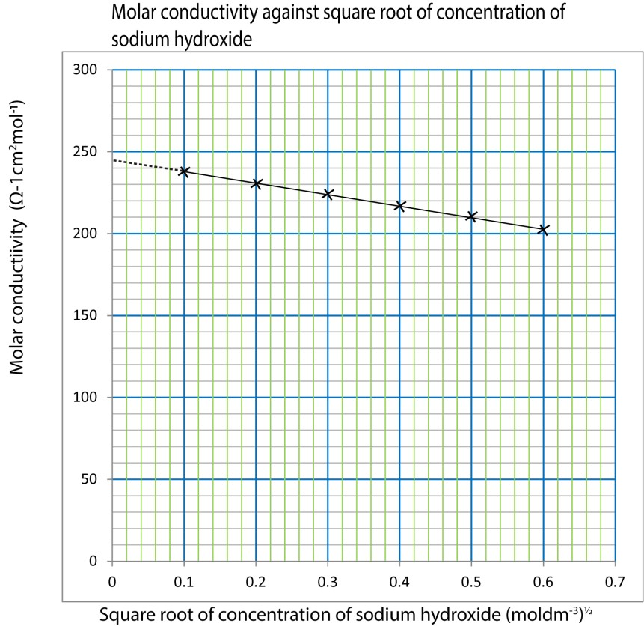

- NaOH is Strong electrolyte: molar conductivity is decreases as concentration increase because
  - It is are completely ionized in solution;
  - at high concentration the solution contains high density of K⁺ and Cl⁻ ions
  - high density of ions lead ion interaction that increases the drag force of ions which lowers molar conductivity.
  - On dilution the tendency to form these interactions reduce lowering the drag force thus molar conductivity increases.
- 245 Ω⁻¹cm²mol⁻¹
(c) (i) K = x cell constant
0.0116 = 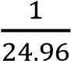 x cell constant
Cell constant = 0.29cm⁻¹
- K for bromoethanoic acid = 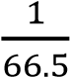 x 0.29 = 4.36 x 10⁻³ Ω⁻¹cm⁻¹
- Λ_{c} 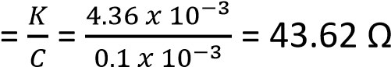⁻¹cm²mol⁻¹
(iii) α = 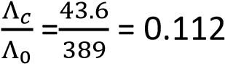
[H⁺] = αC = 0.112 x 0.1 = 0.0112moledm⁻³ pH -= -log0.0112 = 1.95

Trial 9
The molarity of a sample of hydrochloric acid about 0.1M was determined accurately by measuring the conductivity of solution as1.0M sodium hydroxide was added to 50cm³ of the acid. The results were as follow:
Conductivity/ Ω⁻¹cm⁻¹ | 4.1 | 3.3 | 2.4 | 1.7 | 1.5 | 1.8 | 2.2 | 2.5
Volume of 1.0M NaOH/cm³ | 1 | 2 | 3 | 4 | 5 | 6 | 7 | 8

- (i) Plot a graph of conductivity against the volume of 1.0M sodium hydroxide (3marks)
  - Determine from the graph the volume of 1.0M sodium hydroxide used to reach the end point (1mark)
  - Calculate the molarity of hydrochloric acid (02marks)
  - Explain the shape of the graph (3marks)
- Name one other application of conductivity measurement (1mark)

Solution
6 (a)(i)
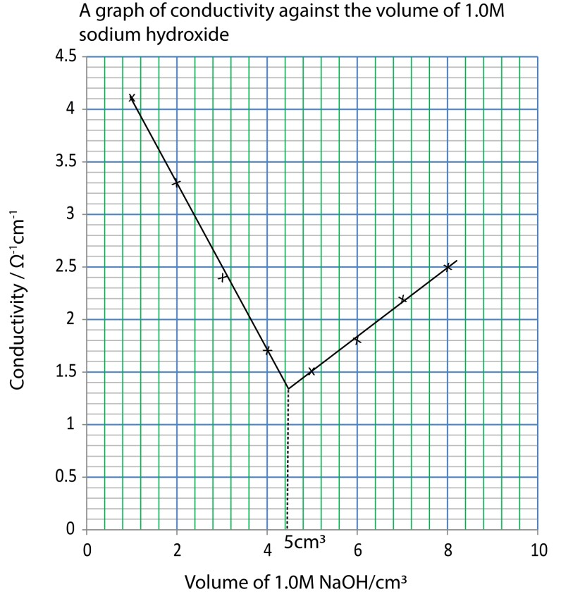
- 5cm³
- moles of hydrochloric acid = moles of sodium hydroxide = 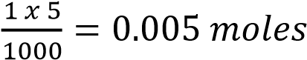
Molarity of hydrochloric acid = 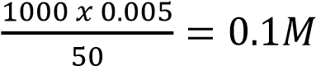
- Conductivity initially decreases with increasing volume of sodium hydroxide due to removal of highly conducting hydrogen ions up to the end point. It then increases due to excess OH⁻ ions. (b) study of complexes

Trial 10
- Define the following terms
  - Conductivity
  - Molar conductivity (3marks)
- The graph below shows the change in conductivity when 0.01M methanoic acid is titrated with 0.1M ammonium solution
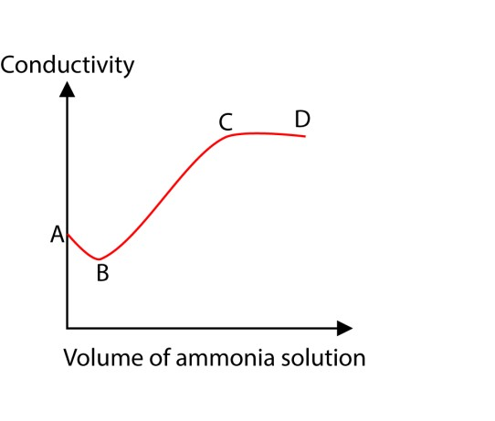
Explain the shape of the graph.
- At 25⁰C, the molar conductivity of silver nitrate, potassium nitrate and potassium chloride are 133.4, 145.0 and 149.9Ω⁻¹cm²mol⁻¹ respectively.

At the same temperature, the conductivity of a saturated solution of silver chloride is 3.41
x10⁻⁶ Ω⁻¹cm⁻¹ while that of pure water is 1.6 x 10⁻⁶ Ω⁻¹cm⁻¹

- Calculate the solubility of silver chloride in moles per dm³ at 25⁰C. (4marks)
- Determine the solubility product of silver chloride at 25⁰C. (3marks)
(d) The ionic conductivities of rubidium and sodium ions are 73.3 and 50.1 Ω⁻¹cm⁻¹ respectively.
Explain why the ionic conductivity of rubidium ion is higher than that of sodium ions (3marks)

Solution
- (i) Electrolytic conductivity is the reciprocal of resistance of a solution between electrodes each 1cm² in area and 1cm a part.
(ii) Molar conductivity is a conductivity of solution that contains 1 mole of electrolyte.
- Initially at A, conductivity is high due to presence of H⁺ from partial ionization of the acid CH₃COOH CH₃CO⁻ + H⁺
Along AB conductivity decreases due to removal of H+.
H⁺(aq) + OH⁻(aq) → H₂O (l)
Along BC conductivity increases due to addition of salt ion
CH₃COOH (aq) + NH₄OH (aq) → CH₃COO⁻(aq) + NH₄⁺(aq) + H₂O(l)
Along CD conductivity remains almost constant due to attainment of equilibrium.
- Λ₀ AgCl = Λ₀ AgNO₃ + Λ₀ KCl – Λ₀ KNO₃
= 133.4 + 149.9 – 145
= 138.3 Ω⁻¹cm²mol⁻¹
KAgCl = 3.41 x 10⁻⁶ – 1.6 x 10⁻⁶
1.81 x 10⁻⁶ Ω⁻¹cm⁻¹

Λ₀ AgCl 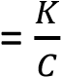

C =

Ksp = [Ag⁺][Cl⁻] = (1.3 x 10⁻⁵)² = 1.7 x 10⁻¹⁰mol²dm⁻⁶.

Trial 11
- (i) state Kohrlrausch’s law of ionic conductivity at infinite dilution (1mark)
(ii) Calculate the molar conductivity of methanoic acid at infinite dilution
(λ₀(HCOONa) = 9.5x 10⁻²Sm²mol⁻¹, λ₀(NaCl) = 1.26x 10⁻¹Sm²mol⁻¹, λ₀(HCl) = 4.26x 10⁻¹Sm²mol⁻¹,) (2marks)
- Ionic conductivities of Ag⁺ and Cl⁻ ions at infinite dilution are 6.2 x 10⁻² and 7.6 x 10⁻² Sm²mol⁻¹ respectively at 298K. The electrolytic conductivity of silver chloride at 298K is 1.22 x10⁻⁴Sm⁻¹. Calculate the solubility, in moldm⁻³, of silver chloride at 298K. (5marks)
- Name one practical application of ionic conductivity apart from the determination of solubility of electrolytes.

Solution
- (i) It state: “the molar conductivity of an electrolyte at infinite dilution is the sum of molar conductivity of the constituent ions at infinite dilution.
(ii) Λ₀ HCOOH = Λ₀ HCOONa + Λ₀ HCl – Λ₀ NaCl
= 0.095 + 0.426 – 0126
= 0.395 Ω⁻¹cm²mol⁻¹
- Λ₀ AgCl = λ₀ Ag⁺ + λ₀ Cl⁻
= 0.062 + 0.076 = 0.138 Ω⁻¹cm²mol⁻¹

Λ₀ AgCl 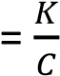

C =
(c) – study complexes
- Determine end point in titration

Trial 12
(a) (i) State Faraday’s laws of electrolysis. (4marks)
(ii) A current of 2A was passed for 30 minutes through a cell containing dilute sulphuric acid and the hydrogen produced at the cathode collected, calculate the volume of hydrogen, in cm³, that was produced at 23⁰C and 100kPa. (6marks)

(b)


P

Q

R

X

Y

Z

Volume of sodium hydroxide

conductivity

Graphs PQR and XYZ show variation of conductivities of solutions formed when equal volumes of 0.1M hydrochloric acid and 0.1M ethanoic acid respectively were titrated with 1M sodium hydroxide. Account for the difference in the shapes of the graphs.

Solution
(a) (i) the mass of a substance liberated at an electrode is proportional to the quantity of electricity used.

the number of moles of electricity liberated by 1 mole of electricity is inversely proportional to the charge on its ions

(ii) Q = it = 2 x 30 x 60 = 3600C
2H⁺(aq) + 2e → H₂(g)
Volume of hydrogen liberated at stp.
96500 x 2 liberates 22400cm³ of hydrogen
3600 liberate 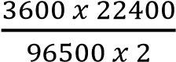 = 417.8cm³

Volume of hydrogen at 23⁰C and 100KPa
From 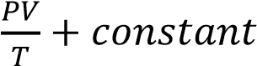
Then, 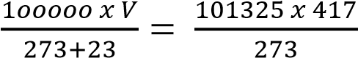
V = 459cm³ (b) Graph PQR
  - At P the conductivity is high due to presence of hydrogen ions from ionization of HCl.
  - Along PQ conductivity decrease due to removal of hydrogen ions by OH⁻ ions.
  - After the end point at Q, conductivity increase due to excess OH⁻ ions.
Graph XYZ
  - At X conductivity is low due to presence of few hydrogen ions from partial ionization of ethanoic acid.
  - Along XY conductivity increases due to addition of salt ions and further ionization of the acid on dilution
  - After the end point at Y conductivity increases due to excess hydroxyl ions from sodium hydroxide

Trial 13
The ionic radii and molar ionic conductivities at infinite dilution at 18⁰C of lithium and cesium ions are given in the table below
 | Li⁺ | Cs⁺
Ionic radius (nm) | 0.06 | 0.17
Molar ionic conductivity (Ω⁻¹cm²mol⁻¹) | 33.5 | 68.0
Explain why the molar conductivity of lithium ions is lower than that cesium ions.

Solution
- Lithium ions have a large charge density.
- In aqueous solution they attract a big cloud of water molecules around themselves.
- This makes their effective size bigger than that of cesium.
- The big size of lithium ions the drag force that reduces its conductivity.

Trial 14
During the electrolysis of dilute sulphuric acid using platinum electrodes, a current of 2A was passed for6.7minutes at room temperature.
Calculate the volume of the gas evolved at
- The anode
- The cathode (6marks)
[1Faraday = 96500C, 1 mole of a gas occupies 24dm3 at room conditions)
- Name one application of
  - Electrolysis
  - Standard electrode potential.

Solution

Q = it = 2 x 6.7 x 60 = 804C
(i) At the anode oxygen is liberated
4OH⁻(aq) + 4e 2H₂O(l) + O₂(gas)
(4 x 96500)C liberate 24000cm³
804 C liberate 50cm³
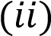 At cathode hydrogen is liberated.
2H⁺(aq) + 2e → H₂ (g)
(2 x 96500)C liberate 24000cm³
804 C liberate 10cm³

Electrochemical cells
When a strip of metal is placed in a solution of its ions, the metal atoms tend to ionize; cations dissolve in solutions while electrons remain on the metal surface. For instance, a divalent metal, M, ionizes as follows
M(s) ↔ M²⁺ (aq) + 2e
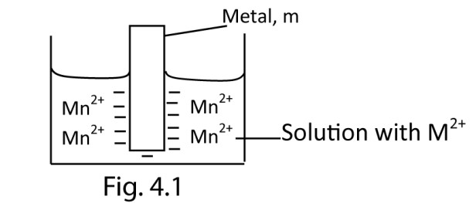
The attraction of the metal rod (containing negative charge) and the solution (containing positive charges) causes a potential difference called electrode potential.
The metal dipped into it’s a solution containing metal ions is called electrode half-cell represented symbolically as M^{n+}/M.

Definition
Electrode potential is a potential difference that is set up between a metal and its solution containing metal ions.

Factors affecting the magnitude of the potential difference
- Concentration of metal ions already in solution. Since the ionization equation (1) is a reversible reaction, the higher the concentration of metal ions in solution, the further to the left will be the state of equilibrium and hence the smaller the electrode potential.
- Temperature. Increasing temperature increases the ionization of metal atoms and thus increases the electrode potential.
- Pressure: applicable to gas systems, the higher the pressure the higher the electrode potential because increased pressure increases the gas concentration at gas –liquid junction.
- Position of metal in electrochemical series.
Metals above hydrogen in electrochemical series, have ionization reactions that lie more to the right than left, thus, the metal tends to be negatively charged with respect to their solutions. Thus have negative electrode potentials.

Metals below hydrogen in electrochemical series, their ionization reaction lie more to the left and their electrode potentials are positive.

Standard electrode potential (SEP)
This is the electrode potential of a metal dipped in a solution containing one mole of metal ions in a dm³/litre of solution at 298K and 1 atmosphere. It is denoted by E⁰.

Factors affecting standard electrode potential
Electrode potential involves formation of hydrated ions. It is a sum of atomization energy (which is endothermic) + ionization energy (which is endothermic) + ionic hydration energy (which is exothermic).

When atomization and/or ionization energy is high, the standard electrode potential becomes more positive.

On the other hand, when the hydration energy is higher than the sum of ionization and atomization energy, standard electrode potential is negative.

Short-hand Notation for an electrode half cell
A metal rod dipped in a solution of metal ions constitutes a half cell. The accepted short form of writing an electrode is to write is to write ‘oxidized form/reduced form’ of metal. For example, the zinc half-cell is written as Zn²⁺/Zn and copper electrode as Cu²⁺/Cu.

Standard Hydrogen electrode (fig. 4.2)
It consists of hydrogen gas at 298K and pressure of 1 atmospheres bubbling over a strip of platinized foil (i.e. platinum coated) in a solution which is 1M with respect to H⁺ ions
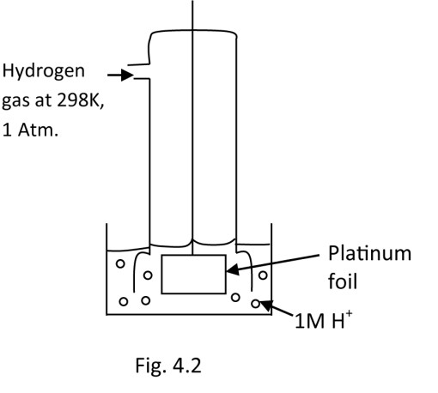
The short hand notation for a hydrogen electrode is
H⁺, M/ ½ H₂, 1 atm. Or H⁺/ ½ H₂.
And electrode reaction is
H+(aq) + e → ½ H₂(g)
A potential develops on the surface of the platinum; by convention, it is assigned an arbitrary value of zero volts.
Hydrogen electrode is use as a reference electrode and the electrode potential of all other electrodes are measured relative to this.

Measurement of electrode potential of metal (fig. 3)
A standard metal electrode is combined with a standard hydrogen electrode as shown in Fig.4.3 below
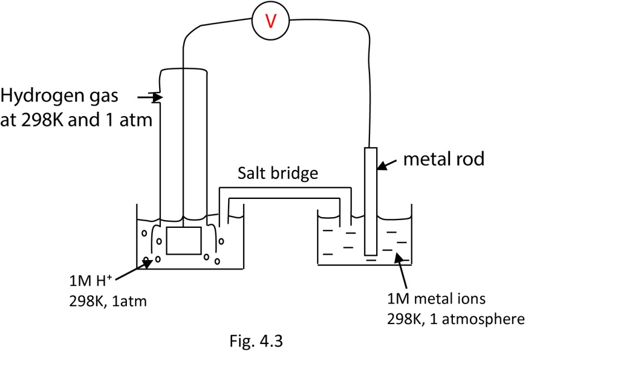
The two compartments in the figure are connected by a salt bridge. This contains an electrolyte such as potassium chloride, which conducts electricity but does not allow mixing of two solutions in half cells. The measurement on the high resistance voltmeter is the standard electrode of the metal since that of hydrogen half-cell is zero.
Definition
Standard electrode potential is the electrode potential value of an electrode measure with respect to a standard hydrogen electrode of 0 volts. When an electrode is immersed or dipped into a solution of 1M concentration of its ions at a standard temperature of 298K and pressure of1atmospheres.
Some electrode and their standard electrode potentials are given below:
Electrode Electrode reaction E⁰/volts
Zn²⁺/Zn Zn²⁺(aq) + 2eZn(s) -0.76
Cu²⁺/Cu Cu²⁺(aq) + 2eCu(s) +0.34
Fe²⁺/Fe Fe²⁺(aq) + 2eFe(s) -0.44
Ag⁺/Ag Ag⁺(aq) + eAg(s) +0.80

Galvanic or Voltaic cells or electrochemical cells
This is a type of cell in which a chemical reaction results in production of an electric current.
By combining two suitable electrodes (half cells) a cell of a particular emf may be obtained. One electrode acts as electron supplier and the other as electron acceptor.
The Daniel cell (fig. 4.4)
It consists of the zinc electrode dipped into 1M zinc sulphate solution and copper electrode dipped into 1M copper sulphate solution, the two solution separated by a porous partition. The cell develops an electromotive force (emf) of 1.10V.
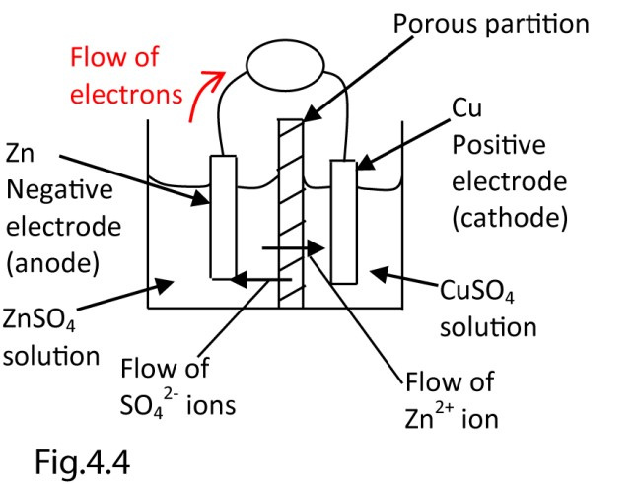

Half call reaction
At zinc electrode (anode)
Oxidation occurs and the electrode dissolves.
Zn(s) – 2e → Zn²⁺(aq)
At the copper electrode
Reduction occurs (cathode)
Cu²⁺(aq) + 2e → Cu(s)
Overall equation
Zn(s) + Cu²⁺ (aq) → Zn²⁺ (aq) + Cu(s)

Cell notation
The cell in fig. 4 can be represented as
Zn(s)/ZnSO₄ (aq)//CuSO₄ (aq)/Cu(s)
Or simply
Zn(s)/Zn²⁺ (aq)//Cu²⁺ (aq)/Cu(s)
The single vertical line (/) indicates a phase boundary and double vertical lines (//) indicate a porous partition between the solutions.

Emf of a cell
The emf of the above cell is given by
E = E_{Cu} – E_{zn}

Rules regarding electrode potentials
- If the direction of an electrode reaction is reversed, the sign of its electrode potential must also be reversed.
Zn²⁺(aq) + 2e →Zn(s) E⁰ = -0.76V
Zn(s) → Zn²⁺ (aq) + 2e E0 = +0.76V

- If an electrode reaction equation is multiplied by a positive factor. The electrode potential must not be multiplied by that factor. It remains unchanged. Zn²⁺(aq) + 2e →Zn(s) E⁰ = -0.76V
2Zn²⁺(aq) + 4e →2Zn(s) E⁰ = -0.76V
Not 1.52V
Generally the emf of a cell is defined as follow
E0 cell = E0R.H.E – E0L.H.E
NB. For a positive cell emf, R.H.E is for the half cell with most positive electrode potential.

Example 4
Calculate the standard emf of Zn/Zn²⁺//Cu²⁺/Cu from the data given below. Write down the half cell reactions and cell reaction.
Electrode E⁰/V
Zn²⁺/Zn -0.76 Cu²⁺/Cu +0.34
Answer
E0cell = E0R.H.E – E0L.H.E
= 0.34 –(-0.76)
= +1.10V
Electrode reactions
At R.H.E (cathode)
Cu²⁺ (aq) + 2e→ Cu(s)
L.H.E (anode)
Zn(s) – 2e → Zn²⁺
Cell reaction
Zn(s) + Cu²⁺(aq) → Zn²⁺(aq) + Cu(s)

Implication of the emf of a cell
For electrode; since, standard electrode potentials are reduction potentials, a negative value for E⁰ implies that the reduction reaction is non-spontaneous while a positive value implies that the reduction reaction is spontaneous.

For a cell a negative value of E⁰_{Cell} indicates that the cell reaction as written is non-spontaneous and instead is spontaneous in the reverse direction.

Therefore, the value of standard electrode potential may be used to predict the direction of spontaneous chemical reaction. Then when writing down or constructing a cell given two electrodes together with their standard electrode potentials, the electrode with the less negative E⁰ (if both are negative or electrode with more positive value if both are positive) must be the right hand electrode of the cell and the other the left hand electrode.

Example 5
- Construct a cell using Li⁺/Li and Mg²⁺/Mg electrodes, given that E⁰Li⁺/Li = -3.04V and E⁰Mg²⁺/Mg = -
2.37V.
- Calculate the E⁰cell.
- Give the cell reaction

Solution
- Li(s)/Li⁺//Mg²⁺(aq)/Mg(s)
- E0cell = E0R.H.E – E0L.H.E
= -2.37 – (-3.04)
= +0.67V

- Cell reaction
2Li(aq) + Mg²⁺(aq) → Li⁺(aq) + Mg(s)

Standard electrode potential and standard free energy change
There is a relationship between electrochemistry and thermochemistry. In the electrode reaction Mn+ (aq) + ne ↔ M(s)
If the standard free energy change, ∆G⁰ then the value of the standard electrode potential, Eº, at the same temperature is given by ∆G⁰ = -nFE⁰
Where n is the number of electrons transferred in the electrode reaction and F is the Faraday constant.

For example, E⁰ = +0.34V at 298K for the reaction
Cu²⁺(aq) + 2e → Cu(s)
The value of ∆G⁰ is given by ∆G₀ = -2 x 96500 x (-0.34)
= 65.6kJmol⁻¹.

Liquid junction potential
Is a potential difference set up across a phase boundary between two solutions in a cell. It tends to oppose the cell potential i.e. it reduces it and hence the observed cell emf is less than the actual emf of the cell

E⁰cell = E⁰ cell – E⁰j

Observed actual the liquid junction
potential

Causes of liquid junction potential
It is caused by the differential diffusion of charges across the porous partition between the two solutions of the cell. For example, in the Daniel cell, the Zn²⁺ ions diffuse into the CuSO₄ solution and Cu²⁺ diffuse into the ZnSO₄ solution.

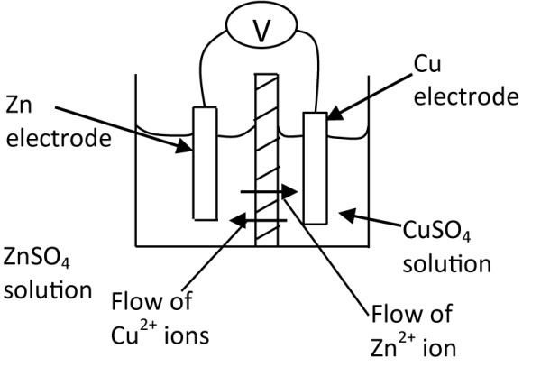

The speed of migration of Zn²⁺ and Cu²⁺ cations across the phase boundary is different due to a number of factors. Some of which are either the ionic size and/or the extent to which they are hydrated. Due to this, a p.d. is set up across the boundary called Liquid Junction Potential.

This liquid junction potential may be eliminated by connecting the solutions in the two half cells by means of a salt bridge which is a glass tube containing a saturated solution of either KCl or NH₄NO₃.

NB. In the cell diagram/notation, the double lines either represent a porous partition or a salt bridge.

Types of electrodes
- The metal/metalloid e.g. Zn²⁺/Zn
- The gas electrode e.g. Pt, H+/ ½ H₂
- The metal/insoluble electrode: this type of a metal coated with one of its insoluble salt surrounded by a solution containing the anion of the salt e.g.
  - Ag/AgCl(s), Cl⁻
Possible electrode reactions
As R.H.E (reduction)
AgCl (s) + e → Ag(s) + Cl⁻(aq)
As L.H.E (oxidation)
Ag(s) + Cl⁻(aq) → AgCl(s) + e
  - Hg/Hg₂Cl₂, KCl(aq) or Hg/Hg₂Cl₂, Cl⁻ This electrode is commonly known as a calomel electrode.
Possible electrode reactions
As R.H.E (reduction)
Hg₂Cl₂(s) + 2e → 2Hg(l) + 2Cl⁻(aq)
As L.H.E (oxidation)
Hg (s) + 2Cl⁻ (aq) - 2e → Hg₂Cl₂(s)

The two electrodes Ag/AgCl(s), Cl⁻ and Hg/Hg₂Cl₂, KCl(aq) have stable potential and are not easily affected by oxidants or reducing agents, and because of their high stability, they are sometimes used as reference electrodes since hydrogen electrode in practice is easily poisoned by oxidants and reducing agents.

- Oxidation—reducing (redox) electrodes
This type comprises of a reduced species and oxidized species in the same solution, e.g. Pt/Fe³⁺, Fe²⁺ or Pt/Cr³⁺,Cr²⁺.

Differences between electrolytic and e.m.f cells
Electrolytic cell | E.m.f. cells
Uses single electrolyte | Uses two electrolytes
Changes electrical energy into chemical energy | Changes chemical energy into electrical energy
Cathode is negative electrode | Cathode is positive electrode
Anode is positive electrode | Anode is negative electrode

Dry cells
These were invented to overcome the difficulty of electrolytic solution leaking out of cell such as Daniel cell. In dry cell, the electrolyte is made into a paste. An example is shown below


Brass cap (positive contact)

Seal

Rod of graphite

Mixture of MnO
2

and
powdered carbon

Paste of NH4Cl(s) + starch

Card covering

Zin
c cap (negative contact

This type of cell is used in radio, flash light and clocks as it is portable. The initial electrode processes are Anode:
Zn(s) → Zn²⁺(aq) + 2e Cathode:
2NH₄⁺(aq) + 2e → 2NH₃(g) +2H₂(g)

The lead-acid accumulator
The cell stores or accumulates electric charge. It consists of two lead plates dipping into a 30% solution of sulphuric acid. Both plate become covered with insoluble film of lead II sulphate
First the cell must be charged. A direct current is passed through the cell. The processes which take place are: Charge
Positive plate
PbSO₄(s) + 2e → Pb(s) + SO₄²⁻(aq)
Negative plate

The plates are now different and therefore have different potentials, so that, when they are connected, an electric current will flow between them. When the cell supplies an electric current, i.e. discharge the process which take place are:

Negative plate
Pb(s) + SO₄²⁻(aq) → PbSO₄(s) + 2e

Positive plates
PbO₂(s) + 4H⁺(aq) + SO₄²⁻⁽aq) + 2e
→ PbSO₄(s) + 2H₂O(l)
NB: the plate which is positive during the charge becomes negative during the discharge.

Example 6
Explain why distilled water is preferred to dilute sulphuric acid when changing an accumulator cell.

During recharging, there can be some production of hydrogen and oxygen caused by splitting of the water part of the acid. This needs to be replaced with distilled water. The sulphuric acid level remains the same, but since water is being lost, the concentration goes up, so adding water restores it to how it was when the battery was new.

Example 7
1(a.) What is meant by the term voltaic cell? 2 marks

A voltaic cell is an electrochemical cell that uses a chemical reaction to produce electrical energy.

b.(i) With aid of labeled diagram describe briefly how the standard electrode potential of a Voltaic cell made up of silver electrode and aluminium electrode can
be determined. 8 marks

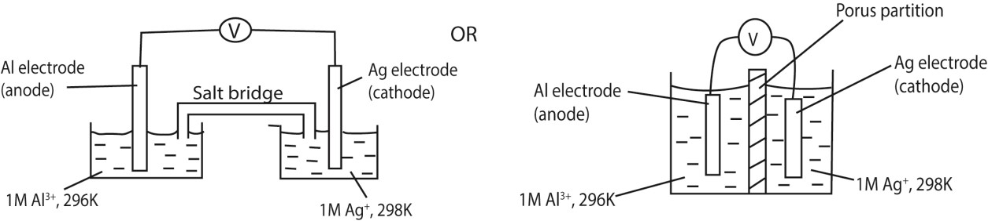
- Write the overall equation for the cell reaction. 1 ½ marks
Al(s) + 3Ag⁺(aq)  Al³⁺(aq) + 3Ag (s)
- If the cell liberated 708.9 kJ of heat, determine the e.m.f of the cell. 3 ½ marks
ΔG = -nFE⁰
708.9 x 1000 = 3 x 96500 x E⁰
E⁰ =2.45V

(c) Some electrode potentials of the electrode reactions of an accumulator cell are shown below;
Pb_{(s)} + SO₄⁻²_{(aq)}  PbS0₄⁻²(s) + 2e E ⁰ = +0.13V
PbS0₄(s) + 2H₂0(l)  Pb0₂(s) + 4H⁺_{(aq)} + SO₄²⁻_{(aq)}+ 2e E⁰=-1.47v
- Write the overall cell reaction and hence determine the e.m.f of the cell.2 ½ marks
PbO₂ (s) + 2H₂SO₄ (aq) + Pb(s) → 2PbSO₄ (s) +2H₂O (l)
- Explain why distilled water is preferred to dilute sulphuric acid when changing an accumulator cell. 2½ marks
During recharging, there can be some production of hydrogen and oxygen caused by splitting of the water part of the acid. This needs to be replaced with distilled water. The sulphuric acid level remains the same, but since water is being lost, the concentration goes up, so adding water restores it to how it was when the battery was new.

Trial 15
The diagram below shows an electrochemical cell
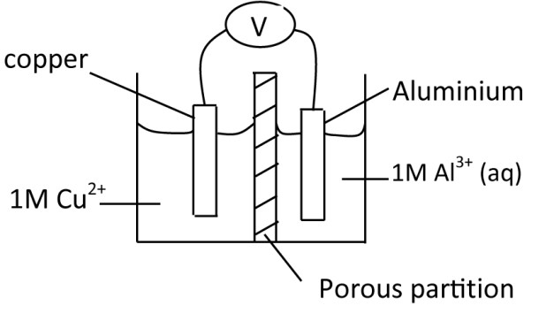
- State the purpose of porous partition (1mark)
- Give the ionic equation for the reaction taking place at each electrode (2marks)
(a) (i) the standard electrode potentials (E⁰) at 25⁰C are +0.34Volts for copper electrode and -1.66V for aluminium electrode. Calculate the e.m.f of the cell.
(ii) What does the value of the e.m.f calculated in (b)(i) signify?

Solution
(a)(i) the porous partition prevents mixing of solution while allowing exchange of charges.
(a)(ii) At copper electrode
Cu(s) - 2e → Cu²⁺(aq)
At aluminium electrode
Al³⁺(s) + 3e → Al(s)
(b) E0cell = E0R.H.E – E0L.H.E
= -1.66-0.34
= -2.00V
(i) A negative e.m.f indicates that the cell as set up is non-spontaneous.

Trial 16
- Explain what is meant by the terms
  - Standard electrode potential (2mks)
  - First ionization energy (2marks)
- The first ionization energies (I.E/kJ) and standard electrode potentials (E⁰/V) of group I elements of the Periodic Table are given in the table below
 | Li | Na | K | Rb | Cs
1st I.E/ kJmol⁻¹ | 518.8 | 497.9 | 422.6 | 401.7 | 380.7
E⁰/V | -3.03 | -2.71 | -2.93 | -2.99 | -3.02
  - Why is the standard electrode potential of lithium is anomalously high? (3mks)
  - What would you expect to be the trend in ionic radii of univalent cations formed by group I elements? Explain your answer. (3mks)

Solution
(a)(i) Standard electrode potential is a reduction potential between a metal and a solution containing 1mole of metal ions, at 298K and 1 atmosphere.

(a)(ii) First ionization energy is the minimum energy required to remove an electron in its ground state completely from a gaseous atom

(b)(i) The small Li⁺ ion has a high charge density leading to high negative hydration energy that offsets its high positive ionization and its high atomization energies. Other elements in the group have ionization, atomization energies and hydration energies.
(ii) ionic radii increase from Li to Cs because
- There an additional filled electron shells from one element to another one element to the next.
- The a reduction in the nuclear charge and an increase in the screening effect down the group

Trail 17
- Draw a fully labeled diagram to show the arrangement of apparatus you would use to measure the emf of a cell consisting of copper and silver electrode. Indicate the direction of electron flow(5mks)
- Write
- The notation for the cell you have drawn in (a) and state the convention used (3mks)
- The equation taking place at each electrode (2mks)
- The overall cell reaction (1mk)
- If the standard electrode potential for copper ions/copper and silver ions/silver are +0.34V and
0.81V respectively, calculate the e.m.f of the cell consisting of copper and silver electrodes.
- Describe briefly how the standard electrode potential of copper can be determined and write the cell notation (7mks)

Solution

)
a
(

V

Flow of
electrons

Cu

Ag

1
M Ag
+

1
M Cu
2+

Porous partition

(b) (i)Cu(s)/Cu²⁺(aq)//Ag⁺(aq)/Ag(s)
(Convention used?)

- At copper electrode (anode)
Cu(s) – 2e→ Cu²⁺(aq)
At silver electrode (cathode)
2Ag⁺(aq) + 2e → 2Ag(s)
Overall cell reaction
- Cu(s) + 2Ag⁺(aq) → Cu²⁺(aq) + 2Ag(s)

- 0.47V
- Arrange the apparatus as in fig.5 below; since the standard electrode potential of hydrogen gas is zero, the reading on the voltmeter is the standard electrode potential of copper electrode.
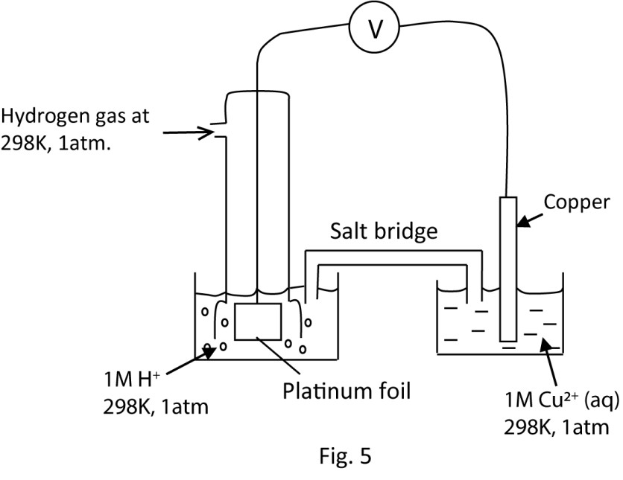
Cell notation
1H₂(g)/H⁺(aq),Pt//Cu²⁺(aq)/Cu(s)

Trial 18
The standard electrode potentials E⁰ for four half-cell reactions are given below
 | E⁰/V
MnO₄⁻(aq) + 8H⁺(aq) + 5e → Mn²⁺(aq) +4H₂O(l) | +1.52
SO₄²⁻(aq) + 2H⁺(aq) + 2e → SO₃²⁻(aq) + H₂O(l) | + 0.20
Br₂(aq) + 2e →2Br⁻(aq) | +1.06
Cl₂(aq)+ 2e → 2Cl⁻(aq) | +1.36
- (i) write an equation between sulphate ions and acidified solution of potassium manganate (VII)
(ii) Calculate the E⁰ for the reaction in (I)
- Explain why hydrochloric acid is not used to acidify titrants in volumetric analysis involving manganate (VII)
- Write the cell convention for the reaction between bromine water and acidified potassium manganate(VII)

Solution
(a)(i) 5SO₃²⁻(aq) + 2MnO₄⁻(aq) + 6H⁺(aq) → 2Mn²⁺(aq) + 5SO₄²⁻(aq) + 2H₂O(l)
(a)(ii) E⁰_{cell} | = | E⁰Reduction – E⁰oxidation
 | = | 1.52-0.20
 | = | 1.32V
- Because chloride ions are strong oxidizing agents and will be oxidized by manganate (VII) in the reaction.
- Br-(aq)/½ Br₂(aq)//MnO₄⁻, H⁺(aq)/Mn²⁺(aq)

Trial 19
A cell consisting of copper and silver electrode is shown in the diagram below

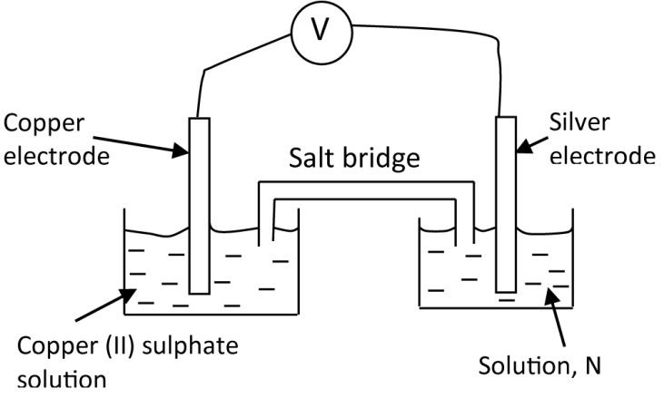
- What is solution, N? (1mark)
- Write
  - The notation for the cell (2mks)
  - Overall equation for the cell (2mks)
- (i) Write a substance that can be used in the salt bridge (1mk) (ii) State the purpose of the salt bridge (1mk)
- Calculate the overall electrode potential, E, of the cell (2mk)

Solution
- 1M Silver nitrate solution (or any soluble silver salt)
- (i) Cu(s)/Cu²⁺(aq)//Ag⁺(aq)/Ag(s)
(ii) Cu(s) + 2Ag⁺(aq) → Cu²⁺(aq) + 2Ag(s)
- (i) KCl or NH₄NO₃
- 0.46V

Trial 20
A cell was constructed as shown below
Pt/Cr²⁺(aq), Cr³⁺(aq)//MnO₄⁻(aq),Mn²⁺(aq), H⁺(aq)/Pt
- Write equation for the reaction that occur at each electrode (2½mks)
- Write the equation for overall reaction
- The electrode potential for system Cr³⁺/Cr²⁺ and MnO₄⁻/Mn²⁺ are -0.402 and +1.52volts respectively. Calculate the cell voltage (1mk)

Solution
- L.H.E
Cr²⁺(aq) – e Cr³⁺(aq)
R.H.E
MnO₄⁻(aq) + 8H⁺(aq) + 5e → Mn²⁺(aq) +4H₂O(l)

- 5Cr²⁺(aq) + MnO₄⁻(aq) + 8H⁺(aq) → 2Mn²⁺(aq) + 5Cr³⁺aq) + 4H₂O(l) (c) 1.922V

Trial 21
Equation and electrode potentials for some reaction are given below
E⁰/V
2H⁺(aq) + O₂(g) +2e → H₂O₂(aq) +0.68
Ag⁺(aq) + e → Ag(s) +0.80
H₂O₂(aq) + 2H⁺(aq) + 2e → 2H₂O(l) +1.77
- (i) write equation for the reaction between silver nitrate and hydrogen peroxide (2mk)
(ii) Calculate E⁰ cell for the reaction (i)
- State the property shown by hydrogen peroxide in the reaction in (a)(i) (1mk)

Solution
(a)(i) H₂O₂(aq) + 2Ag⁺(aq) → 2Ag(s) + 2H⁺(aq) +O₂(g)
(a)(ii) +0.12V
(b) it is a reducing agent

Trial 22
The equation for some half-cell reaction are given below
Cd²⁺(aq) + 2e → Cd(s) E⁰ = -0.440V
H₂O₂(aq) + 2H⁺(aq) +2e → 2H₂O(l) E⁰ = +1.77V
- Write
  - The cell notation
  - The equation for overall cell reaction.
- The electrodes were connected externally by a conductor. State the direction of flow of electrons.

Solution
(a)(i) Cd(s)/Cd²⁺(aq)//H₂O₂(aq)/H₂O(l), Pt
(ii) Cd(s) + H₂O₂(aq) + 2H⁺(aq) → Cd²⁺(aq) + H₂O(l)
(b) from Cd (anode) to H₂O₂, Pt

Trial 23
Some half reactions and their corresponding reduction potentials are given below:
MnO₄⁻(aq) + 8H⁺(aq) + 5e | E⁰/V
→ Mn²⁺(aq) +4H₂O(l)  MnO₂(s) + 4H⁺(aq) + 2e | +1.52
→ Mn²⁺(aq) +2H₂O(l) | +1.23
Sn²⁺(aq) + 2e →Sn(s) | -0.136
Sn⁴⁺(aq) + 2e → Sn²⁺(aq) +0.15V
- (i) state what would be observed when excess tin powder is added to acidified solution of potassium manganate (VII). Explain your answer
(ii) Write equation for the reaction that takes place.
- Solid manganese (IV) oxide was added to acidified solution of tin (II) ions
  - State what was observed and explain your answer (3mks)
  - Write equation for the reaction (1½mks)

Solution
(a)(i) The purple color of acidified potassium manganate (VII) decolorize; because manganate (VII) is reduced to colorless Mn²⁺ ions
(a)(ii) Note that in excess tin powder, tin is oxidized to tin II rather Tin (IV)
5Sn(s) + 2MnO₄⁻(aq) + 8H⁺(aq) → 2Mn²⁺(aq) + 5Sn²⁺aq) + 4H₂O(l)
(b) (i) Solid manganese (IV) oxide dissolved forming colorless solution because it is reduced to soluble colorless Mn²⁺ ions.
(ii) MnO₂(s) + 4H⁺(aq) +Sn²⁺(aq) → Mn²⁺(aq) +2H₂O(l) + Sn⁴⁺(aq)

Trial 24
Given the following electrode potentials
 |  | E⁰/V
Na⁺(aq) + e → Na(s) |  | -2.71
Cu²⁺(aq) + 2e → Cu(s) |  | +0.337
Zn²⁺(aq) + 2e →Zn(s) |  | -0.763
Ag⁺(aq) + e → Ag(s) |  | +0.799
- Arrange the electrodes in order of reducing power starting with the least reducing (1mk)
- (i) Which two electrodes will form a cell of maximum emf? ( ½mk)
(ii) Write the cell notation for the cell you gave in (i) above (1½mks) (iii) Write the overall cell reaction for the cell in (i). (1½mks)

Solution
- Ag, Cu, Zn, Na (i.e. the more negative the E⁰, the more reducing or the less oxidizing the electrode
is)
- (i) Ag and Na
  - Na(s)/Na⁺(aq) // Ag⁺(aq)/Ag(s)
  - Na(s) + Ag⁺(aq) → Na⁺(aq) + Ag(s)

Trial 25
The diagram below shows emf cell for the reaction between iron (III) chloride and potassium iodide solution
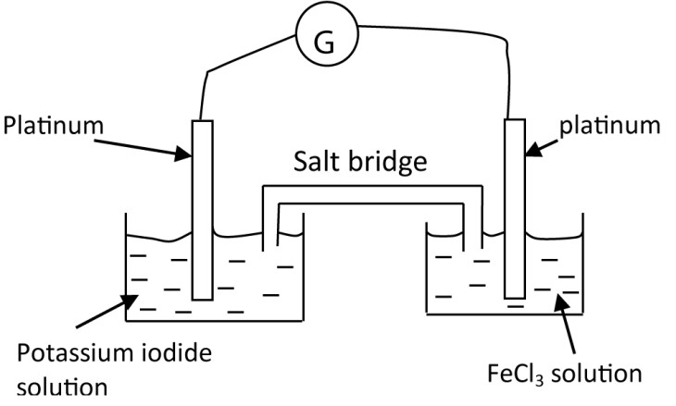

- Indicate on the diagram the direction of flow of current ( ½mk)
- State what is observed at the
  - Anode
  - cathode
- Write equation for the cell reaction

Solution
- From a platinum electrode dipped into iron (III) chloride to platinum dipped in KI. Note current and electron flow are in opposite direction)
- (i) brown solution
(ii) Brown solution turns green
- 2I⁻(aq) + 2Fe³⁺(aq) → I₂(aq) + 2Fe²⁺(aq)

Trial 26
Equations for some half cell reactions are given below
Hg₂Cl₂(s) + 2e → 2Hg(l) + 2Cl⁻(aq) E⁰ = +0.334V
Cr₂O₇²⁻ + 14H⁺(aq) + 6e → 2Cr³⁺(aq) + 7H₂O(l) E⁰ = +1.33V
- Write the convention for the cell (1mk)
- Write equation for the overall reaction (1½)
- Calculate the cell voltage

Solution
- Pt, Hg(l),Cl⁻(aq)/Hg₂Cl₂(s)//Cr₂O₇²⁻(aq),H⁺(aq)/Cr³⁺(aq),Pt
- 6Hg(l) + 6Cl⁻(aq) + Cr₂O₇²⁻(aq) + 14H⁺(aq) → 3Hg₂Cl₂(s) + Cr³⁺(s) + 7H₂O(l)
- +0.996V

Trial 27
The electrode potentials, E⁰, of lead and magnesium are shown below
Pb²⁺(aq) + 2e → Pb(s) E⁰ = -0.13V
Mg²⁺(aq) + 2e → Mg(s) E⁰ = -2.40V
- Write the cell convention for the cell that can be formed
- Writ the equation for the
  - Reaction taking place at each electrode
  - Overall reaction
- Calculate the emf of the cell

Solution
- Mg(s)/Mg²⁺(aq)//Pb²⁺(aq)/Pb(s)
- (i) anode: Mg(s) → Mg²⁺(aq) + 2e Cathode: Pb²⁺(aq) + 2e → Pb(s)
(ii) Mg(s) + Pb²⁺(aq) → Mg²⁺(aq) + Pb(s)
-0.13—2.40 = +2.27V

Trial 28
The standard electrode potentials for some system are given below:
E⁰/V
Mn³⁺(aq)/Mn²⁺(aq) +1.5
V³⁺(aq)/V²⁺(aq) -0.26
- Write the convention for the cell formed by combining two systems (1mk)
- Write the overall equation for the cell reaction (1½mk)
- Calculate the emf of the cell. State whether the reaction is feasible or not and give a reason for your answer (2½mk)

Solution
- V²⁺(aq)/V³⁺(aq)//Mn³⁺(aq)/Mn²⁺(aq)
- V²⁺(aq) + Mn³⁺(aq) → V³⁺(aq) + Mn²⁺(aq) (iii) 1.5 – (-0.27) = +1.77V

Trial 29
(a)(i) Define ‘standard electrode potential’
- Why is it not possible to measure standard electrode potential absolutely?
- Discus the factors which affect the value of standard electrode potential
- Describe a standard hydrogen half cell
- How would you measure standard electrode potential of a metal in a solution of its ions.
- Given that
Ca²⁺(aq) + 2e → Ca(s) E0 = -2.87V Mg²⁺(aq) + 2e →Mg(s) E0 = -2.37 A cell was set up as below:
Mg(s)/Mg²⁺(aq)//Ca²⁺(aq)/Ca(s)
- Calculate the emf of the cell
- What conclusion can you draw from your emf value in (d)(i) above?

Solution
(a)(i) it is the electrode potential value of an electrode measure with respect to a standard hydrogen electrode of 0 volts. When an electrode is immersed or dipped into a solution of 1M concentration of its ions at a standard temperature of 298K and pressure of1atmospheres.

(a)(ii) it requires a second electrode to be introduced since it’s a difference in potential

However, the second electrode also produces its own electrode potential making such a difference relative rather than absolute

(a)(iii) Electrode potential = sublimation energy
+ ionization energy + Hydration energy
- Sublimation energy: the higher the sublimation energy the more positive the electrode potential. This is because it becomes difficult to convert a solid into gaseous atoms (i.e. sublimation is endothermic)
- Ionization energy: if ionization energy is high; electrode potential becomes more positive because ionization energy is endothermic.
- Hydration energy: a high hydration energy give a more negative electrode potential since hydration is exothermic reaction.

- It consists of a molar solution of H+ ions having platinized titanium or platinum coated with finely divided titanium, around which pure hydrogen gas at 1 atmosphere and 298K (25⁰) is bubbled.
- The metal is placed in one molar solution of its ions and connected to the standard hydrogen electrode by a salt bridge

A voltmeter connected in parallel will show the emf of the cell

The standard electrode potential of the metal is equal to the emf shown by the voltmeter, measured relative to the electrode potential of hydrogen electrode considered to be zero

- (i) E0cell = E0Reduction – E0oxidation
= -2.87-(-2.37) = -0.5V
(ii) The cell as set up is non-spontaneous because emf is negative. It is spontaneous in the opposite direction.

Trial 30
(c) Explain is meant by the term ‘standard electrode potential’ (2mks) (d) Same half cells and their emf are given below:
Half-cell emf/volts
I₂(aq)/2I⁻(aq) 0.54
Fe³⁺(aq)/Fe²⁺(aq) 0.76
- Write the cell convention for the cell made up of the half cells (01mk)
- Write equation for the cell reaction
- Determine emf of the cell
- Calculate the standard free energy for the reaction and indicate its units
- State whether the reaction (ii) is possible or not give reason for your answer (2mks) Solution
(d)(i) 2I⁻(aq)/I₂(aq)//Fe³⁺(aq)/Fe²⁺(aq)
(ii) I⁻(aq) + Fe³⁺(aq) → ½ I₂(aq) + Fe²⁺(aq)
- 0.22V
- ∆G⁰ = -1 x 96500 x (-0.22)
= 42.46kJmol⁻¹
- The reaction is feasible because emf is positive.

Trial 31
Equations for some half cell reaction are shown below
Sn⁴⁺(aq) + 2e ↔ Sn²⁺(aq) E⁰ = 0.15V
PbO₂(s) + 4H⁺(aq) + 2e ↔ Pb²⁺(aq) + 2H₂O(l) E0 = +1.46V
- Write the overall equation for the spontaneously feasible reaction
- Calculate the emf of the cell in (e)(i)

Solution
- Sn²⁺(aq) + PbO₂(s) + 4H⁺(aq)
→ Sn⁴⁺(aq) + Pb²⁺(aq) + 2H₂O(l)
- 1.31V

Electrolysis
This is the decomposition of an ionic compound in molten or solution form to its constituent elements.
Mechanism of electrolysis
Consider electrolysis of molten sodium
In molten form sodium chloride ionizes as follows
NaCl → Na⁺ + Cl⁻
In an electrolytic cell, unlike charges attract; Na⁺ migrate to the cathode while Cl⁻ migrate to the anode.
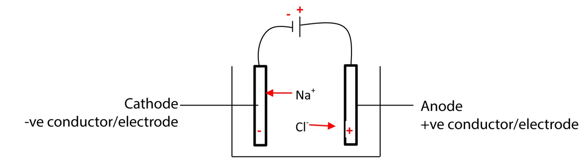
At the cathode, Na⁺ ion acquires an electron to become sodium atom.
Na⁺ + e → Na
At the anode the Cl⁻ loses and electron to form a Cl atom
Cl- - e Cl
The chlorine atoms combine to form chlorine a gas.
Cl + Cl Cl₂ (g)
Ultimately, sodium chloride in molten for is decomposed by electrolysis to sodium metaland chlorine gas.

Selective discharge
Consider electrolysis of sodium chloride solution
Both sodium chloride and water ionize to form ions
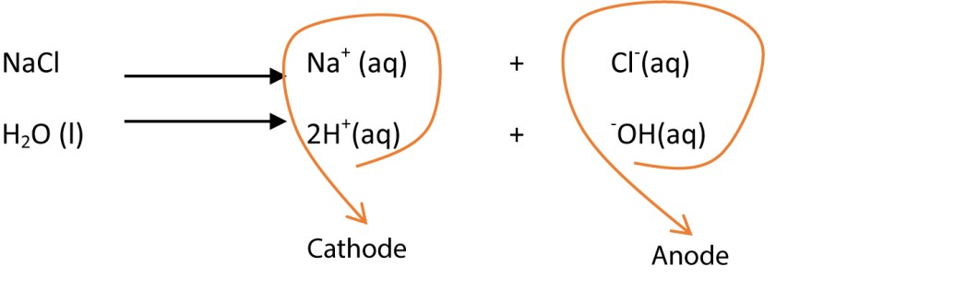
The positively charged ion migrate to the cathode while negatively charged ions migrate to the anode.

Factors that decide the ion to be eliminated or discharged first.
(i) Position in electro-chemical series:
Series for cations (high to low) K⁺, Ca²⁺, Na⁺, Mg²⁺, Al³⁺, [C], Zn²⁺, Fe²⁺, Pb²⁺, Cu²⁺, Ag⁺ Series for anions (high to low) SO₄²⁻, NO₃⁻, Cl⁻, Br⁻, I⁻, -OH

The ion lower in electro-chemical series is discharged first. Consequently, during electrolysis of dilute sodium chloride, H⁺ which is low in the reactivity series than Na⁺ is discharged at the cathode whereas, ⁻OH ions are discharged at the anode.

 | At the cathode |  |  |  | At the anode
 | 2H⁺(aq) + 2e → | H₂(g) |  |  | 4⁻OH (aq) – 4e → | 2H₂O(l) + O₂(g)
(ii) | Concentration:
When Cl⁻, Br⁻ or I⁻ are concentrated, then they will be discharged with respect to –OH. In this case electrolysis of concentrated sodium chloride solution liberates chlorine at the anode and hydrogen gas at the cathode (concentration does not affect Na⁺)

At the cathode At the anode
2H⁺(aq) + 2e → H₂(g) 2Cl⁻ (aq) – 2e → Cl₂(g)

(iii) Nature of electrode
(a) When mercury cathode is used Na⁺ is discharged with preference to H⁺.
Therefore, electrolysis concentrated sodium chloride using mercury cathode liberate Na at the cathode and chlorine gas at the anode (due to high concentration of Cl⁻).
At the cathode At the anode
Na⁺(aq) + e → Na 2Cl⁻ (aq) – 2e → Cl₂(g)

Application of electrolysis
- Industrial preparation of gases; Cl2, H2 and O2.
- Extraction of metal: metals above carbon in the reactivity series are almost all extracted by electrolysis.
Example Extraction of sodium.
Ore: molten NaCl
Anode: iron cylinder is cheap and has a melting point above the melting point of NaCl. Cathode: carbon because it does not react with chloride.

Calcium chloride added to the mixture to
- lower the melting point of sodium chloride from 800⁰Cto 600⁰C, - reduce solubility of sodium in molten sodium chloride, - Lower the corrosive vapor of sodium chloride.
Sodium is collected in dry nitrogen to protecting it from reacting with air.
At the cathode | At the anode
Na⁺ + e Na | 2Cl⁻– 2e Cl₂(g)

Setup
The setup is such chlorine produced does not react with sodium

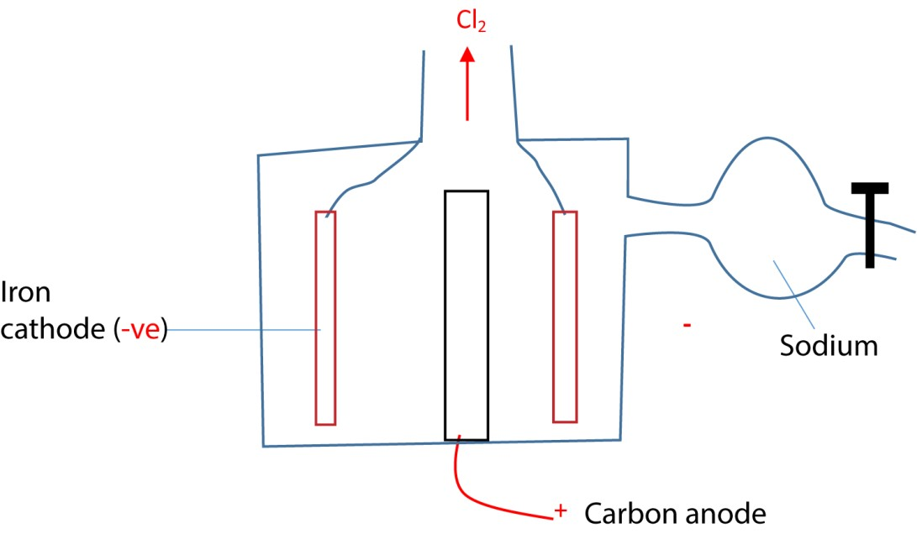

(iii) Preparation of sodium hydroxide
By electrolysis of concentrated solution of sodium chloride using carbon anode and mercury cathode. At the anode chlorine is liberated and at mercury cathode Na⁺ instead of H⁺ is discharged and dissolved in mercury to form mercury amalgam.

At the cathode At the anode
Na⁺ + e → Na 2Cl⁻– 2e → Cl₂(g)
When sodium amalgam is dropped in water, sodium reacts to form sodium hydroxide and hydrogen gas.
2Na + 2H₂O (l) →2NaOH (aq) + H₂(g)
Sodium hydroxide is concentrated to form pellets.
This process is disadvantageous because it releases poisonous mercury into the environment Setup
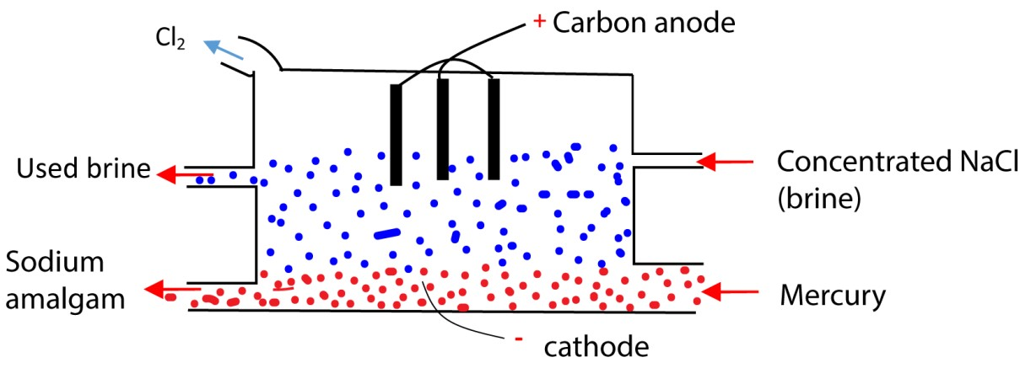

(iv) Purification of copper
Anode: impure copper (dissolves)
Cu (s) – 2e → Cu²⁺ (aq)
Cathode (copper is deposited)
Cu²⁺ (aq) + 2e → Cu (s)
Electrolyte: copper sulphate solution

Copper migrated from the anode to the cathode.

Faraday’s Laws of electrolysis
- The mass of a substance liberated at an electrode is proportional to the quantity of electricity used.
The quantity of electricity Q in coulombs = It
(I = current of electricity in amperes, t = time in second)
- The moles of electricity required to liberate one mole of an element is proportion to the charge on its ions. (1mol of electricity = 1Faraday = 1F = 96500 C)
Example
Calculate the mass of copper liberated by a current of 1A for 1hour. (Cu = 63.5)

Quantity of electricity Q= It = 1 x (1 x 60 x 60) = 3600C
Cu (s) – 2e → Cu²⁺ (aq)

It implies that (96500 x2) C is required to liberate 63.5 g of copper
Therefore, 3600C will liberate 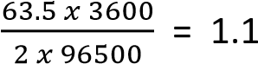

TOPIC 2/2: Periodicity II
Topic competency: The learner analyses the trends in the physical and chemical properties of Group 14 elements, Group 17 elements and d-block elements and relates these trends to their applications in industrial and environmental contexts.

Group 14 Elements, carbon, Silicon, germanium, tin and lead
Members
Elements symbol Carbon
C Silicon Si
Germanium Ge
Tin Sn
Lead Pb

Physical properties
- Carbon and silicon are nonmetals.
- Germanium is a metalloid ▪ Tin and lead are metal

Electron configuration
General electron configuration of group 14 elements is ns²np²

Oxidation states
The common oxidation state of group 14 elements is +2 and +4

Stability of oxidation states
Oxidation state +2 become more stable down the group Oxidation state +4 become less stable down the group.

For instance carbon burns in oxygen to form carbon (IV) oxide (CO₂) whereas lead form Lead (II) oxide (PbO).

Secondly, CCl₄ is stable whereas PbCl₄ easily decomposes on heating giving lead (II)
chloride and chlorine
PbCl₄ (g) (heat) →PbCl₂ (s) + Cl₂ (g)

Reasons for Variation of Stability
- Inert pair effect: Down the group, the ns² electrons (valence s-electrons) are less likely to participate in bonding. This makes the +2 oxidation state more stable for heavier elements (Sn, Pb). Example: Pb²⁺ is more stable than Pb⁴⁺.
- Atomic size: Larger atoms (like Sn and Pb) have weaker effective nuclear charge on outer electrons.This reduces the ability to stabilize higher oxidation states.
- Shielding effect: Poor shielding by d and f electrons in heavier elements reduces the effective nuclear attraction. This favors lower oxidation states.
- Relativistic effects: In very heavy atoms (like Pb), relativistic contraction of the s-orbital makes the ns² pair even more inert. This strongly stabilizes the +2 oxidation state.

Relativistic Effects
Relativistic effects in chemistry refer to changes in the behavior of electrons in heavy atoms (especially those with high atomic numbers) due to the principles of Einstein’s theory of relativity. When electrons move at speeds close to the speed of light, their mass increases and their orbitals contract or expand in unusual ways.
s-orbital contraction:
- Electrons in s-orbitals (closest to the nucleus) move fastest.
- Their relativistic mass increases, causing the orbital to contract and electrons to be held more tightly.
- Example: In gold (Z = 79), the 6s orbital contracts significantly.

Properties of compound with +2 and +4 oxidation states
(i) Compounds in oxidation state +4 are predominantly covalent because formation M⁴⁺ requires a lot energy whereas compound in oxidation state +2 are ionic

This explains the fact that PbCl₄ is soluble in organic solvents like ethanol whereas PbCl₂ does not.

Note that
- covalent compounds are soluble in organic solvents whereas ionic compounds do not.
- Covalent compound have low melting and boiling points whereas ionic compounds have high melting and boiling point.
- Covalent compounds do not conduct electricity whereas ionic compounds do. On this basis compound in oxidation state +4 show properties of covalent compounds because they are predominately covalent.

Chemical properties

Reaction of group 14 elements with water
Carbon does not react with cold water but reacts with steam to form water gas C(s) + H₂O(g) → CO(g) + H₂(g)

Silicon, germanium and Tin do not react with water up to 100⁰C because they are protected by thin layer of oxide. But they react with steam at very high temperatures to form dioxides

Ge(s) + 2H₂O(g) → GeO₂(s) +2H₂(g)

Lead reacts with soft water (water that contains oxygen) to form lead II hydroxide.
Pb(s) + 2H₂O(g) + O₂(g) → Pb(OH)₂(s)

Reaction of group 14 elements with acids
- Dilute non oxidizing acid like HCl.
C, Si, and Ge do not react

Sn liberates hydrogen
Sn(s) + 2H⁺(aq) Sn²⁺(aq) + H₂(g)

Pb lead does not react with dilute hydrochloric acid and sulphuric acid due to formation of insoluble salts.

- Nitric acid
With concentrated nitric acid.
C, Si, Ge and Sn react to form dioxide
C(s) + 4HNO₃(aq)→ CO₂(g) +4NO₂(g) + 2H₂O(l)

Pb reacts to form lead II nitrate and nitrogen dioxide.
Pb(s) + 4HNO₃(aq) → Pb(NO₃)₂(aq) + 2NO₂(aq)+ 2H₂O(l)

With 50% nitric acid.
Pb reacts to form lead II nitrate and nitrogen monoxide.
3Pb(s) + 8HNO₃(aq) → 3Pb(NO₃)₂(aq) + 2NO(aq)+ 4H₂O(l)

- With sulphuric acid Dilute sulphuric acid
C, Si and Ge do not react.
Sn and Pb reacts dilute concentrated sulphuric acid liberating hydrogen.
Pb (s) + H₂SO₄(aq) → PbSO₄(s) + H₂(g)

With hot concentrated sulphuric acid
C, Si and Ge react to form dioxides
C(s) + 2H₂SO₄(aq) → CO₂(g) + 2SO₂(g) +2H₂O(l)

Sn and Pb reacts hot concentrated sulphuric acid liberating sulphur dioxide.
Pb(s) + 2H₂SO₄(aq) → PbSO₄(s) + SO₂(g) +2H₂O(l)
Sn(s) + 2H₂SO₄(aq) → SnSO₄(s) + SO₂(g) +2H₂O(l)

- With acetic or ethanoic acid C, Si Ge and Sn do not react.
Pb reacts ethanoic acid in presence of air giving lead II ethanoate and water Pb (s) + 4CH₃COOH(aq) + O₂(g) → Pb(CH₃COO-)₂(aq) +2H₂O(l)

Reaction with sodium hydroxide C does not react.

Si Ge and Sn react liberating hydrogen and silicate (IV), germates (IV) and stannates (IV) respectively

Si (s) + 2NaOH(aq) + H₂O(l) → Na₂SiO₃(aq) + 2H₂(l)

Lead reacts to form plumbates (II).
Pb(s) + 2NaOH(aq) → Na₂PbO₂(aq) + 2H₂(g)

Unique characteristics of carbon

1. Forms gaseous oxides, the rest form solid oxides

Note that
- Carbon dioxide is a gas because its molecules are bonded by weak van der Waal forces.

- Silicon dioxide is a solid of high melting point because each silicon atom is bonded to four oxygen atom by strong covalent bonds.

- Catenation: carbon forms chains, rings and branches with single, double and triple bonds while others do not

- Forms compounds mainly with oxidation sate (IV); other elements form compounds with oxidation states +2 and +4.

- Carbon tetrachloride and carbon tetrahydride do not hydrolyze in water. Chlorides of other elements hydrolyze in water.

- Carbon form CF₄ and not CF₆⁻²

Reason for uniqueness of carbon
- Has a very small atomic radius allows formation of strong C-C bonds.
- Has high electronegativity enables formation of stable covalent bonds with other elements like N, O and H

- Lacks easily accessible d-orbital in its valence shell stabilizes the double and triple bonds
- Variety of hybridization: Carbon undergoes sp³ (tetrahedral), sp² (planar), and sp (linear) hybridization. This leads to diverse structures (alkanes, alkenes, alkynes, aromatic compounds). Heavier elements rarely show such versatility.

Allotropes of carbon
Allotropy is the existence of two or more different physical forms in the same state of a chemical element.

An allotrope is any of the different physical form in the same state into which a chemical element can exist.
Carbon exists in two main allotropes, i.e. graphite and diamond.

Graphite
In graphite, each carbon atom is covalently bonded to 3 carbon atoms to form a layer of hexagons. Each layer is bonded to another by weak van der Waal forces.

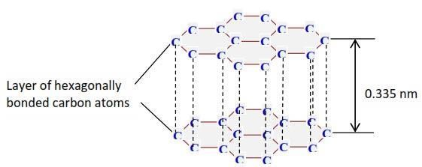

Properties of graphite as a result of its structure
- Has open structure and low density.
- It is slippery and used as a lubricant.
- Has unbonded π-electron that is free to move about making graphite a good conductor of electricity and heat

b. Diamond
Structure of diamond
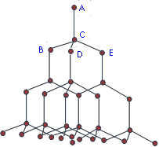

Each carbon atom is bonded tetrahedrally to four carbon atoms to form a 3D compact structure by strong covalent bonds. As a result diamond has a high density, melting and boiling point. It is the hardest substance known.

Diamond is used as an ornament, and to drill and cut other substances.

Differences between diamond and graphite
- The density of graphite (2.3 gcm⁻³) that of diamond (3.5 g cm⁻³)
- Diamond is very hard while graphite is soft
- Graphite is slippery while diamond is not
- Graphite conducts electricity while diamond does not.
Experiment to show that graphite and diamond are allotropes of carbon
When equal masses of graphite and diamond are burn in air, they give equal volume of carbon dioxide.

Compounds of carbon
1. Hydrides: they include alkanes, alkenes, alkyne and aromatic compounds studied in organic chemistry

2. Halides of carbon
Carbon forms all the four tetrahalides: CF₄, CCl₄, CBr₄ and CI₄
Comments
- The melting points of halides increase with molecular masses. All tetrahalides are volatile liquids .
- The stability of the halides decrease from CF₄ > CCl₄ > CBr₄ > CI₄ due to decrease in the bond strengths as electronegativity of the halogen decrease.
- CCl₄ is a good solvent, being very stable and heavier than air; is used in fire extinguisher to protect the burning substance from oxygen.
- CCl₄ is not hydrolyzed by water due to lack of accessible d-orbital to accommodate the lone pair of electron from water and weaken the C-X bond.

3. Oxides f carbon (a) Carbon monoxide (CO)

Preparation
By dehydration of methanoic acid with concentrated sulphuric acid.
HCO₂H(l) + Conc. H₂SO₄(l) → CO(g) + H₂O(l)

Uses of carbon monoxide
(i) It reduces most metal oxides to metals.
Fe₂O₃ (s) + 3CO (g) → 2Fe (s) + 3CO₂ (g)
NiO (s) + CO (g) → Ni (s) + CO₂ (g)

This property is employed industrially in the extraction of iron and nickel.

It is used to purify nickel: it forms a volatile carbonyl that decompose t o give a pure Metal



Ni (s) + 4CO(g) 90⁰ Ni(CO)₄(g)
0

180 C
Ni(CO)₄(g) Ni (s) + 4CO (g)

- It is used preparation of carbonyl chloride that is used in the production of polyurethane form of plastics and pesticides. CO (g) + Cl₂ (g) → COCl₂ (g)
[carbonyl chloride]

- CO reacts with fused NaOH under pressure to give sodium methanoate. Methanoic acid is produced from this salt by the addition of dilute HCl. NaOH (l) + CO (g) → HCOONa (s)
then HCOO- (aq) + H⁺ (aq) → HCOOH (l)

Methanoic acid is used to produce insecticides and for dyeing, tanning, and electroplating.

(b) Carbon dioxide (CO2)
Preparation
By decomposition of calcium carbonate
CaCO₃(s) (heat) → CaO(s) + CO₂(g)
Limestone quick lime

Uses of carbon dioxide
- Flavors fizzy drinks.
- It is heavy and stable so is used in fire extinguishers to displace oxygen from burning objects.

Carbonic acid
Preparation
By reacting carbon dioxide and water. There is however, equilibrium in solution of carbonic acid, hydrogen ions, hydrogen carbonate and carbonate ions.
CO₂ (g) + H₂O (l) ↔ H₂CO₃ (aq)
H⁺(aq) + HCO₃⁻ (aq) ↔ 2H⁺ (aq) + CO₃²⁻ (aq)

Structure of carbonic acid
Has 3 resonance hybrid whose bond lengths are intermediate between a C=O and C-O bonds
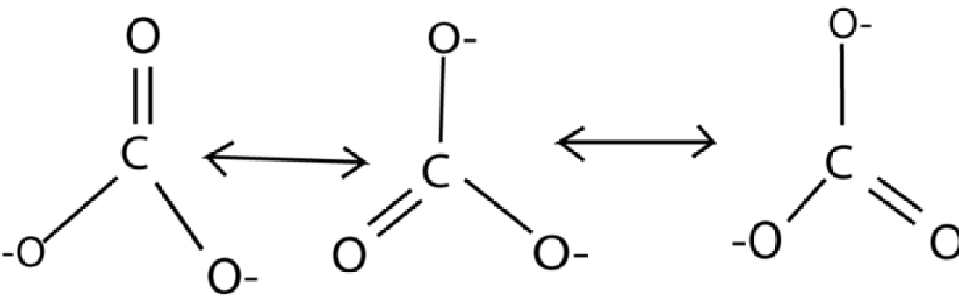

Carbonates and hydrocarbonate
- Both react with acids to liberate carbon dioxide
CO₃²⁻ (aq)+ 2H⁺ (aq) → H₂O (l) + CO₂ (g)
HCO₃⁻ (aq)+ H⁺ (aq) → H₂O (l) + CO₂ (g)
- CO₃²⁻ forms white ppt with Mg²⁺ whereas HCO₃⁻ does not.

Silicon
Existence Exists as silica, SiO₂ or sand used for building or making glass.

Chemical properties of SiO₂

(a) Reaction with NaOH
SiO₂(s) + 2NaOH(aq) → Na₂SiO₃(aq) + H₂O(l) SiO₂(s) + 2⁻OH (aq) → SiO₃²⁻ (aq) + H₂O (l).

(b) Reaction with HF
SiO₂(s) + 4HF(g) → SiF₄(aq) + H₂O(l)
SiF₄(aq) + 2HF(aq) → H₂SiF₆(aq)

(c) Reaction of silicon with acids

Silicon does not react with most acids under normal conditions but is dissolved by hydrofluoric acid, HF, to form fluorosilicic acid, a reaction apparently driven by the stability of the Si(IV) fluoride complex [SiF₆]²⁻.
Si(s) + 6HF(aq) → 2H₂(g) +H₂SiF₆ (aq) (fluorosilicic acid)

Germanium, tin and lead
Points to note
- They form compounds with oxidation states +2 and + 4. The stability of compounds with oxidation states +2 increases down the group due to ‘inert pair effect’ while those of oxidation states +4 decreases down the group.

- Compounds with oxidation state +2 are reducing. For instance tin II ions reduce iron III ions to iron II ions.
Sn²⁺(aq) + Fe³⁺(aq) → Sn⁴⁺(aq) + Fe²⁺(aq)

- Compounds with oxidation state +4 are oxidizing. For instance lead IV oxide ions oxidizes HCl ions to chlorine
PbO₂ (s) + 4HCl (aq) → PbCl₂(s) + 2H₂O (l) + Cl₂ (g)

- Compounds with oxidation state +4 are predominantly ionic whereas those in oxidation state +4 are predominantly covalent. This explains the fact that PbCl₂ is soluble in water but insoluble in ethanol whereas PbCl₄ is soluble in ethanol

Chemical properties
The principal reactions of germanium and tin are similar, both elements exhibiting oxidation state of 4
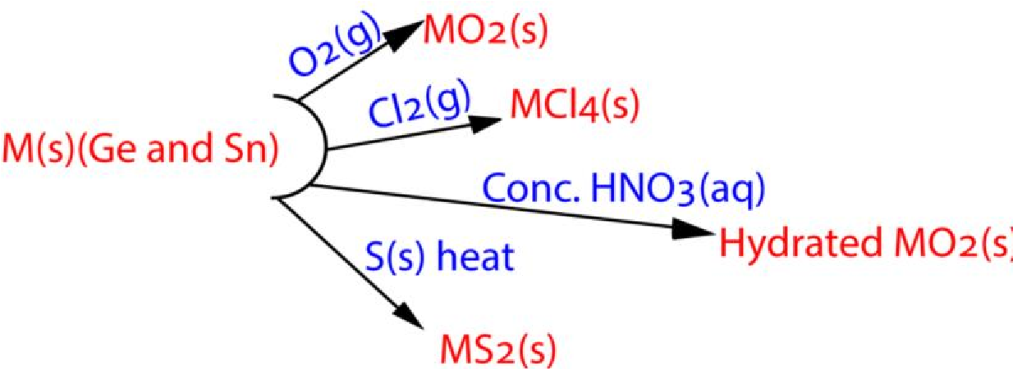

The principal reactions of lead are summarized below
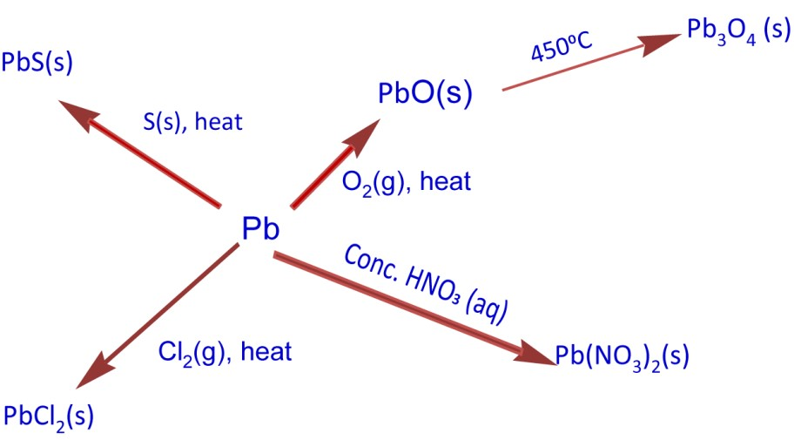

Lead IV halide
Lead forms ionic Pb⁴⁺(F⁻)_{4,} and covalent liquid PbCl_{4.}
The tetra-bromide and tetra-iodide do not exist, presumably because bromine and iodine are not sufficiently strong oxidizing agents to convert Pb²⁺ to Pb⁴⁺.

Lead IV chloride

Preparation
By reacting lead IV oxide with cold concentrated hydrochloric acid. PbO₂
(s) + 4 HCl (aq) (conc. and cold) → PbCl₄(aq) +2H₂O(l)

Effect of Heat on Lead (IV) chloride
Decomposes on heating liberating chlorine PbCl₄
(g) (heat) → PbCl₂ (s) + Cl₂ (g)

Hydrolysis of lead (IV) chloride
Lead tetrachloride is readily hydrolyzed by water (white fumes of HCl and brown precipitate of PbO₂ are observed)
PbCl₄ (s) + 2H₂O (l) → PbO₂ (s) + 4HCl (aq)

Reaction of lead (IV) chloride with sodium hydroxide solution
Lead(IV) chloride react with sodium hydroxide to produce lead(IV) oxide, sodium chloride and water. Sodium hydroxide - diluted solution.

PbCl4 + 4NaOH → PbO2 + 4NaCl + 2H2O

The compound PbO2 reacts with the sodium hydroxide to produce the hexahydroxoplumbate(IV) ion [Pb(OH)6]²⁻, soluble with the water.
PbO2 + 2NaOH + 2 H2O → Na2[Pb(OH)6]

Reaction of lead (IV) chloride with ammonium chloride
Lead(IV) chloride react with ammonium chloride to form a yellow solid of ammonium hexachloridoplumbate(IV).
PbCl₄ + 2NH₄Cl → (NH₄)₂[PbCl₆]

Lead II halide
Preparation
By reacting soluble salt like lead nitrate with soluble halide Pb²⁺(aq) + 2X⁻(aq) → PbX2(s) ( X = F, Cl, Br, I).
E.g. Pb²⁺(aq) + 2Cl⁻(aq) → PbCl2(s)

Properties of lead II chloride
Except the iodide, which is yellow, they are white solids. Lead (II) chloride forms chloro- complexes, e.g., [PbCl₄]²⁻, with Cl⁻ ions and because of this, it is soluble in concentrated hydrochloric acid.

Reaction of lead (II) chloride with sodium hydroxide solution
Lead II chloride reacts with sodium hydroxide solution to form lead (II) hydroxide which dissolves inexcess sodium hydroxide to form sodium plumbate (II)
PbCl₂ (s) + 2OH⁻(aq)  Pb(OH)₂(s) + 2Cl⁻(aq)
Then
Pb(OH)₂(s) + 2OH⁻ (aq)  Pb(OH)₄²⁻(aq)

Lead IV oxide

Preparation of lead (IV) oxide
- Lead (IV) oxide, PbO₂, is a brown solid obtained by oxidation of a soluble lead (II) salt with hot sodium chlorate (I).
Pb²⁺(aq) + H₂O(l) + ClO⁻ (aq) → PbO₂(s) + Cl⁻(aq) +2H⁺(aq)
- By action of nitric acid on trilead tetra oxide, Pb₃O₄.
Pb₃O₄ (s) + 4HNO₃ (aq) → 2Pb(NO₃)₂(aq) + PbO₂(s) + 2H₂O(l)

Chemical properties of lead (IV) oxide
- Decomposes on heating
2PbO₂ (s) + heat → 2PbO (s) + O₂ (g)
- Reacts with cold concentrated hydrochloric acid to form a yellow liquid lead (IV) chloride and water
PbO₂(s) + 4HCl (aq) → PbCl₄(l) + 2H₂O(l)
- Oxidize hot concentrated hydrochloric acid to chlorine
PbO₂(s) + 4HCl(aq) → PbCl₂ (s) + 2H₂O(l) + Cl₂(g)
- React with the sodium hydroxide to produce the hexahydroxoplumbate (IV) ion [Pb(OH)6]²⁻, soluble with the water.
PbO₂ + 2NaOH + 2 H₂O → Na₂[Pb(OH)₆]

Qualitative analysis of Pb²⁺
- Forms a white precipitate with sodium hydroxide soluble in excess
Pb²⁺(aq) + 2OH⁻(aq) → Pb(OH)2 (s) + 2OH-(aq) →Pb(OH)4²⁻ (aq)
- Forms white precipitate with ammonia solution insoluble in excess
Pb²⁺(aq) + 2OH⁻(aq) → Pb(OH)2 (s)
- Forms yellow precipitate with potassium iodide
Pb²⁺(aq) + 2I⁻(aq) → PbI2 (s)
- Forms white precipitate hydrochloric acid soluble on warming
Pb²⁺(aq) + 2CI⁻(aq) → PbCI2 (s)
- Forms white precipitate with sulphate ions
Pb²⁺(aq) + SO₄²⁺(aq) → PbSO4 (s)

Trial 1
1. Explain the following observation:
- Graphite and copper are both good conductors of electricity. (4 marks)
- Lead (II) chloride is insoluble in water whereas lead (IV) chlorides readily dissolve in the same solvent. (2marks)
- Carbon which is in the same group as lead in the periodic table shows one valence of 4 in its compounds but lead shows two valences of 2 and 4.
- Lead IV chloride readily decomposes to lead (II) chloride when heated but lead II chloride
is not affected by heat. (2marks)

- The solubility of lead (II) halides increase in order PbI2<PbBr2<PbCl2.

- When dilute hydrochloric acid is added to a solution of lead ethanoate, a white precipitate is formed. The precipitate is soluble in excess concentrated hydrochloric acid. (4marks)

- Crystals of lead (II) chloride can be prepared in the laboratory by heating lead (II) oxide with dilute hydrochloric acid and cooling. When lead (II) oxide is treated with concentrated hydrochloric acid under the same conditions, no crystals form. Give a reason for this observation and illustrate your answer with equations.

Solutions

- Both copper and graphite conduct electricity because they both possess mobile electrons. The mobile electrons of copper are the delocalized valence electrons whereas those of graphite are those of unbounded p-electrons.

- Lead (II) chloride is ionic whereas lead (IV) chloride is covalent. Lead (IV) chloride is formed by sharing electrons because the amount of energy required to form Pb⁴⁺ is too much. Lead (IV) chloride is easily hydrolysed rather than dissolving

(iii)Carbon form compound with oxidation state +4 because it experiences no inert pair effect while lead does. Thus, lead for compounds predominantly of oxidation of II due to inert pair effect; i.e. the 6s² electrons are reluctant to participate in reactions.

- Lead (II) oxidation state is more stable due to inert pair effect.

- Because the lattice energy decrease in order PbI₂>PbBr₂>PbCl₂ and the ionic charater increase in order PbI₂<PbBr₂< PbCl₂ because electronegativity of chloride is in order Cl> Br> I

- A white precipitate of PbCl₂ is formed with dilute HCl which dissolves in concentrated HCl due to formation of a soluble complex.

Pb²⁺(aq) + 2Cl⁻(aq) → PbCl₂(s) (aq)

- (g) Lead (II) oxide forms insoluble lead (II) chloride with dilute hydrochloric acid which dissolves in concentrated hydrochloric acid to form a soluble complex.

Pb²⁺(aq) + 2Cl⁻(aq) → PbCl₂(s)
PbCl₂(s) + 2Cl⁻(aq) → [PbCl₄]²⁻⁽aq)

Trial 2
- (i) Define the term allotrope.
(ii) Give evidence that shows that graphite and diamond are allotropes of carbon.
- Explain the following:
  - Graphite conducts heat and electricity yet it is a non-metal.
  - Diamond is a very hard element.
- Some properties of graphite and diamond are shown in the table below:

Allotrope | Density g/cm³ | Heat of combustion at 298K (KJ/mol.)
Graphite | 2.25 | -393.5
Diamond | 3.51 | -395.4

- Calculate the heat of conversion of graphite to diamond and state the allotrope that is more stable at room temperature (298 K). Give your reasoning.
- State what would happen to the total volume of the system if a given mass of diamond is converted completely into graphite. Explain your answer.
- Suggest, with a reason, one condition required for the converting of graphite to diamond. (iv) Calculate the change in volume when one gram of graphite is converted completely into diamond.
- Give one use of diamond and graphite.

Solution
(a)(i) An allotrope is one of the structural forms of the same element
(ii) When equal masses of graphite and diamond are burnt in oxygen they produce equal columes of carbon dioxide only.
(b)(i) Graphite has mobile unbounded p-electrons that conduct heat and electricity

(ii) Each carbon atom is bonded to four carbon atoms by strong covalent bonds to form a compact solid

(c)(i) +1.9kJmol⁻¹

- graphite is more stable because it contains less energy.
- heat or high pressure

- volume decrease by 0.16cm³

Trial 3
State four properties in which carbon differs from the rest of members in group (IV). (4 marks)

Trial 4
Carbonates are salts of carbonic acid which its self is obtained when carbon dioxide dissolves in water.
- Write the structural formulae of carbon dioxide and carbonate ions. On the structure you have written, indicate the type of bonding.
- The bond length of carbon-oxygen single bond and carbon-oxygen double bond are 0.143 nm and
0.122 nm respectively.
    - Estimate the bond lengths in carbonate ions and carbon dioxide. Give reason for your answers. (4 marks)
    - Write the structural formula of carbonic acid and estimate the oxygen-carbon bond length. (2 marks)
    - Give approximate value of the OCO bond angle in the structure you gave in (ii) and explain your answer.
- Write the formulae of two ions which are isoelectric (contain equal number of electrons) with carbonate ions (2 marks)
- The solubility of carbon dioxide in water is 0.51 cm³/g at s.t.p. Assuming the density of water is 1 g cm⁻³, calculate the solubility of carbon dioxide in moldm⁻³ at s.t.p (1mole of a gas occupies 22.4 l at s.t.p). (3 marks)
- A sample of potassium carbonate was dissolved in water and the pH of solution determined. Was
the pH of solution greater or less than 7? Explain your answer. (2 marks)
- Explain why it’s possible to get two end-points when carbonate ions are titrated against an acid. (2 marks)

Solution
- 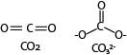

- (i) Bond length in CO₂ = 0.122nm

Bond length in CO₃²⁻ = 0.136 and average between two single bond and 1 double bond

  - 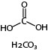

  - Bond angle = 120⁰ due to uniform repulsion between the bonds

- SO32-

- 0.0446moldm⁻³

- pH will be more than 7 due to hydrolysis of carbonate ions to form hydroxide ions

CO₃²⁻(a) + H₂O(l) ↔ HCO₃⁻ (aq) + OH⁻(aq)

- The first end point occurs due to formation of hydrogen carbonate ions (HCO₃⁻) and the second one due to formation of carbon dioxide and water.

Trial 5
Write an ionic equation for the reaction between sodium hydroxide and silicon (IV) oxide.

Trial 6
Carbon, silicon, tin and lead are elements of group (IV) of the periodic table.
(i) How do these elements react with sodium hydroxide?

Trial 7
Carbon, silicon, tin and lead are elements of in group IV of the periodic table.
(a) State:
- the common oxidation states shown by elements in group IV of the P.T. (1 marks)
- how the stability of the oxidation states of group (IV) elements varies down the group.
(Illustrate your answer with the chlorides of carbon and lead). (03 marks)
(b) Give a reason for your answer in (a) (ii). (01 mark)

Trial 8
- When red lead Pb3O4 was reacted with nitric acid, a solid was formed.
Write the equation for the reaction. (2 marks)
- The mixture from (a) was filtered and the residue warmed with concentrated hydrochloric acid,
  - What was observed? Explain your answer. (1 marks) (ii) Write the equation for the reaction. (1½ mark)
- The filtrate from (a) was divided into two parts.
  - To the first part was added aqueous potassium iodide. State what was observed and write the equation for the reaction. (2 marks)
  - The second part was evaporated to dryness and heated strongly. Explain what was observed and write the equation for the reaction that took place. (2½ marks)

Solution
- Pb₃O₄ (s) + 4HNO₃(aq) → PbO₂ (s) + 2Pb(NO₃)₂(aq) + 2H₂O(l)

- Green gas and white solid that dissolved in excess acid to form colorless solution
PbO₂(s) + 4HCl(aq) → PbCl₂ (s) + Cl₂(g) + 2H₂O(l)
ThenPbCl₂(s) + 2Cl⁻ (aq) → PbCl₄(aq)

- (i) yellow ppt
Pb²⁺(aq) + 2I⁻(aq) → PbI₂(s)

(ii) orange residue and brown fumes

2Pb(NO₃)₂(s) → 2PbO(s) + 4NO₂(g) + O₂(g)

Trial 9
A sample of lead (IV) oxide was treated with warm concentrated hydrochloric acid.
(i) State what was observed. (1½ marks) (ii)
Write the equation for the reaction. (02 marks)

Trial 10
Write down the equations for the reactions between:
- The oxides of group (IV) elements and sodium hydroxide. (06 marks )
- Lead IV oxide and concentrated hydrochloric acid. (1½ marks)

(b) Write the ionic equation for the reaction between sodium hydroxide and lead (II) oxide. (1 ½ marks)

Trial 11

- State two industrial uses of tin.
- Tin is said to be enantiotropic, explain what this means.
- How would you convert a solution containing tin (II) ions into a solution containing tin (IV)
ions?

- Pure tin was reacted with chlorine to give a colorless liquid that fumed in moist air. A solution of 0.162 g of the liquid in water was equivalent to 24.00 cm³ of exactly 0.1 M sodium hydroxide solution using methyl orange as the indicator. Calculate the percentage purity of the liquid in tin compound.

Solution
- Tin is widely used in industry for soldering, protective coatings (tin plating), alloy formation (bronze, pewter), glass production, and electronics. Its corrosion resistance and non-toxic nature make it valuable in food packaging and specialized manufacturing.
- Tin is enantiotropic because it exists in two different interconvertible crystalline forms (allotropes) that are stable under different temperature conditions. i.e. Grey tin (α-tin): Stable below 13.2 °C. It has a diamond-like structure and is brittle, non-metallic. And white tin (β-tin): Stable above 13.2 °C. It has a metallic structure, is malleable, and conducts electricity.
- By oxidation with acidified potassium permanganate or dichromate solution or iron (III) salt.

- SnCl₄(aq) + 2H₂O(l) → SnO₂(s) + 4HCl(aq)
Moles of HCl produced = moles of NaOH = 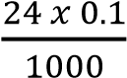 = 0.0024moles

Moles of SnCl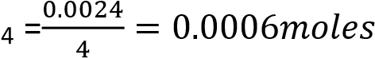

Mass of pure SnCl₄ = 0.0006 x(119 + 35.4 x 4) = 0.15636

% of SnCl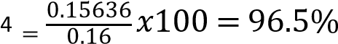

Trial 12
Give a comparative account of the Chemistry of the oxides and chlorides of silicon, germanium, tin and lead, paying particular attention to: -
- the formation, composition and stability of oxides.
- the formation, hydrolytic behavior and stability of chlorides.

Trial 13
Give a concise account of the Chemistry of elements of group 4 of the periodic table (carbon, silicon, germanium, tin and lead) referring your answer to all the following aspects:
- The variation in the first ionization energy.
- The hydrolysis of the tetrachloride.
- The acid-base character of the oxides of the elements in the oxidation states II and IV.
- The relative stabilities of II and IV oxidation states of elements in oxides and chlorides.
- Show how the electron pair repulsion theory can be used to predict the shape of the silicon
tetrachloride molecule.

Trial 14
- Carbon, silicon, germanium, tin and lead are elements of group IV in the periodic table. (i) Describe the types of chlorides formed by these elements.
(ii) Show how the chlorides of these elements react with water.
- Describe the trends in the basicity of the oxides of group IV elements and write equations to show how the oxides of carbon, silicon and germanium react with sodium hydroxide.
(c)When a mixture of carbon and an oxide of a group II element was heated to a very high temperature, a compound X was formed. X reacted with cold water to give a gas Y that decolourised chlorine water.
(i) Identify the element in group (II) and substances Xand Y. (ii) Write equations leading to the formation of Y.

Solution
(c)(i) Element is calcium, X is CaC₂ and Y is HCCH.
(ii) Ca (s) + 2C (s) →CaC₂ (s) then CaC₂ (s) + 2H₂O (l) → Ca(OH)₂ (aq) + Y (HCCH) (g)

Trial 15
- Illustrate the transition from nonmetallic to metallic character of carbon, silicon and tin by describing the structure of and giving one chemical property of, any one type of these elements.
- One of the products of the reaction between magnesium silicide (Mg2Si) and sulphuric acid is a gas X.
A 0.620 g sample of X occupied 224 cm³. When hydrolysed, this sample yielded1568 cm³ of hydrogen and a residue (SiO₂) which, after it had been strongly heated, weighed1.200 g. (All gas volumes corrected to S.T.P.)
(i) What is the molecular formula of X? [SiH₄] (ii) Write an equation for the hydrolysis of X.
[SiH₄ (g) + 2H₂O (l) → SiO₂ (s) + 4H₂ (g)]

Trial 16
- (i) State two important oxidation states exhibited by carbon, silicon, tin and lead.
    - Describe how the stability of the two states varies from carbon to lead. Use the oxides of the elements to illustrate your answer.
    - Explain the inert pair effect in group (IV) elements.

- State what would happen if tetrachloromethane, silicon (IV) chloride, tin(IV) chloride and lead (IV) chloride are separately shaken with water. Write equations to illustrate your answer where necessary.

- (i) Write equations to show how lead (II) chloride can be prepared in the laboratory. State the conditions for the reaction.
  - What type of bonding exists in lead (II) chloride?
  - State two physical properties that show that lead (II) chloride exhibits the type of bonding you have stated in (ii) above.

Trial 17
- Write the outermost electronic configuration of group (IV) elements. (01 marks) ns²np²
- Describe the reaction of:
  - Carbon, silicon, tin and lead with water (6½ marks)
Carbon does not react with cold water but reacts with steam to form water gas
C(s) + H2O(g) → CO(g) + H2(g)

Silicon, germanium and Tin do not react with water up to 100⁰C because they are protected by thin layer of oxide. But they react with steam at very high temperatures to form dioxides

Ge(s) + 2H2O(g) → GeO2(s) +2H2(g)

Lead reacts with soft water (water that contains oxygen) to form lead II hydroxide. Pb(s) + 2H2O(g) + O2(g) → Pb(OH)2(s)

  - Lead with ethanoic acid (2½ marks)
Pb reacts ethanoic acid in presence of air giving lead II ethanoate and water Pb (s) + 4CH3COOH(aq) + O2(g) → Pb(CH3COO-)2(aq) +2H2O(l)

  - Chlorides of lead with sodium hydroxide solution (04marks)
Lead II chloride reacts with sodium hydroxide solution to form lead (II) hydroxide which
dissolves in excess sodium hydroxide to form sodium plumbate (II)
PbCl2 (s) + 2OH⁻(aq)  Pb(OH)2(s) + 2Cl⁻(aq) Then
Pb(OH)2(s) + 2OH⁻(aq) [Pb(OH)₄]²⁻(aq)

Lead(IV) chloride react with sodium hydroxide to produce lead(IV) oxide, sodium chloride and water. Sodium hydroxide - diluted solution. PbCl4 + 4NaOH → PbO2 + 4NaCl + 2H2O
The compound PbO2 reacts with the sodium hydroxide to produce the hexahydroxoplumbate (IV) ion [Pb(OH)₆]²⁻, soluble with the water.
PbO2 + 2NaOH + 2 H2O → Na2[Pb(OH)₆](aq)

(iv) Silicon with acids (03 marks)

Silicon does not react with most acids under normal conditions but is dissolved by hydrofluoric acid, HF, to form fluorosilicic acid, a reaction apparently driven by the stability of the Si(IV) fluoride complex [SiF₆]²⁻.
Si(s) + 6HF(aq) → 2H2(g) +H₂SiF₆ (aq) (fluorosilicic acid)

(c) Carbon does not react with chlorine but reacts readily with fluorine. Explain this observation. (03 marks)

Fluorine is a stronger oxidizing agent than chlorine, has very low F-F bond energy and form stronger
C-F bond the C-Cl bond, these factors promote reaction of fluorine with carbon.

Trial 17
C, Si, Ge, Sn and Pb are elements of group (IV) of the periodic table. (a) Explain the following trends among the group (IV) elements:
- electropositivity. (4marks)
- stability of +2 oxidation state. (2 ½ marks)
- State four properties in which carbon differs from the rest of the members of group (IV). (4 marks)
- Explain why carbon tetrachloride molecule is nonpolar yet the bonds in
carbon tetrachloride are polar. (3 marks)
- A sample of lead (IV) oxide was treated with warm concentrated hydrochloric acid
  - State what was observed. (½ marks)
  - Write an equation for the reaction. (2 marks)

Trial 18
Carbon, silicon, tin and lead are elements of in group (IV) of the periodic table
- State
  - The common oxidation state shown by the elements of group (IV). (1 mark)
  - How the stability of the oxidation states of group (IV) elements varies down the group. (Illustrate your answer with the chlorides of carbon and lead). (03 marks)
- Give a reason for your answer in (a)(i) . (01 mark) (c) Discuss the reactions of the chlorides of each element with water (06marks) (d) Write down equations for the reactions between:
  - The oxide of each element and sodium hydroxide. (06 marks)
  - Lead (IV) oxide and concentrated hydrochloric acid. (1½ marks)

Group 17: Fluorine, chlorine, bromine, iodine
Members
Elements Symbols
Fluorine F
Chlorine Cl
Bromine Br
Iodine I

General comment
- The halogens are one electron short of the noble gas configurations, and the elements form the anion X⁻ or a single covalent bond.
- They are all non-metals
- The changes in behavior with increasing size are gradual. i.e., fluorine and chlorine are gases, bromine is a volatile liquid and iodine is a dark shiny dark solid.

Generally the properties of fluorine are different from those of other halogens because it (i) Has small atomic radius
    - Has high electronegativity
    - Has abnormally low F-F bond energy (158kJ/mol) due to high electron repulsion of non bonding electron pairs.

NB: Generally bond energy decreases down the group from chlorine to iodine due to decrease in electronegativity as the size of the atoms increase, i.e, Cl-Cl = 242
Br-Br = 193
I-I = 151

Properties
Fluorine is the most chemically reactive of all the elements and combines directly (often with extreme vigor), at ordinary or elevated temperatures, with all elements other than O2, He, Ne, and Kr.

- Fluorine is the most electronegative element and displaces all other halogens from their ionic halides.
2Cl⁻ + F2 (g) → 2F⁻ + Cl2 (g)
- Fluorine substitutes oxygen from silicon dioxide and water.

SiO2(s) + 2F2(g) → SiF4(g) + O2(g)
2H2O(l) + 2F2(g) → 4HF(aq) + O2 (g)

- Fluorine reacts with cold dilute solutions of alkalis to give oxygen difluoride; F2O, and with warm concentrated alkalis to give oxygen.
(Cold dilute) 2OH⁻ (aq) + 2F2 (g) → F2O (g) + 2F⁻ (aq) + H2O (l)
(Warm conc.) 4OH⁻ (aq) + 2F2 (g) → O2 (g) + 4F⁻ (aq) + 2H2O (l)

Reason for high reactivity of fluorine
- It has abnormally low (F-F) bond energy by comparison with other halogens (i.e., F2, 158; Cl2, 247; Br2, 193; I2, 151 kJ mol⁻¹).

The low (F-F) bond energy is probably due to greater repulsion between nonbonding electrons.

- Fluorine forms strong covalent bonds with other elements, e.g., C-F, 484; C-Cl, 338; C-Br, 276; C-I, 238 kJ mol⁻¹.
- Fluorine has the highest electronegativity of all elements.

Trial 19
- Explain why fluorine shows some differences in its properties from the rest of the group 7 elements (chlorine, bromine, and iodine) of the periodic table: (3marks)
- State the difference between the chemistry of fluorine and the rest of the elements of group VII of PT. (8 marks)

Preparation of hydrogen fluoride
- By the action of concentrated sulphuric acid on calcium fluoride. CaF2 (s) + H2SO4 (l) → CaSO4 (s) + 2HF (g)

- By heating acid fluoride in a copper or platinum tube,
e.g., KHF2 (s) → HF (g) + KF (s)

Chemical properties of hydrogen floride
- In dilute solution it partially ionizes to form a weak acid HF (g) + H2O(l) → H3O⁺(aq) + F⁻(aq)

- In concentrated solution, partially ionizes as in dilute solution but excess HF molecules complex with F⁻ ions leading to further ionization of the acid producing more H⁺.
F⁻ (aq) + HF (g) → HF2⁻ (aq)
This makes concentrated HF stronger acid than dilute acid solution

Trial 20
(a) Write the equations for the ionization of aqueous hydrogen fluoride in.
- Dilute solution. (1marks)
- Concentrated solution. (1mark)
In which of the solutions in (a) above would you expect hydrogen fluoride to be relatively more acidic? Explain your answer.

- Moist hydrogen fluoride and aqueous solutions of the acid attack silica and glass, so the solution is stored in polythene containers.
SiO2 (s) + 4HF (aq) → SiF4 (aq) + 2H2O (l)
SiF4 (aq) + 2HF (aq) → H2SiF6 (aq) (fluorosilicic acid)

Trial 21
Write an equation for the reaction between hydrofluoric acid and silicon dioxide (1½ marks)

Uses fluorine and its compounds
- Calcium fluoride is used in toothpastes to prevent tooth decay.
- Caryolite, Na3AlF6, is added to aluminium oxide to lowers its melting point to about 900⁰C and improves conduction during extraction of aluminium metal by electrolysis of bauxite.

Chlorine, bromine and iodine
Industrial preparation
(i) Chlorine is prepared by electrolysis of brine (concentrated sodium chloride solution) (ii) Bromine and iodine are prepared by displacement with chlorine from sea water.

Laboratory preparation
By oxidation of acidified solutions of the halides with manganese dioxide or potassium permanganate (VII).

MnO2 (s) + 4H⁺ (aq) + 2X⁻ (aq) → Mn²⁺ (aq) + 2H2O (l) + X2 (s)
2MnO4⁻ (as) + 16H⁺ (aq) + 10X⁻ (aq) → 2Mn²⁺ (aq) + 8H2O (l) + 5X2 (s)

Trial 22
(a) Describe one general method for preparing the halogens (excluding fluorine) in the

laboratory and write equations for the reactions. (4½ marks)

(b) How can you distinguish between sodium bromide and sodium iodide, given chlorine water
and tetrachloromethane. (3½ marks)

Physical properties of chlorine, bromine and iodine
Chlorine is a greenish - yellow poisonous gas with an extremely irritant smell. Chlorine is easily liquefied at room temperature under a pressure of about 7 atmospheres to a yellow liquid.

Bromine is a dark red liquid with an unpleasant and poisonous vapour, and iodine is a dark shiny solid which produces purple vapors on heating.

Chemical properties of chlorine, bromine and iodine

(a) Reactions Cl, Br, I with other elements.
Chlorine, bromine and iodine combine with many metals and non-metals. Usually, the combination with chlorine is most vigorous and with iodine is least vigorous.

Metals that form more than one chloride form the higher one in combination with chlorine, e.g., iron forms iron (III) chloride and not iron (II) chloride because chlorine is a strong oxidizing agent.

Trial 23
- Explain why chlorine reacts with iron to form FeCl3 but not FeCl2.
- Describe the process for the formation of FeCl3(s).

b) Reaction Cl, Brand I with water.
Chlorine and bromine are moderately soluble in water (bromine more so than chlorine); while iodine is only sparingly soluble. Chlorine is hydrolyzed in water to some extent.

Cl2(g) + H2O(l) → HCl (aq) + HOCl (aq)

Iodine is more soluble in KI than in water due to formation of complexes. KI + nI2 → KI(2n+1)

Trial 24
Explain the following observation.
Iodine is more soluble in potassium iodide than in water. (3 marks)

c) Reaction Cl, Brand I with alkalis.
Chlorine reacts with cold dilute sodium hydroxide solution to give sodium chloride and sodium chlorate (I).
2OH⁻ (aq) + Cl2 (g) → Cl⁻ (aq) + ClO⁻ (aq) + H2O (l)

Chlorine reacts with warm concentrated sodium hydroxide solution to give sodium chloride and sodium chlorate (V):
6OH⁻ (aq) + 3Cl2 (g) → 5Cl⁻ (aq) + ClO3⁻ (aq) + 3H2O (l)

Chlorate (V)

Bromine and iodine react with sodium hydroxide solution to give the halide and halate (V):
6OH⁻ (aq) + 3Br2 (g) → 5Br⁻ (aq) + BrO3⁻ (aq) + 3H2O (l)
6OH⁻ (aq) + 3I2 (g) → 5I⁻ (aq) + IO3⁻ (aq) + 3H2O (l)

Trial 25
Discuss the reactions between the elements of group (VII) of the periodic table (fluorine, chlorine bromine and iodine) with
- water. (5 marks)
- sodium hydroxide. (7 marks)

Trial 26
Write equations to show how fluorine and chlorine react with:
- water. (3 marks)
- cold dilute sodium hydroxide solution. (3 marks)
- hot concentrated sodium hydroxide solution. (3 marks)

Trial 27
Describe briefly how chlorine can be converted to potassium chlorate (V) crystals in the laboratory. (5 marks)

The hydrides of chlorine, bromine and iodide
- Ease of oxidation of HX:
Hydrogen iodide is very easily oxidized even by atmospheric oxygen, it is therefore, a strong reducing agent, and is used as a test for oxidizing agents.

Hydrogen bromide is a less strong reducing agent but is oxidized fairly easily, e.g., both hydrogen bromide and hydrogen iodide are oxidized by concentrated sulphuric acid to corresponding free halogens.

2HBr (g) + H2SO4 (l) → SO2 (g) + 2H2O (l) + Br2 (aq)
2HI (g) + H2SO4 (l) → SO2 (g) + 2H2O (l) + I2 (aq)

- Acidity of HX
Pure hydrogen halides are covalent, but polar; they ionize in water to give acidic solutions. The three acids - hydrochloric, hydrobromic and hydro iodic are all strong acids in water.
In other solvents, however, the strengths of these acids decrease in the order HI > HBr > HCl: due to the decrease in the H-X bond energy in the order HCl > HBr > HI.

Trial 28
Explain the following observation;
The acidity of halogens acids decrease in the order HI>HBr>HCl although their ionic characters increase in the reverse order. (4 marks)

Trial 29
The melting points of chlorine, bromine and iodine are in the order; iodine>bromine>chlorine but the temperatures at which the molecules of the halogens dissociate into atoms are in the reverse order.

Explain the trend in the melting points of the elements. (3 marks)

Transition elements
Transition elements are elements with partially filled d-orbital

Table of members of transition elements
Elements | Atomic number | Electronic configuration
Sc  Ti  V Cr  Mn Fe  Co  Ni  Cu  Zn | 21  22  23  24  25  26  27  28  29  30 | [Ar] 3d ¹ 4s ²  [Ar] 3d ² 4s ²  [Ar] 3d ³ 4s ²  [Ar] 3d ⁵ 4s ¹  [Ar] 3d ⁵ 4s ²  [Ar] 3d ⁶ 4s ²  [Ar] 3d ⁷ 4s ²  [Ar] 3d ⁸ 4s ²  [Ar] 3d ¹ ⁰ 4s ¹  [Ar] 3d ¹ ⁰ 4s ²

Properties of transition metals

(a) Physical properties
They are hard metals, with high melting and boiling points due to strong interatomic bonding that involves the participation of both the 4s- and 3d-electrons.

They are good conductors of heat and electricity due a big number of delocalized electrons in s- and d- orbitals.

They have high densities are due to small atomic radii and high atomic masses.

(b) Paramagnetism
Due to presence of unpaired electrons transition metals are weakly attracted by a magnet but they lose their magnetism in the absence of magnetic field.

Those that are strongly attracted by a magnet are said to be ferromagnetic, e.g., iron, cobalt and nickel.

(c) Formation of colored ions
Most compounds and complexes of transition metal ions are colored, with the actual color depending on the oxidation states of the central ions.
For example Fe²⁺ is green
Fe3+ is brown

Reason for formation of colored ions
Transition elements form colored ions because their partially filled d-orbitals allow electrons to absorb specific wavelengths of visible light when they transition between split energy levels. The remaining light is transmitted or reflected, giving the ion its characteristic color. E.g. Cu²⁺ ions appear blue because they absorb red/orange light while Ni²⁺ ions appear green because they absorb red light.

(d) Complex ions formation
Transition metals form many complex ions; e.g. [Fe(CN)₆]³⁻
A complex ion is the one that contains a central ion linked to other atoms, ions or molecules called ligands through dative bonds.

A dative bond is a covalent bond in which the shared electron pair is contributed by a single atom.

Why transition element form complexes
- The ions of transition elements have a high charge density to attract electrons from ligands.
- The ions of transition elements have vacant d-orbitals that can accommodate electron pairs to form dative bonds
- Variable oxidation states enable transition elements to bond with different ligands under different conditions.

Coordination number
A coordination number is number of ligands that form dative bonds with the central ions. For example; [Fe(CN)₆]³⁻ has a coordination number 6

Trial 30
Determine the oxidation states and co-ordination numbers of the central metal ions in each of the following complexes.

Complex | Oxidation state | Coordination number
Cu(NH₃)₄(OH)₂
[Cr(H₂O)₅Cl]Cl₂.H₂O
[Co(CN)]³⁻
Cr2O72-

Trial 31
One of the properties of transition metals is complex ion formation
(a)(i) Define the term ‘complex ion’. (2 marks)
(ii) Explain why transition metals form complexes (2 marks)

(b) Fe(CN)₆³⁻ and [CuCl₄]²⁻ are complexes formed by iron and copper respectively. State;
- The oxidation states of;
Iron
Copper
- The co-ordination numbers of;
Iron
Copper (2marks)

(e) Variable oxidation states
Most transition metals exhibit variable positive oxidation states. For example iron has Fe²⁺ and Fe³⁺.
Transition metals form variable oxidation state because they have many electrons in outermost shell with almost the same energy.

f. Catalytic activity
Transition metals have high catalytic activity. The transition metals use their variable oxidation states to provide alternative mechanisms to the reactions that require low activation energies thus speeding up chemical reactions.

A catalyst is a substance that speeds up a chemical reaction without taking part in the reaction.
Example: V₂O₅, in Contact process

g. The formation of interstitial compounds
The sizes of transition metal atoms and their crystal structures are such that small atoms like hydrogen, boron, carbon and nitrogen can occupy the spaces within the crystal and form interstitial compounds. No definite chemical formula can be attached to these substances since they are non-stoichiometric.

Trial 32
With reference to transition metals, explain what is meant by the following:
- Complex-ion, (5 marks)
- Catalytic activity, (3 marks)
- Colored ion formation. (5 marks) iv.

Scandium
It is the first element in the first transition series. Apart from having partially filled d-orbital; it show no other property of transition elements. It has a fixed oxidation state of +3.

Titanium
Properties as a transition element
- It has variable oxidation states i.e. +2, +3 and +4.
- It is a catalyst as TiCl₄ in polymerization of ethene to polyethene.

Important compounds of titanium
- Titanium IV oxide, TiO₂ is used as a white pigment in soaps and paints
- Titanium IV chloride is used as a catalyst in the polymerization of ethene to polyethene.
Vanadium

Electron configuration [Ar]3s²3d³ Characteristic as a transition element
- Forms colored compounds; for instance V₂O₅ is yellow.
- Has variable oxidation states; +2, +3, +4, +5.
- Has catalytic properties; e.g. V₂O₅ is a catalyst in contact process for conversion of SO₂ to SO₃. d) Forms complexes such as V₂O₃.

Chromium
Electron configuration of chromium.
[Ar]4s¹3d⁵

Characteristic of chromium as a transition element (i) Forms colored compounds; for instance Cr³⁺ is green (ii) Has variable oxidation states; +2, +3, +4, +5, +6.
.
- Forms complexes, e.g. Cr(NH3)₆³⁺
- Has catalytic properties: for instanceCr₂O₃ + ZnO catalyzes formation of methanol from CO and hydrogen.
CO (g) + 2H2(g) →
CH3OH

Trial 33
- Write electron configuration of chromium.
- Giving examples state the properties that show that chromium is a transition metal.

Oxidation states of chromium
Chromium has oxidation states of +6 (oxidizing), +3 (the most stable) and +2 (reducing).

Reaction of chromium with Air
It is extremely stable and is not affected by moist air. The inertness is probably due to a protective oxide layer. It however burn at about 2000⁰C with a brilliant flame to form chromium III oxide

2Cr(s) + 3O2(g) → Cr2O3 (s)

Reaction of chromium with water
Chromium does not react with water but at red heat with steam is to form chromium III oxide 2Cr(s) + 3H2O(g) → Cr2O3 (s) + 2H2(g)

Reaction of chromium with Halogens
F2 and Cl2 combine with hot metal to give chromium III halides.
2Cr(s) + 3X₂(g) → 2CrX₃ (X = Cl, F)

Chromium reacts directly with fluorine, F₂, at 400°C and 200-300 atmospheres to form chromium(VI) fluoride, CrF₆. Cr(s) + 3F₂(g) → CrF₆(s) [yellow]

Reaction of chromium with alkalis
Chromium does not react with alkalis at ordinary temperature.

Reaction chromium with ammonia or nitrogen
It forms nitrides
2Cr (s) + 2NH3(g) → 2CrN(s) + 3H2(g) Cr (s) + N2(g) → CrN(s)

Reaction of chromium with dilute acid
(a) In the absence of air, dil. HCl and dil. H2SO4, chromium react with air form chromium II chloride and chromium II sulphate. Cr (s) + 2HCl(aq) → CrCl2(s) + H2(g)
Cr (s) + 2H2SO4(aq) → CrSO4 (aq) + H2(g)

Reaction chromium with nitric acid
Chromium does not react with nitric acid due to the formation impervious oxide layer.

Important compounds in oxidation state 6

Chromates (VI) and dichromates (VI)
Sodium and potassium chromates (VI) are yellow solids that dissolve in water to form yellow solutions.

Silver chromate is red
Sodium and potassium dichromates (VI) are orange solids that dissolve in water to form orange solutions.

Uses Chromates (VI) and dichromates (VI)
- They are used as oxidizing agents in the laboratory Half equations
Cr2O₇²⁻(aq) + 6e + 14H⁺ (aq) → 2Cr³⁺(aq) + 7H₂O(l)
CrO₄²⁻ (aq) + 3e + 8H⁺(aq) → Cr³⁺(aq) + 4H2O(l)
In the process of oxidation dichromates are reduced to chromium (III) ions and the color changes from orange to green. Note that in acidic solution chromates are converted to dichromates while in alkaline solution dichromates are converted to chromates

Cr2O₇²⁻(aq) + 2OH-(aq)  CrO₄²⁻(aq)
CrO₄²⁻(aq) + 2H⁺ (aq)  Cr2O₇²⁻(aq) + H₂O(l)
- Pieces of filter paper impregnated with acidified solutions of sodium dichromate (VI) can be used to test for reducing gases, e.g., sulphur dioxide and hydrogen sulphide. E.g.
Cr₂O₇²⁻ (aq) + 8H⁺ (aq) + 3H₂S (g) → 2Cr³⁺(aq) + 7H₂O (l) + 3S (s)
The orange spot turns green owing to the formation of chromium (III) ions.

- Potassium dichromate (VI) is used in volumetric analysis to estimate reducing agents, e.g.,
Fe2+
Cr2O7²⁻ (aq) + 14H⁺ (aq) + 6Fe²⁺ (aq) → 2Cr³⁺ (aq) + 6Fe³⁺ (s) + 7H2O (l)
- Dichromates are used in preparation of carbonyl compounds from alcohols and carboxylic acid from aldehydes and many oxidation processes. Dichromates are preferred to manganates (VII) because they are not very strong oxidizing agent to cleaves carbon-carbon bonds in organic chemistry

Advantage of potassium dichromate over potassium permangate in volumetric analysis
- Hydrochloric acid can be used to acidify titration involving potassium dichromate since are not strong oxidizing agents to oxidize chloride ions to chlorine like permangate (VII) would do.
- Potassium dichromate can obtained in stable pure form.

Trial 34
A solution of potassium dichromate (VI) was added to an acidified solution of iron (II) sulphate.
- State what was observed. (1mark)
- Write an ionic equation for the reaction that took place. (1½ marks)

Trial 35
Potassium dichromate in the presence of sulphuric acid is widely used as an oxidizing agent.
Write
- Half equation for the reaction between potassium dichromate and potassium iodide (2½ marks)
- Write an overall equation for the reaction between potassium dichromate and
potassium iodide in acidic solution. (1 ½ mark)
- Name one practical application of potassium dichromate as an oxidizing agent.(1 mark)

Conversion dichromate to chromate
In presence of an alkali dichromate (orange) is converted into chromate (yellow) ions. And chromate ions in acid solution are converted into dichromate solution.
Cr2O7²⁻(aq) + 2OH⁻ (aq) → 2CrO4²⁻(aq) + H2O(l)
2CrO4²⁻(aq) + 2H⁺ (aq) → Cr2O7²⁻(aq) + H2O(l)

Trial 36
State what is observed and write equation for the reaction that took place when sodium hydroxide is added to potassium dichromate solution followed by excess dilute sulphuric acid

Use of chromate and dichromate to test for lead and barium ions
Potassium chromate and dichromate form yellow precipitates with Pb⁺² and Ba²⁺ and a r e used to test for these ions
M²⁺(aq) + CrO₄²⁻(aq) → MCrO4(s)2M²⁺(aq) + Cr₂O₇²⁻(aq) + H₂O(l) → MCr₂O₇(s)+ 2H⁺(aq)Lead chromate is soluble in sodium hydroxide whereas barium chromate is not.
PbCrO4(s) + 4OH⁻(aq) → PbO₂²⁻(aq) +2H₂O(l)+ CrO₄²⁻(as).

Reaction dichromate with hydrogen peroxide
In dilute acidified solutions, dichromate (VI) reacts with hydrogen peroxide solution to form a blue chromium peroxide CrO(O₂)₂:
Cr₂O₇²⁻ (aq) + 2H⁺ (aq) + 4H₂O₂ (aq) → 2CrO(O₂)₂ (aq) + 5H2O (l)
The reaction provides a sensitive test. For chromium

Chromium III chloride
It is particularly of interest in exams because it shows isomerism of inorganic compounds.

Isomerism is the existence of compounds with the same molecular formula but different structural formulae

Isomers of chromium III chloride are:
(a) [Cr(H₂O)₆]³⁺(Cl⁻)3 Grey-green (b) [Cr(H2O)5Cl]²⁺⁽Cl⁻)2.H2O Light green
(c) [Cr(H2O)4Cl]²⁺(Cl⁻)3.2H₂O

Method of distinguishing the isomers of chromium (III) chloride
(i) The structural isomers of chromium (III) chloride can be identified by titration with silver nitrate solution; the isomers precipitate different number of chloride ions per mole of the isomers
Moles of chloride ion precipitated per mole of the isomers

(a) [Cr(H₂O)₆]³⁺(Cl⁻)₃ |  | 3 chloride ions per mole
(b) [Cr(H2O)5Cl]²⁺⁽Cl⁻)₂.H2O |  | 2 chloride ions per mole
(c) [Cr(H2O)4Cl]²⁺(Cl⁻)₃.2H₂O  2. By electrical conductivity. |  | 1 chloride ions per mole
(a) [Cr(H₂O)₆]³⁺(Cl⁻)₃ |  | 4 conducting ions
(b) [Cr(H2O)5Cl]²⁺⁽Cl⁻)₂.H2O |  | 2 conducting ions
(c) [Cr(H2O)4Cl]²⁺(Cl⁻)₃.2H₂O |  | 1 conducting ions

Trial 37
- Write the structural formulae of the isomers of chromium (III) chloride, CrCl3.6H2O. (3 marks)
- State one way of distinguishing the isomers. (½ mark)

Trial 38
Chromium (III) chrolide-6-water, CrCl3.6H2O, is an example of hydrate isomerism.
- Write the formulae of the three possible isomers of CrCl3.6H2O.
- The co-ordination number of chromium is the same in the isomers of CrCl3.6H2O.
  - Explain briefly what is meant by the term co-ordination number.
  - What is the co-ordination number of chromium in CrCl3.6H2O.

Hydrolysis of chromium (III) salts
Chromium (III) salts hydrolyze in water to give acidic solutions, which turn blue litmus paper red and liberate carbon dioxide from carbonates Cr³⁺(aq) + 3H₂O(l) → Cr(OH)₃(s) + 3H⁺(aq)
Consequently, a solution of chromium (III) salt
- Has a pH less than 7
- Change the color of blue litmus paper to pink
- Liberates carbon dioxide (effervescence) from carbonate and hydrogen carbonates.

Trial 39
Chromium (III) sulphate was dissolved in water and a few drops of concentrated sodium carbonate solution added to the solution.
- State what was observed. (2marks)
- Give a reason for your answer and equations for the reaction (2½ marks) Solution
- Effervescence and green precipitate formed
- Chromium three ions are hydrolyzed to produce acidic solution that liberates carbon dioxide from the carbonate. The green precipitate is chromium (III) hydroxide formed. 2Cr³⁺(aq) + 3CO₃²⁻(aq) + 3H₂O (l) → 2Cr(OH)₃(s) + 3CO₂(g)

Qualitative analysis of chromium (III) salts
With sodium hydroxide solution:
It forms a green precipitate soluble in excess
Cr³⁺ (aq) + 3OH⁻(aq) → Cr(OH)₃(s)
Cr(OH)₃(s) + OH⁻(aq) → Cr(OH)₄⁻ (aq)

With dilute ammonia solution:
It forms a green precipitate insoluble in excess
Cr³⁺ (aq) + 3OH⁻ (aq) → Cr(OH)₃ (s)

Confirmatory test;
It forms a green precipitate with sodium hydroxide soluble in excess turns yellow with hydrogen peroxide solution and temporary blue when a few drops of concentrated sulphuric acid are added to the mixture..

Equations
Cr³⁺ (aq) + 3OH⁻(aq) → Cr(OH)₃(s)
Cr(OH)₃(s) + OH⁻(aq) → Cr(OH)₄⁻ (aq)
Cr2O₇²⁻(aq) + 2H⁺ (aq) + 4H₂O₂ (aq) → 2CrO(O₂)₂ (aq) + 5H₂O (l)

Trial 40
Dilute sodium hydroxide solution was added drop wise until in excess to aqueous chromium
(III)chloride
- State what was observed. (1½ mark)
- Write an equation for the reaction. (2 marks)
- To the product in (a) was added a few drops of hydrogen peroxide and the mixture boiled
  - State what was observed. (1mark)
  - Write an equation for the reaction. (1½ marks).

Trial 41
A dark purple crystalline solid Z dissolved in water to give violet solution. When aqueous sodium hydroxide was added to the solution of Z drop wise, a green precipitate was formed and it dissolved in excess sodium hydroxide to give a green solution.
- Identify the cation in Z. (1 mark)
- Write the formula of the species responsible for the formation of: The violet colour. (1 mark) (c) Green solution (1 mark)

Trial 42
A dilute solution of chrome alum, K₂Cr₂(SO₄)₄.2H₂O was prepared and divided into two portions.
- The first portion turned blue litmus red. Explain the observation and write an equation to illustrate your answer. (4 marks)

- To the second portion was added few drops of sodium carbonate solution. State what
was observed and explain your answer. (3marks)

Trial 43
- When about 1cm³ of dilute sulphuric acid was added to about 1cm³ of potassium chromate, an orange solution was observed. Addition of an excess dilute sodium hydroxide solution to the mixture gave a yellow solution. Write an equation for the reaction that took place. (3 marks)
- Briefly describe a test that can be carried out in the laboratory to confirm that potassium chromate contains chromium ions. (3mark)

Trial 44
When hydrogen peroxide was added to the green solution, a yellow solution was formed, which on treatment with lead ethanoate solution formed a yellow solid. Write an equation for the reaction leading to the formation of:
- The Green solution.
- The yellow solution.

Manganese and its compounds
Electron configuration of manganese
[Ar]4s²3d⁵
Properties of manganese as a transition element
(i) Forms colored compounds; for instance Mn⁷⁺ is purple (ii) Has variable oxidation states; +2, +3, +4, +5, +6, +7 (iii) Forms complexes, e.g. MnO₄⁻.
(iv) Has catalytic properties, e.g., MnO₂ catalyze release of oxygen from hydrogen peroxide

Reaction of manganese with air
Manganese is not very reactive in regards to air. The surface of manganese lumps oxidizes a little. Finely divided manganese metal burns in air. In oxygen the oxide Mn₃O₄ is formed and in nitrogen the nitride Mn₃N₂ is formed.
3 Mn(s) + 2 O₂(g) → Mn₃O₄(s) 3 Mn(s) + N₂(g) → Mn₃N₂(s)

Reaction of manganese with Halogens
Manganese reacts with the halogens, forming the corresponding manganese(II) halides. For fluoride, manganese(III)fluoride is also formed
Mn(s) + F₂(g) → MnF₂(s)
2 Mn(s) + 3 F₂(g) → 2 MnF₃(s)
Mn(s) + Cl₂(g) → MnCl₂(s) [3]
Mn(s) + Br₂(g) → MnBr₂(s) Mn(s) + I₂(g) → MnI₂(s)
Reaction of manganese with water
Manganese reacts slowly with water forming manganese dioxide
Mn(s) +2H₂O(l) → MnO₂ (s) + 2H₂(g)
Reaction of manganese with acids
Manganese dissolves readily in dilute sulphuric acid, forming a colorless solution of Mn(II) ions and hydrogen gas, H₂.

Mn(s) + H₂SO₄(aq) → Mn²⁺(aq) + SO₄²⁻(aq) + H₂(g)

Important compounds of manganese Potassium Manganate (VII), KMnO₄
- It used as an oxidizing agent to oxidize alcohols and aldehydes to carbonyl compounds and carboxylic acids respectively.
- it is used to standardize iron (II), Hydrogen peroxide and oxalic acid
Half equation for manganate 7
MnO₄⁻ (aq) + 5e + 8H⁺(aq) → Mn²⁺(aq) + 4H₂O(l)

Trial 45
Complete and balance the following equations
Fe²⁺ (aq) + H⁺ (aq) + MnO₄⁻(aq) →
H₂O₂ (aq) + H⁺ (aq) + MnO₄⁻(aq) →
C₂O₄²⁻ (aq) + H⁺ (aq) + MnO₄⁻(aq) →
Manganese (VII) oxidizes halides in the preparations of halogens
2MnO₄⁻ (aq) + 10X⁻(aq) + 16H⁺(aq) → 2MnX₂(aq) + 8H₂O(l) + 5X₂ (X= Cl, Br, I)

Solution
5Fe²⁺ (aq) + 8H⁺ (aq) + MnO₄⁻(aq) → 5Fe³⁺(aq) + Mn²⁺(aq) + 4H₂O(l)
5H₂O₂ (aq) + 6H⁺ (aq) + 2MnO₄⁻(aq) → 2Mn²⁺(aq) + 8H₂O(l)
5C₂O₄²⁻ (aq) + 16H⁺ (aq) + 2MnO₄⁻(aq) → 2Mn²⁺(aq) + 8H₂O(l) + 10CO₂(g)

Trial 46
Complete and balance the following equations
Cl⁻ (aq) + H⁺ (aq) + MnO₄⁻(aq) →
For this reason HCl is not used to acidify MnO₄⁻ in its oxidation reaction because Cl⁻ ion is oxidized as well.
Solution
2MnO₄⁻ (aq) + 10Cl⁻(aq) + 16H⁺(aq) → 2MnCl₂(aq) + 8H₂O(l) + 5Cl₂ (g)

Variation of oxidizing power of manganate (VII) ions with pH
The oxidizing power of potassium permanganate depends on the pH as shown below:
- Acidic solution
MnO₄⁻ (aq) + 8H⁺ (aq) + 5e →Mn²⁺ (aq) + 4H₂O (l)
- Neutral or alkaline solutions,
The manganate (VII) is reduced to manganese (IV) oxide.
MnO₄⁻ (aq) + 2H₂O (l) + 3e → MnO₂ (aq) + 4OH- (l)
- Strongly alkaline solution
Manganate (VII) is reduced to green manganate (VI).
MnO₄⁻ (aq) + e- → MnO₄²⁻ (aq)

Disadvantages of using potassium permanganate (VII) in volumetric analysis
- Manganate (VII) cannot be used as a primary standard because
  - it cannot be obtained in pure form. The impurities are MnO₂.
  - Aqueous solutions of manganese (VII) is unstable and slowly deposit brown manganese (IV) oxide on standing.
- Hydrochloric acid cannot be used as an oxidizing agent of potassium permanganate VII
- Nitric acid cannot be used to oxidize potassium permanganate (VII) solution because it is an oxidizing agent

Trial 47
- Potassium manganate (VII) is not used as a primary standard in volumetric analysis and has to be standardized
  - What is a primary standard? (2marks)
  - State three characteristics of a primary standard. (3 marks)
  - Explain why potassium manganate (VII) is not used as a primary standard. (2 marks)
  - Name one substance, other than ethane dioc acid which can be used as a primary standard for potassium manganate. (VII) (1 mark
- Explain why hydrochloric acid is not used usually to acidify solutions of potassium manganate (VII)
(2 marks)
- Acidified potassium manganate (VII) reacts with ethane dioc acid
Write
  - The half equations for the reaction. (2 marks)
  - The overall equation for the reaction. (2 marks)
- 20.00 cm³ of 0.01 M manganate (VII) ions solution required exactly 16.65 cm³ of a solution containing 5.1 g l⁻¹ of an oxalate (COO⁻X⁺)₂.2H₂O. Calculate the atomic mass of X.

Solution
- (i) A primary standard is a substance of known high purity which may be dissolved in a known volume of solvent to give a primary standard solution (ii) Features of a primary standard include:
  - High purity.
  - Stability (low reactivity)
  - Low hygroscopicity (to minimize weight changes due to humidity) • High equivalent weight (to minimize weighing errors) • Non-toxicity.
  - Ready and cheap availability.
- Chloride ions react with manganate (VII) ions.
2MnO₄⁻ (aq) + 10Cl⁻ (aq)+ 16H⁺ (aq) → Mn²⁺(aq) + 5Cl₅(g) + 8H₂O(l)
- (i) MnO₄⁻ (aq) + 8H⁺ (aq) + 5e →Mn²⁺ (aq) + 4H₂O (l)
C₂O₄²⁻ (aq) -2e → 2CO₂(g)
(ii) 5C₂O₄²⁻ (aq) + 16H⁺ (aq) + 2MnO₄⁻(aq) → 2Mn²⁺(aq) + 8H₂O(l) + 10CO₂(g) (d) X =23

Trial 48
Iron (II) sulphate is normally used to standardize a solution of potassium manganate (VII) acidified with sulphuric acid
(a) Write an equation for the reaction between potassium manganate and iron (II) sulphate.(1 ½ marks)
(ii) State why hydrochloric acid is not used to acidify potassium manganate (VII). (2 ½ marks)
(b) 20.00 cm³ of acidified solution of 0.02M potassium manganate (VII) reacted exactly with 25.10cm³ of sodium nitrite. Potassium manganate (VII) reacts with sodium nitrite according to the following equation.
2MnO₄⁻ (aq) + 5NO₂⁻(aq) +6H⁺(aq)  2Mn²⁺(aq) + 5NO₃⁻(aq) +3H₂O(l)
Calculate the concentration of the sodium nitrite in moles per litre.[ 0.04M]
Manganese (VI) compounds:
The sodium and potassium manganates (VI) are the only pure compounds containing manganese in the +6 oxidation state. Both these compounds are dark green solids, the colour being due to the MnO₄²⁻ ion.
Manganese (VI) disproportionate in acidic medium to give purple manganate VII ions
3MnO₄²⁻ (aq) + 2H₂O (l) → 2MnO₄⁻ (aq) + MnO₂ (s) + 4OH⁻ (aq)
Definition
Disproportionation reaction is a reaction where there is concurrent oxidation and reduction
Disproportion of manganese (VI) is speeded up by bubbling a stream of carbon dioxide through the solution, since this removes the hydroxyl ions as hydrogen carbonate ions
4⁻OH (aq) + 4CO₂ (g) → 4HCO₃⁻ (aq)
Manganese (IV) compounds
Manganese (IV) oxide, MnO₂, is the main manganese (IV) compound; it occurs naturally as the ore pyrolusite; and it can be made by the action of heat on manganese (II) nitrate.
Mn(NO₃)₂ (s) → MnO₂ (s) + 2NO₂ (g)
Uses of manganese IV oxide
- preparation of chlorine
MnO₂ (s) + 4HCl (aq) → MnCl₂ (aq) + 2H₂O (l) + 2Cl₂ (g)
- it is a catalyst in the preparation of oxygen from hydrogen peroxide.
Reaction of Manganese (IV) compounds.
In presence of air or oxidizing agent (e.g. KNO₃, KClO₃) MnO₂ reacts with fused KOH to give potassium manganate, K₂MnO₄.
2MnO₂(s) + 4KOH(l) + O₂ (g)→ 2K₂MnO₄(aq) + 2H₂O(l)

Qualitative analysis of Manganese II
(a) Addition of dilute sodium hydroxide of ammonia solution drop wise until in excess.
A white ppt. insoluble in excess, rapidly turning brown.
Mn²⁺ (aq) + 2⁻OH (aq) → Mn(OH)₂ (s)
Then
4Mn(OH)₂ (s) + O₂(g) → Mn₂O₃(s) + 2H₂O(l)
Confirmatory test of Mn²⁺
Mn²⁺ aqueous solution turn purple solution on addition concentrated nitric acid followed by sodium bismuthate or Lead (IV) oxide.
2Mn²⁺ (aq) + 5BiO₃⁻ (s) + 14H⁺ (aq) → 2MnO₄⁻ (aq) + 5Bi³⁺ (aq) + 7H₂O (l)
2Mn²⁺ (aq) + 5PbO₂(s) + 4H⁺ (aq) → 2MnO₄⁻ (aq) + 5Pb²⁺ (aq) + 2H₂O (l)

Trial 49
A crystalline solid Y dissolved in water to give a pink solution. Addition of excess aqueous sodium hydroxide produced a dirty white precipitate which rapidly turned brown on standing.
When nitric acid was added to the solution Y followed by sodium bismuthate solution, the solution changed from pink to purple.
- Identify the cation in Y. (1 mark)
- Write:
  - The equation for the reaction that took place when sodium hydroxide was added to the solution. (1½ marks)
  - The formula of the species responsible for the purple color. (1 mark)
  - Equation for the reaction leading to the formation of the brown solid. (1½ marks)

Trial 50
(a) Write the outer electronic configuration of manganese. (1 mark)
- State the possible oxidation states of manganese. (2 ½ marks)
- How does the acidity of the oxides of manganese vary with increasing oxidation states?
(½ marks)
- What is the change in oxidation state of manganese when potassium manganate (VII) is reduced in alkaline medium? (1 mark)
- State four applications of potassium manganate (VII) in the laboratory as oxidizing agent?
(4 marks)

Iron and its compound
Electron configuration of Iron
[Ar]3d⁶4s²
Properties of iron as a transition element
- Forms colored compounds; for instance Fe²⁺ is green
- Has variable oxidation states; +2, +3,
- Forms complexes, e.g. Fe(CN)₆³⁻.
- Has catalytic properties, e.g., iron catalyze formation of ammonia from nitrogen and hydrogen.

Extraction of iron
Iron, which is the second most abundant metal occurring in the earth’s crust, is extracted from its ores which are;
haematite, | Fe₂O₃
magnetite, | Fe₃O₄,
siderite, | FeCO₃.

Extraction of iron from hematite
Main Impurities
Silica, SiO₂
Reactions leading to reduction of iron oxide are
C (s) + O₂ (g) →CO₂ (g)
CO₂ (s) + C (s) →2CO (g)
Fe₂O₃ (s) + 3CO (g) → 2Fe (s) + 3CO₂ (g)
Reactions leading to removal of impurities
CaCO₃ (s) → CaO (s) + CO₂ (g)
CaO (s) + SiO₂ (s) → CaSiO₃ (l) CaO (s) + Al₂O₃ (s) → CaSiO₃ (l) slag

Procedure
Iron ore, lime stone and coke in the correct proportions are reacted with preheated air in a blast furnace.
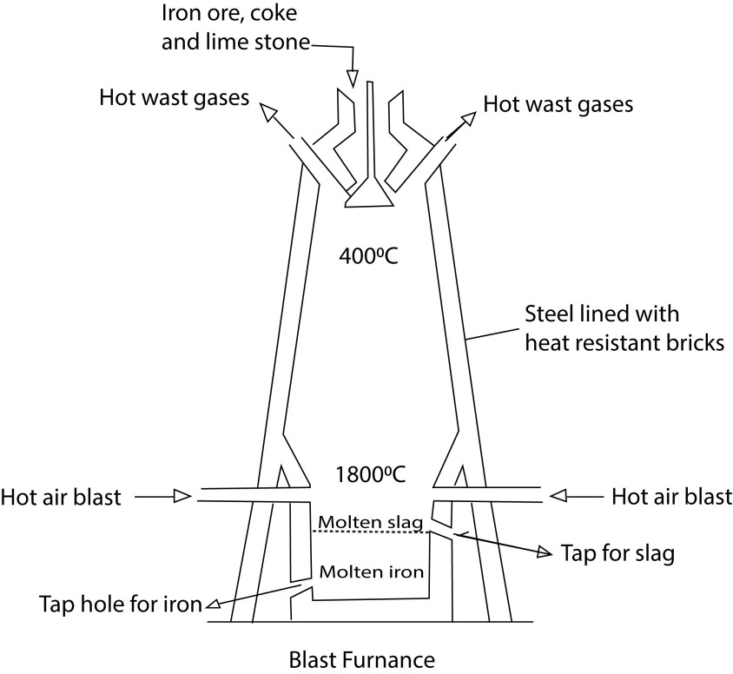
Molten iron and slag percolate to the bottom of the furnace and taped of through different taps.

Trial 1
In the production of iron metal, haematite, Fe₂O₃, is mixed with coke and lime stone and heated in a blast furnace.
(a) What is the purpose of adding
(i) lime stone (1 mark)
(i) coke? (1 mark)
- Write three different equations for the reaction in which haematite are converted into iron in the blast furnace. (3marks)
- Explain why it is possible to extract iron by the method described above. ( 2 marks)
- Name one other method that can be used to extract iron from its ore. ( 1 marks)
- Suggest a reason why the method you have named in d(i) is not used commonly in the production of iron.

Oxidation states of Iron
Iron has oxidation states +2 and +3
Oxidation state Fe³⁺ ([Ar]3d⁵) is more stable than F²⁺ ([Ar]4s¹3d⁵) because Fe³⁺ has stable half full electron configuration.

Trial 51
This explains why green iron II compounds rapidly turn into brown iron III compounds.
Properties of iron
Pure iron is a silvery colored metal with a melting point of 1535⁰C and boiling point 3000⁰C.
It is a soft, ductile and malleable metal, which is strongly ferromagnetic.
Rusting of iron
Iron in presence water and air form a brown coat called rust or hydrated iron (III) oxide, Fe₂O₃.xH₂O,
Disadvantage of rusting
- Weaken tools
- Makes objects look ugly

Methods of preventing rusting
- Keeping objects in dry places.
- Painting
- Oiling
- Greasing
- Coating with another metal.
- Zinc plating

Reaction of iron with water
Iron does not react with cold water but with steam to form blue-black tri-iron trioxide oxide
3Fe(s) + 4H₂O(g) → Fe₃O₄(s) + 4H₂(g)
Reaction of iron with acids
Iron displaces hydrogen readily from dilute hydrochloric acid and sulphuric acids, forming iron (II) salts. Dilute nitric acid forms iron (II) nitrate and oxides of nitrogen.

Fe(s) + 2HCl(aq) → FeCl₂ (aq) 2H₂(g)
Fe(s) + H₂SO₄(aq) →FeSO₄(aq) + H₂(g)
Concentrated H₂SO₄ gives a mixture of ferrous and ferric sulphates.
Fe(s) + 2H₂SO₄(aq) → FeSO₄(aq) + SO₂(g) + 2H₂O(l)
2FeSO₄ (aq) + 2H₂SO₄ (aq) → Fe₂(SO₄)₃ (aq) + 2H₂O (l) + SO₂ (g)

Action of alkalis, halogen and sulphur on iron
Iron does not react with alkalis.
Halogens and sulphur combine with the heated metal forming halides and sulphide respectively.
2Fe(s) + 3Cl₂(g) → 2FeCl₃ (g)
Fe(s) + S(s) → FeS (s)

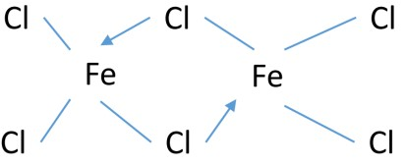

Displacement of less electropositive metals
Iron displaces copper from a solution of copper sulphate.
Fe(s) + Cu²⁺(aq) → Fe²⁺(aq) + Cu(s)
Hydrolysis of Iron III slats in water
Iron III salts hydrolyze in water to form acidic solution
Fe³⁺(aq) + 3H₂O(l) → Fe(OH)₃(s) +3H⁺(aq)
Consequently, Iron III solution
- turns blue litmus paper red.
- Liberate carbon dioxide from carbonates with formation of brown precipitate - Has pH less than 7
Reaction iron III solution with sodium carbonate solution
2F³⁺(aq) + 3CO₃²⁻(aq) + 3H₂O(l) → 2Fe(OH)₃(s) + 3CO₂(g)
Observation
A brown ppt. formed with effervescence

Trial 52
State what would be observed and write an equation for the reaction that takes place when aqueous iron (III) chloride with sodium carbonate (3½ marks)
Reactions of iron (III) as an oxidizing agent
Iron (III) compounds are strong oxidizing agents, for instance, it oxidizes iodide ions (I⁻) to iodine and tin (II) compounds to tin (IV) compounds and itself reduced to Fe²⁺ compounds.
2Fe³⁺(aq) + 2I⁻(aq) → 2F²⁺(aq) + I₂(aq)
2Fe³⁺(aq) + Sn²⁺(aq) → 2F²⁺(aq) + Sn²⁺(aq)

Trial 53
A solution of Iron (III) chloride was added to an aqueous solution of tin (II) chloride acidified with hydrochloric acid and the mixture shaken.
- State what was observed. (1 mark)
- Write an equation for the reaction that took place.

Qualitative analysis of Fe²⁺ salt
Common iron II salts include
- Ferrous sulphate: FeSO₄.7H₂O
- Ammonium ferrous sulphate (NH₄)₂Fe(SO₄)₂.6H₂O
- Ferrous oxalate. FeC₂O₄

Qualitative analysis of Fe²⁺ salt
- Addition of dilute sodium hydroxide or ammonia solution
Observation
A dirty green precipitate insoluble in excess turn brown on standing.
Fe²⁺(aq) + 2OH⁻(aq) → Fe(OH)₂(s)
- Confirming presence of Iron II ions
Forms a deep blue solution with potassium hexacyanoferrate III.

Qualitative analysis of Fe³⁺ salt
- Addition of dilute sodium hydroxide or ammonia solution Observation
A dirty brown precipitate insoluble in excess.
Fe³⁺(aq) + 3OH⁻(aq) → Fe(OH)₃(s)
- Confirming presence of Iron III ions
Forms a deep blue solution with potassium hexacyanoferrate II.
Forms a red solution with ammonium thiocyanate solution.

Cobalt and its compounds
Electron configuration of cobalt
[Ar]4s³d⁷

Properties as a transition element
- Forms colored compounds; for instance Co²⁺ is pink
- Has variable oxidation states; +2, +3,
- Forms complexes, e.g. CoCl₄²⁻.

Physical properties of cobalt
Cobalt is a silver-white lustrous metal, slightly harder than iron. It is malleable and ductile. It is more magnetic than all other metals except iron. It has a density equal to 8.9. It melts at 1495⁰C and boils at 2900⁰C.

Action of air:
Dry air has no action on cobalt but the metal reacts with O₂ to form Co₃O₄ when red hot.
3Co(s) + 2O₂(g) → Co₃O₄(s)

Action of water:
Cobalt does not react with cold water. However, it decomposes steam to hydrogen.
Co(s) + H₂O(steam) → CoO(s) + H₂(g)

Action of acids
Dilute Hydrochloric acid and sulphuric acid form salts and hydrogen with cobalt.
Co(s) + 2H⁺(g) → Co²⁺(aq) + H₂(g)

Dilute nitric acid dissolves the metal and renders it passive due to formation of a protecting thin layer of metal oxide on the surface of the metal.

Action of alkalis:
Even concentrated alkali has no action on the metal. The metal is dissolved in fused caustic potash at 550⁰C.

Action of Carbon monoxide:
Finely divided Cobalt combines with carbon monoxide at 150⁰C and under 30 atmospheres to form orange-red Co₂(CO)₈

Action of ammonia: Co₄N₂ is formed.
4Co(s) + 2NH₃(g) → Co₄N₂(s) + 3H₂(g)

Action with other elements:
Cobalt readily combines with H₂, S, P and B but N₂ has no action on it. Co(s) + H₂(g) → CoH₂(s) Co(s) + S(s) → CoS(s)
3Co(s) + 2P(s) → Co₃P₂(s)

Uses of cobalt
- Cobalt is used for electroplating.
- For preparation of alloys; e.g. cobalt steel for making permanent magnets, stellite (Co, Cr and W (tungsten)) for making surgical instruments, and Co-chrome (Co, Cr and Fe) for making resistance wires.
- Cobalt oxides and silicates are used for coloring glass, pottery and glazes.

Qualitative analysis of cobalt II salts
Common salt: Cobalt sulphate: CoSO₄
With dilute sodium hydroxide solution and ammonium solution

Observation
Blue precipitate insoluble in excess turns brown on standing

Confirmatory test
Forms deep blue solution with concentrated hydrochloric acid.
Co(H₂O)₆²⁺ (aq) + 4Cl⁻ (aq) →CoCl₄²⁻ (aq) + 6H₂O (l)

(b) With Concentrated ammonia forms a blue precipitate soluble in excess to give pale yellow solution; the solution turns brown on standing.
[Co(H₂O)₆]²⁺ (aq) + 2OH⁻ (aq) → Co(OH)₂ (s)
pink blue ppt
Co(OH)₂ (s) + 6NH₃ (aq) s → *Co(NH₃)₆]²⁺(aq) red-brown
[Co(NH₃)₆]²⁺(aq) → Co(NH₃)₆]³⁺(aq) red-brown yellow solution

Trial 54
(a) Write equations for the reactions which take place and in each case, state what would be observed when;
(i) Concentrated ammonia is added drop wise to an aqueous solution of cobalt (II) sulphate and when the resultant solution is allowed to stand in air. (4 marks)

Nickel and its compounds Electron configuration
*Ar+4s²3d⁸

Properties as a transition element
- Forms colored compounds; for instance Ni²⁺ is green
- Has variable oxidation states; +2, +3,
- Forms complexes, e.g. Ni(NH₃)₆²⁺.
- Catalytic property: it is a catalyst in hydrogenation of alkenes, alkyne

Physical Properties
Nickel is a hard metal that is quite lustrous. It melts at 1452⁰C and has a density of 8.90 g cm⁻³. Nickel is used in making of alloys, electroplating of materials; and as a catalyst in the hydrogenation of fats and in making synthesis gas.
Reaction of air with nickel:
It reacts slowly at ordinary temperature but vigorously at high temperature to form nickel oxide
2Ni(s) + O₂(g) → 2NiO(g)

Action of water on nickel
Nickel decomposes steam at red heat to hydrogen
Ni(s) + H₂O(g) ↔NiO(s) + H₂(g)

Action of acids on nickel
Dilute hydrochloric acid sulphuric acids have slow action on nickel.
But nitric acid readily dissolves the metal.
3Ni(s) + 8HNO₃(aq) → 3Ni(NO₃)₂(aq) + 2NO(g) + 4H₂O(l)

Action of halogen on nickel
Chlorine reacts with nickel to form nickel (II) chloride.
Ni(s) + Cl₂(g) → NiCl₂(s)

Action of sulphur on nickel
Sulpur reacts with nickel to form nickel sulphide
Ni(s) + S(s) → NiS(s)
Qualitative analysis f nickel II ions Common nickel II salts

Nickel (II) sulphate, NiSO₄.7H₂O
Nickel (II) carbonate, NiCO₃
(NH₄)₂SO₄.NiSO₄.6H₂O

Addition of dilute sodium hydroxide
Forms a green precipitate insoluble in excess
Ni²⁺ (aq) + 2OH⁻ (aq) → Ni (OH)₂ (s)

Addition of dilute ammonia solution
Forms a green precipitate soluble in excess
Ni²⁺ (aq) + 2OH⁻ (aq) → Ni (OH)₂ (s)
Then
Ni(OH)₂(s) + 6NH3(aq) → Ni(NH₃)₆²⁺

Confirming Ni²⁺ ions
Forms a pink ppt on addition of a few drops of ammonia followed by dimethylglyoxime.

Trial 55
When a pale green solid was heated, it decomposed to a green solid, Q, and a gas that turned lime water milky was evolved. Q dissolved in dilute nitric acid to give a green solution, R. On addition of dilute sodium hydroxide solution to R, a green precipitate, S, insoluble in excess alkali was obtained. S dissolved in aqueous ammonia to give a purplish blue solution.
- Identify compounds P, Q, S and solution R. (4 marks)
- Write equations for the reactions between;
- Q and nitric acid. (1½ marks)
- R and sodium hydroxide.(1½ marks) (iii) S and ammonia. (2 marks)
Copper and its compounds

Electron configuration of copper
1 10
*Ar+4s 3d

Properties of copper as a transition element
- Forms colored compounds; for instance Cu²⁺ is blue
- Has variable oxidation states; +1, +2,
- Forms complexes, e.g. Cu(NH₃)₄²⁺.
- CuSO₄ is a catalyst in preparation of hydrogen from dil. sulphuric acid

Trial 56
- Write the electron configuration of copper. (01mark)
- State properties which show copper as a d-block element. (01mark)

Properties and uses of copper
Copper has a melting point of 1083⁰C and a density of 8.94 g cm⁻³. It is a tough, malleable and ductile metal with an attractive golden color. It has electrical and thermal conductivity, thus used for electric cables and calorimetres. Extraction of copper copper pyrites, CuFeS₂, copper glance, CuS, cuprite, Cu₂O.

Extraction of copper from pyrites

1. Concentration of the ore by floatation method
The finely pulverized ore is mixed with water, containing ‘frothing’ agent (s).
Air is blown into the mixture, froth is produced and the earthly material is "wetted" and sinks.

The sulphide ore particles, rise to the surface in the froth and are skimmed off the surface.
Anti- frothing agent is added to break up the froth, the concentrated ore is filtered and dried.

2. Roasting
The ore is then roasted in a limited supply of air to convert the iron into iron (II) oxide.
2CuFeS₂ (s) + 4O₂ (g) → Cu₂S (s) + 3SO₂ (g) + 2FeO (s)

3. Addition of SiO₂ to remove impurities
Silica, SiO₂, is added to the mixture and heated in the absence of air to convert the iron (II) oxide into a slag of iron (II) silicate, FeSiO₃, which is poured away.
FeO(s) + SiO₂ → FeSiO₃(s) (slag)

4. Conversion of copper sulphide to copper
The copper (I) sulphide is reduced to copper by heating in a controlled amount of air.
Cu₂S (s) + O₂ (g) → 2Cu (s) + SO₂ (g)

5. Purification of copper by electrolysis
Anode: Impure copper: Cu(s) – 2e → Cu²⁺ (aq)
Cathode; pure copper strip: Cu²⁺(aq) + 2e → Cu(s)
Electrolyte: Copper sulphate

Trial 57
- Write the formulae of two ores of copper (1marks)
- (i) suggest one method by which the ores may be concentrated (1marks) (ii) outline, giving equations, the process by which impure copper is obtained from the concentrated ore(6)
- (i) Name the method by which impure copper is purified (1mark)
(ii) Describe, giving equations the process of purification of copper in (i) above (4marks)
- Give two large scale uses of copper (1mark)
- 6.53 g of impure copper dissolved in excess nitric acid. The solution obtained was made up to 250cm³ of solution with water. To 25cm³ of this solution excess aqueous potassium
iodide was added. The reaction that took place is given by the equation 2Cu²⁺(aq) + 4I⁻ (aq) → Cu₂I₂(s) + I₂(aq)
The iodine liberated reacted with 20cm³ of 0.5M aqueous sodium thiosulphate according to the equation
I₂(aq) + 2S₂O₃²⁻(aq) → S₄O₆²⁻(aq) + 2I⁻(aq)
Calculate the percentage by mass the purity of copper in sample (Cu=64) (6marks) [98%]

Trial 58
In extraction of copper from its ore, the ores are first concentrated and then roasted in air. The roasted material is then mixed with silica and heated by hot air in a blast furnace producing cooper
- Write the formula of one ore from which copper can be extracted ( ½ mark)
- Describe the process by which the ore named in (a) can be concentrated (4marks)
- Write an equation for the reaction that takes place when the ore is roasted in air ( 1½ marks)
- Write equation for the reaction that lead to the formation of copper in the blast furnace (3marks)

Properties and uses of copper
Copper has a melting point of 1083⁰C and a density of 8.94gcm⁻³. It is tough, malleable and ductile metal with attractive golden color. It has high electrical and thermal conductivity, thus used for electric cables and calorimeters.

Reaction of copper with air
Copper reacts slowly with air forming a mixture copper (I) and copper (II) oxides
3Cu (s) + O₂(g)  CuO(s) + Cu₂O(s)
Reaction of copper with water
Copper does not react with water
Reaction of copper with dilute acids
Copper does not react with dilute or non-oxidizing acids

Reaction of copper with concentrated hydrochloric acid
With hot concentrated hhydrochloric acid copper form a dichlorocopper I complex ion
2Cu (s) + 4HCl (aq)  2[CuCl₂]⁻(aq) + 2H⁺(aq) + H₂(g)

Reaction of copper with concentrated sulphuric acid
Hot concentrated sulphuric acid oxidizes to copper sulphate, sulphur dioxide and water
Cu (s) + 2H₂SO₄ (aq) → CuSO₄ (aq) + SO₂ (g) + 2H₂O (l)

Reaction of copper with concentrated nitric acid
Copper is oxidized by dilute and concentrated nitric acid to copper II ions as shown below
3Cu (s) + 8HNO₃ (l) → 3Cu(NO₃)₂ (aq) + 4H₂O (l) + 2NO (g)
dilute
Cu (s) + 4HNO₃ (l) → Cu(NO₃)₂ (aq) + 2H₂O (l) + 2NO₂ (g)
conc.

Uses of copper
- for the winding of dynamos and for conveying electrical power.
- Its resistance to chemical attack and its high thermal conductivity make it useful metal for the construction of condensers for chemical plants and car radiators.
- Finely divided copper is used as an industrial catalyst.

Trial 59
- State the condition under which copper reacts with the following acids and in each case write an equation for reaction:
  - Sulphuric acid (03marks)
  - Nitric acid (03marks)
- State what would be observed and write equation which take place when the following reagents are added drop wise to a solution of copper (II) sulphate until in excess
  - Concentrated hydrochloric acid (03marks)
  - Sodium hydroxide solution (02marks)

Copper compounds
Copper exhibits oxidation states +2 (the most common) and +1 (only stable in aqueous solution if part of a stable complex ion). A few compounds containing copper (III) are known, e.g., K₃CuF₆, but this ox-idation state of the metal is not important.

Simple covalent compounds of copper (II) are generally less thermally stable than corresponding copper (I) compounds. Where compounds with weakly electropositive groups are concerned, e.g., copper (II) iodide and copper (II) cyanide, the decomposition into corresponding copper (I) compound is spontaneous at room temperature.

2CuI₂ (s) → 2CuI (s) + I₂ (s)
2Cu(CN)₂ (s) →2CuCN (s) + C₂N₂ (g)

With more electronegative groups, the decomposition requires a higher temperature, and many copper (II) compounds change into the corresponding copper (I) compounds on strong heating.

2CuCl₂ (s) → 2CuCl (s) + Cl₂ (g)
4CuO (s) → 2Cu₂O (s) + O₂ (g)
2CuS (s) → Cu₂S (s) + S (s)

In aqueous solution, the hydrated copper (I) ions are unstable and disproportionate into copper (II) ion and copper.
2Cu⁺ (aq) Cu²⁺ (aq) + Cu (s) E^{θ} = +0.36V
The positive e.m.f of the above cell reaction implies that hydrated copper (I) ions are thermodynamically unstable in solution with respect to copper and hydrated copper (II) ions. This is the reason why the chemistry of copper (I) compounds is largely that of its water insoluble compounds and of its stable complexes.

Copper (I) oxide, Cu₂O.
It is a dark red, insoluble solid made by partially reducing alkaline copper (II) solution. It is necessary to prevent the initial formation of a precipitate of copper (II) hydroxide. Experimentally, the following procedure is followed: a solution of copper (II) sulphate is added to an alkaline solution of sodium potassium tartrate to give a deep blue solution, the color being due to the presence of a copper (II) tartrate complex. This solution is then, warmed with a suitable reducing agent, e.g., ethanal or sugars to give a red precipitate of copper (I) oxide. This reaction is the basis of the qualitative and quantitative test for reducing sugars.
Copper (I) oxide is a covalent basic oxide; it reacts with acids to form copper (I) salts, but these immediately disproportionate into copper (II) salts unless they are insoluble, e.g.,

Cu₂O (s) + 2HCl (aq) → 2CuCl (s) + H₂O (l)
Cu₂O (s) + H₂SO₄ (aq) → Cu₂SO₄ (aq) + H₂O (l)
Then Cu₂SO₄ (aq) → CuSO₄ (aq) + Cu (s)

Copper (I) sulphate, Cu₂SO₄
It is obtained as a white solid when copper (I) oxide is heated with anhydrous dimethyl sulphate.
Cu₂O (s) + (CH₃)₂SO₄ (l) → Cu₂SO₄ (s) + (CH₃)₂O (l)

In the absence of moisture, it is stable. However, on dissolving it disproportionate rapidly into copper (II) sulphate and copper:

Copper (I) chloride, CuCl
It is prepared by boiling copper (II) chloride solution with excess copper and concentrated hydrochloric acid; copper (I) is present in this solution as the CuCl₂⁻ (aq) complex ion:
2Cu(s) + 4HCl (aq)  2H⁺(aq) + 2[CuCl₂]⁻(aq) + H₂(g)
On pouring the solution into air free distilled water, copper (I) chloride precipitates as a white solid:
Cu (s) + Cu²⁺ (aq) + 2Cl⁻ (aq) → 2CuCl (s)

It is oxidized by moist air to copper (II) chloride.

Other halides
Copper (I) bromide, CuBr, can be made by a method similar to that used for making copper (I) chloride. It resembles the chloride in most respects.

Copper (I) iodide, CuI, precipitates as a white solid when an aqueous solution of a copper (II) salt is treated with an aqueous solution of potassium iodide.
Cu²⁺ (aq) + 4I⁻ (aq) → 2CuI (s) + I₂ (s)
White ppt. brown solution
The above reaction can be used to estimate the concentration of a copper (II) salt, since the quantitative formation of iodine can be determined by titration with standard thiosulphate solution.
I₂(aq) + 2S₂O₃²⁻(aq)  2I⁻(aq) + S₄O₆²⁻(aq)

Trial 60
State what would be observed and write equation for the reaction that takes place when the following compounds are reacted
Aqueous copper (II) sulphate with potassium iodide (2 ½ marks)

Copper (II) compounds
This is the most common oxidation state of copper and in aqueous solution copper (II) salts are blue, the color being due to the presence of [Cu(H₂O)₆]²⁺ ions.

Copper (II) oxide, CuO
This is a black, insoluble covalent solid and may be obtained by heating the metal in air or oxygen or by heating the nitrate or carbonate of the metal
2Cu (s) + O₂ (g) → 2CuO (s)
CuCO₃ (s) → CuO (s) + CO₂ (g)
2Cu(NO₃)₂ (s) → 2CuO (s) + 4NO₂ (g) + O₂ (g)

On heating to a temperature of above 800⁰C, it decomposes into copper (I) oxide and oxygen. 4CuO (s) → 2Cu₂O (s) + O₂ (g)

It reacts readily with dilute mineral acids, on warming, with the formation of copper (II) salts. It is also easily reduced to copper on heating in a stream of hydrogen:
CuO (s) + 2H⁺ (aq) → Cu²⁺ (aq) + H₂O (l)
CuO (s) + H₂ (g) →Cu (s) + H₂O (l)

The detection of carbon and hydrogen in organic compounds can be achieved by heating with dry copper (II) oxide, when carbon dioxide and water are formed.

Copper (II) hydroxide, Cu(OH)₂
Copper (II) hydroxide is precipitated as a blue-green gelatinous solid when an aqueous solution of copper (II) salt is made alkaline with sodium hydroxide
Cu²⁺ (aq) + 2⁻OH (aq) → Cu(OH)₂ (s)
It can be filtered and dried at 100⁰C to the composition of Cu(OH)₂. However, heating the unfiltered suspension to about 80⁰ results in its decomposition into copper (II) oxide and water.
Copper (II) hydroxide is readily soluble in an aqueous solution of ammonia with formation of the intense blue [Cu(NH₃)₄]²⁺ ions.
Cu(OH)₂(s) + 4NH₃(aq)  [Cu(NH₃)₄]²⁺(aq) + 2OH⁻(aq)
It reacts readily with dilute acids to give copper (II) salts.
Cu(OH)₂ (s) + 2H⁺ (aq) → Cu²⁺ (aq) + 2H₂O (l)

Copper (II) carbonate, aCuCO₃.bCu(OH)₂
The pure substance is unknown and any method of preparation, e.g., the addition of either sodium carbonate or sodium hydrogen carbonate solution to a solution of copper (II) salt, results in formation of a blue-green basic carbonate. It naturally occurs as malachite, CuCO₃.Cu(OH)₂, and as a zurite, Cu(OH)₂.2CuCO₃.
Basic copper (II) carbonate is insoluble in water but dissolves in ammonia solution, since the dark blue, Cu(NH₃)₄²⁺ (aq) ion is formed and the reaction moves to the right. CuCO₃(s) + 4NH₃ (aq)  [Cu(NH₃)₄]²⁺ (aq) + CO₃²⁻(aq)

Copper (II) sulphide, CuS
It is made by gently heating powdered copper with excess sulphur or by passing hydrogen sulphide into an acidic solution of a copper (II) salt.
Cu²⁺ (aq) + H₂S (g) → CuS (s) + 2H⁺ (aq)
It is a black solid, insoluble in water and is slowly oxidized in moist air to the sulphate and converted into copper (I) sulphide and sulphur on strong heating.

Copper (II) chloride, CuCl₂
It is predominantly covalent dark brown solid when anhydrous and is obtained by passing chlorine over heated copper.
Cu (s) + Cl₂ (g) → CuCl₂ (s)
Copper (II) chloride is very soluble in water. A concentrated aqueous solution is dark brown to yellow, the color being due to the presence of complex ions such as CuCl₄²⁻ (aq), but with dilution the color changes to green and then to blue.

[Cu(H₂O)₆]²⁺(aq) + 4Cl⁻(aq) [CuCl₄]²⁻(aq) + 6H₂O(l)
Blue green/yellow

These color changes are due to the successive replacement of chlorine ions in the complex by water molecules. The final color being that of the Cu(H₂O)₆²⁺ (aq) ions. The dihydrate, CuCl₂.2H₂O, which is a green solid, can be obtained by crystallizing the solution.

Trial 61
Explain the following observations: To dilute solution of copper (II) sulphate was added concentrated hydrochloric acid drop wise until in excess. A student wrote the following equation for the reaction that took place
CuSO₄(aq) + 2HCl (aq) → CuCl₂(aq) + H₂SO₄(aq)
Explain what is wrong with the equation (4marks)

Trial 62
Copper (ii) chloride dissolves in concentrate hydrochloric acid to form a brownish yellow solution; which on dilution with water turns green-blue and finally pale blue. Explain the observation.

Trial 63
To an aqueous solution of CuSO₄.5H₂O was added concentrated hydrochloric acid drop wise until in excess
- Name the copper species present in the solution before hydrochloric acid was added (1mark)
- Write the formula of the copper species in the solution, containing excess hydrochloric acid
- The solution containing excess hydrochloric acid was diluted with water
  - State the color changes that took place (1mark)
  - Write an equation for the reaction that took place (2marks)

Copper (II) sulphate, CuSO₄.5H₂O (blue vitriol)
This prepared in the laboratory by addition of dilute sulphuric acid to copper (II) oxide, hydroxide or carbonate. The solution is heated to obtain a saturated solution and the blue solid pentahydrate separates on cooling (a few drops of dilute sulphuric acid are generally added before heating to prevent the hydrolysis). On industrial scale, copper (II) sulphate is obtained by oxidizing copper with air and the resulting oxide reacts with the acid
2Cu (s) + 2H₂SO₄ (aq) + O₂ (g) → 2CuSO₄ (aq) + H₂O (l)
Copper (II) sulphate pentahydrate loses four of its molecules of water of crystallization on heating to 100⁰C, the fifth molecule of water is lost at a temperature of about 250⁰C:



CuSO
4

.5
H
2
O (s)
CuSO
4
.H
2
O (s) + 4H
2

O (l)

CuSO

4

(
s) + H
2

O (l)
blue

white

100

0
250

0
The anhydrous salt decomposes into black copper (II) oxide and sulphur trioxide on strong heating.
CuSO₄ (s) → CuO (s) + SO₃ (g)
The sulphate is the most important copper (II) compound. It is used in electroplating, as a timber preservatives, in treating water, and in dyeing. Most of it is used as an agricultural fungicide, e.g., Bordeaux mixture (CuSO₄ and Ca (OH)₂) and Burgundy mixture (CuSO₄ and Na₂CO₃).

Reaction of copper (II) salts with potassium hexacyanoferrate II
Copper (II) sulphate solution form brown precipitate with potassium hexacyanoferrate (II)

Trial 64
A green powder was dissolved in dilute hydrochloric acid to form a green solution. The solution was divided into three parts.
- To the first portion of the solution was added a few drops of potassium hexacyanoferrate (II) solution. A brown precipitate was formed. Name the cation in the powder (1mark)
- To the second portion of the solution was added concentrated hydrochloric acid drop wise until in excess
  - State what was observed
  - Write an equation for the reaction that took place (1 ½ marks)
- Magnesium powder was added to the third portion of the solution and the mixture warmed
  - State what was observed
  - Write an equation for the reaction that took place (1 ½ marks)

Similarities between Ni and Cu
- Both have coordination number 4
- Their hydrate salts react with acid due hydrolysis
- Basic carbonates with formula XCO₃.X(OH)₂ are precipitate on heating their salts solution with sodium carbonate.
- Both are catalyst
2CH₃OH Cu, 500⁰C 2HCHO(l) + 2H₂O (l)
CH₂=CH₂ +H₂ Ni, 140⁰C CH₃-CH₃
- Both exhibit bivalency
- Both form colored compounds
- Both form black sulphides
- Both form complex compounds e.g. [Cu(NH₃)₄]SO₄ and [Ni(NH₃)₆]SO₄
- Their carbonates and nitrates decompose on heating to oxides
- Both form double salts of the following composition, MSO₄.(NH₄)₂SO₄.6H₂O

Zinc and it compounds Electron configuration
[Ar]3d¹⁰4s²
Zinc compounds are generally white because it has a full d- orbital. Also zinc is not a transition element because it has got a full d-orbital.

Trial 65
Explain the following observations
(a) Although zinc belongs to the d-block elements in the periodic Table, it does not behave as a typical transition element (3marks)

Occurrence and extraction of zinc
The principal ore of zinc is zinc blende, ZnS, which occurs in Australia, Canada and the U.S.A., although the metal is also extracted from calamine, ZnCO₃.
In the extraction of zinc, zinc blende is first concentrated by the flotation process (as in the extraction of copper). The concentrated ore is then roasted in air to convert it into the oxide:
2ZnS (s) + 3O₂ (g) → 2ZnO (s) + 2SO₂ (g)
ZnCO₃ (s) → ZnO (s) + CO₂ (g)

The sulphur dioxide is used to manufacture sulphuric acid. The zinc oxide is reduced by heating with coke. The zinc is led off as a vapor, which is then cooled.
ZnO (g) + C (g) → Zn (g) + CO (g)

Redistillation is used to purify the zinc and 99.99 percent pure metal is available commercially. Where there are cheap supplies of electricity, zinc is also purified by electrolysis of zinc sulphate, the solution being made from zinc oxide and sulphuric acid.
Trial 66
- Name one ore of zinc and give its formula (2marks)
- (i) Describe briefly how the ore you named in (a) is concentrated (3marks) (ii) What further treatment of the ore is required immediately after concentration
(1mark)
- Outline the process, giving equations for the production of zinc metal from the treated ore
(5marks)
- Zinc belongs to the d-block in the periodic Table yet it is not a transition element. Explain this statement (3marks)
- Zinc chloride readily dissolves in water to form a solution with pH less than 7. Give reason for this observation and write equation for the reaction that takes place
(3marks)
- A piece of zinc metal was suspended in a solution of copper (II) sulphate in water. State what was observed and write an equation for the change that took place
(3marks)

Trial 67
(a)(i ) Write the formula and name of one ore of zinc (2marks)
(ii) Briefly describe how pure zinc can be obtained from the ore you have named in (i)
(7marks)
(b)(i) Name one reagent that can be used to distinguish between zinc ions and aluminium ions in solution (1) [dilute ammonia]
(ii) State what would be observed when zinc and aluminium ions are separately treated with the reagent. Write equations for the reactions (5marks)
(iii)Explain how zinc protects iron from rusting (5marks)

Properties of zinc

Reaction of zinc with air
Hot zinc reacts with air to form yellow zinc oxide when hot and white when cold
2Zn(s) + O₂(g)  2ZnO(s)

Reaction of zinc with water
Zinc does not react with water due to insoluble protective layer of zinc oxide. However, with steam it reacts temporarily to form zinc oxide
Zn (s) + H₂O (g) → ZnO (s) + H₂ (g)

Reaction of zinc with Acids
The pure metal is resistant to attack by dilute non-oxidizing acids (e.g., HCl, H₂SO₄), since they exhibit a high over potential to discharge of hydrogen (this appears to be due to high activation energy). Concentrated sulphuric acid attacks the metal with formation of sulphur dioxide. Oxides of nitrogen are formed by the action of both dilute and concentrated nitric acid.
Zn (s) + 2H⁺ (aq) → Zn²⁺ (aq) + H₂ (g)

Reaction of zinc with nonmetals
Nonmetals such as oxygen, sulphur and halogens combine with the metals on heating
2Zn (s) + O₂ (g) → 2ZnO (s)

Reaction of zinc with sodium hydroxide
Zinc reacts slowly with sodium hydroxide solution liberating hydrogen because it is amphoteric.
Zn (s) + 2⁻OH (aq) + 2H₂O (l) → Zn(OH)₄²⁻ (aq) + H₂ (g)

Uses of zinc
Zinc is used as a protective coating for steel from rusting by forming a protective coat but it also reduces iron salt to iron in case the coat is cracked.
In galvanization, the steel is first cleaned by dipping it in sulphuric acid and then coated by dipping it in molten zinc or by electroplating.
Zinc is also used in alloys such as brass.

Trial 68
- Describe using equations the reaction of zinc with
  - Air
  - Water
  - Sodium hydroxide (10marks)
- (i) Explain why is not considered a typical transition metal (3marks)
  - State three ways in which the chemistry of zinc is similar to that of magnesium (3marks)
- (i) State what is observed when dilute aqueous ammonia is added drop wise to the solution containing zinc ions (2marks)
  - Write equation(s) for the reaction that take place in (c)(i) (2marks)

Zinc compounds
The only characteristic that zinc has in common with transition metals is its ability to form complexes. Otherwise, it is different from transitional metals in as far as they exhibit oxidation state of +2

Zinc oxide, ZnO
These oxides may be obtained by burning the metals in air or by the thermal decomposition of the carbonate or nitrate, e.g.
Zn CO₃ (s) → ZnO (s) + CO₂ (g)
Zinc oxide is a white solid which turns reversibly yellow on heating.
Zinc oxide readily react with dilute acids to give salts.
ZnO (s) + 2H⁺ (aq) → Zn²⁺ (aq) + H₂O (l)
Zinc oxide dissolves in sodium hydroxide.
ZnO (s) + 2⁻OH (aq) + H₂O (l) → Zn(OH)₄²⁻ (aq)

Uses of zinc oxide
Zinc oxide is used as a white pigment, as a filter in rubber and as a component in various glazes, enamel and antiseptic ointments.
In combination with chromium (III) oxide, it is used as a catalyst in manufacture of methanal from synthesis gas.

Zinc hydroxide, Zn(OH)₂
The hydroxide is obtained as gelatinous white solids when sodium hydroxide solution is added to aqueous solutions of zinc salts.
Zn²⁺ (aq) + 2⁻OH (aq) → Zn(OH)₂ (s)
Zinc hydroxide is amphoteric like the oxide, thus it will react with both dilute acid and sodium hydroxide solution
Zn(OH)₂ (s) + 2H⁺(aq) → Zn²⁺ (aq) + 2H₂O (l) Zn(OH)₂ (s) + 2⁻OH ₍aq) → *Zn(OH)₄]²⁻ (aq)

Zinchydroxide readily dissolve in excess ammonia, forming amine complexes.
Zn(OH)₂ (s) + 4NH₃ (aq) → *Zn(NH₃)₄]²⁺ (aq) + 2OH⁻ (aq)

Zinc sulphide, ZnS, and cadmium sulphide, CdS
Zinc sulphide occurs naturally as zinc blende. It can be formed by direct combination of heated metal and sulphur or by precipitation of the metal salts ions with hydrogen sulphide or ammonium sulphide.
Zn²⁺ (aq) + H₂S (g) → ZnS (s)

Zinc sulphide, which is white readily dissolves in dilute hydrochloric acid.

Zinc sulphide is used in paint and, when impure, it is luminous.

Zinc chloride, ZnCl₂,
The anhydrous salt may be obtained by passing chlorine over the heated metal.
Zn (s) + Cl₂ (g) → ZnCl₂ (g)
Zinc chloride is used as a wood preservative, as a catalyst or dehydrating agent in organic reactions.

Zinc sulphate, ZnSO₄.7H₂O
Zinc sulphate may be made by reacting its oxide, hydroxide or carbonate with dilute sulphuric acid followed by partial evaporation and crystallization; they are white solids.
Zinc sulphate is used in galvanizing iron and steel (the electrolytic process) and in the manufacture of lithopone, a white pigment:
ZnSO₄ (s) + BaS (s) → ,BaSO₄ (s) + ZnS (s)}
lithopone

Zinc nitrate, Zn (NO₃)₂.xH₂O
It can be obtained by reacting its oxide, hydroxide or carbonate with nitric acid. Both It is very deliquescent and since it is soluble in ethanol it presumably possesses considerable covalent character. They decompose on heating into the metallic oxide, nitrogen dioxide and oxygen.

2Zn(NO₃)₂ (s) → 2ZnO (s) + 4NO₂ (g) + O₂ (g)

Zinc carbonate, ZnCO₃
It is precipitate as white solids when hydrogen carbonate solution is added to an aqueous solution of the zinc salt, e.g.,

Zn²⁺ (aq) + 2HCO₃⁻ (aq) → ZnCO₃ (s) + H₂O (l) + CO₂ (s)

Sodium carbonate which is more alkaline than the hydrogen carbonate precipitate basic carbonates.
2Zn²⁺ (aq) + 2CO₃²⁻ (aq) → ZnO.ZnCO₃ (s) + CO₂ (s)

Complexes of Zn
Zinc forms many complexes, e.g., [Zn(H₂O)₄]²⁺ (aq), and [Zn(NH₃)₄]²⁺

Similarities between zinc and magnesium
- Both exhibit a valence of +2.
- Both react with air to form oxides
2Zn(s) + O₂(g) → 2ZnO(s)
- Both do not react with cold water but with steam to form oxides
Zn (s) + H₂O (aq) → ZnO (s) + H₂ (g)
- Their nitrate decompose into oxide nitrogen dioxide and oxide
2Zn(NO₃)₂ →2ZnO(s) + 4NO₂(g) + O₂(g)
- Their carbonates decompose on heating into carbon dioxide ZnCO₃(s) → ZnO (s) + CO₂(g)

Similarities between zinc and copper
- Both exhibit bivalency
- Sulphide, phosphate and carbonates are insoluble
- Their chloride and sulphates are soluble in water
- Their carbonates and nitrates decompose on heating into oxides

2Zn(NO₃)₂ (s) ^{heat} 2ZnO (s) + 4NO₂(g) + O₂(g)
CuCO3(s) (s) ^{heat} CuO(s) + CO₂ (g)
- Both form complex compounds
[Cu(NH₃)₄]SO₄ and [Zn(NH₃)₄]SO₄
- Both form double salts of the following composition; MSO₄.(NH₄)2SO₄.6H₂O where M = Cu or Zn

